Scott James

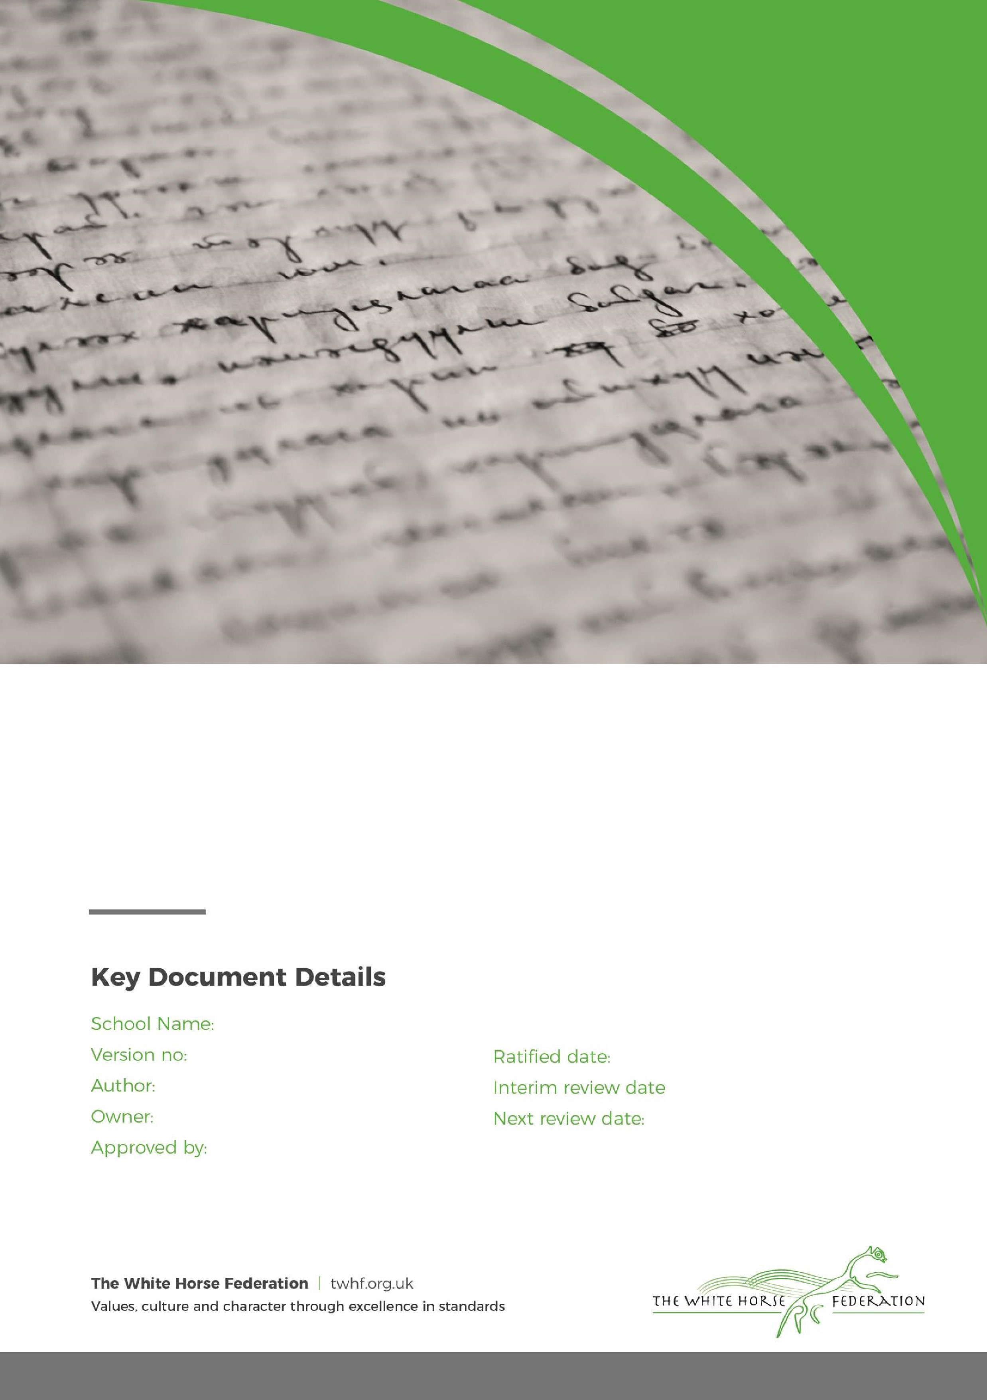

Special Education Needs (SEN)

Information Report

1

Tim James

Tim James

September / 2024

September / 2025

Forest and Sandridge CE Primary School

March / 2024

# **Dear Parents and Carers,**

The aim of this information report is to explain how we implement our SEND policy. In other words, we want to show you how SEND support works in our school.

If you want to know more about our arrangements for SEND, read our SEND policy.

You can find it on our website

**Note:** If there are any terms we’ve used in this information report that you’re unsure of, you can look them up in the Glossary at the end of the report.

# **What types of SEN does the school provide for?**

Our school provides for pupils with the following needs:

|  |  |
| --- | --- |
| **Area of need** | **Condition** |
| **Communication and interaction** | Autism spectrum disorder |
| Speech and language difficulties |
| **Cognition and learning** | Specific learning difficulties, including dyslexia, dyspraxia, dyscalculia |
|
|
| Moderate learning difficulties |
| Severe learning difficulties |
| **Social, emotional and mental health** | Attention deficit hyperactive disorder (ADHD) |
| Attention deficit disorder (ADD) |
| **Sensory and/or physical** | Hearing impairments |
| Visual impairment |
| Multi-sensory impairment |
| Physical impairment |

# **Which staff will support my child, and what training have they had?**

# Our special educational needs co-ordinator, or SENDCO

Our SENCO is Helen Chappell.

Helen has 14 years experience in this role and has worked both as a classroom teacher and a SENCO. She is a qualified teacher.

Helen achieved the National Award in Special Education Needs Co-ordination in June 2012.

Helen has also achieved a NPQ in Senior Leadership in July 2024.

Helen is allocated 5 days a week to manage SEN provision.

**Class Teachers**

All of our teachers receive in-house SEN training, and are supported by the SENCO to meet the needs of pupils who have SEN. Teachers are also part of meetings with external professionals so that they are able to share knowledge of the child and be part of the discussion of how to best support the child’s needs.

Teaching assistants (TAs)

We have a team of 12 TAs, in addition to 4 higher-level teaching assistants (HLTAs) who are trained to deliver SEN provision.

We have a number of teaching assistants who are trained to deliver interventions such as Lexia, Speech and Language, ELSA and Thrive.

External agencies and experts

Sometimes we need extra help to offer our pupils the support that they need. Whenever necessary we will work with external support services to meet the needs of our pupils with SEN and to support their families. These include:

* Speech and language therapists
* Educational psychologists
* Wiltshire Specialist SEN Service
* Social, Emotional, Mental Health Outreach Service
* Visual impairment advisory services
* Hearing impairment advisory services
* Advisory Teacher for Physical Disabilities
* Occupational therapists
* Special Educational Needs and/or Disabilities Team (SEND Team)
* GPs or paediatricians
* School nurses
* Child and adolescent mental health services (CAMHS)
* Education welfare officers
* Social services and other LA-provided support services
* Voluntary sector organisations

# **3. What should I do if I think my child has SEN?**

Once your child has settled into school, it may seem to you or your child’s teacher that s/he needs extra help. This may be clear to them from observation, or they may do some assessments. It maybe that later on s/he does not make the progress expected.

If your child has been to a preschool, nursery or another school, they will pass on information.

If you have concerns yourself, please talk to your child’s class teacher. We have an open-door policy at Forest and Sandridge Primary School and you are welcome to express your concerns to the class teacher at any time however please avoid teaching time. After school is better than in the morning, if this is not possible, please phone the school to make an appointment.

If we, in school, identify any special educational needs, we will talk to you about it and tell you what support is available to be put in place.



|  |  |  |
| --- | --- | --- |
| If you think your child might have a Special Educational Need, the first person you should tell is your child’s teacher.  Please contact your child’s teacher via Dojo, face to face or at parents evening.  They will pass the message on to our SENCO, Helen Chappell, who will be in touch to discuss your concerns.  You can also contact the SENCO directly, via the school office. | We will meet with you to discuss your concerns and try to get a better understanding of what your child’s strengths and difficulties are.  Together we will decide what outcomes to seek for your child and agree on next steps.  We will make a note of what’s been discussed and add this to your child’s record. You will also be given a copy of this. | If we decide that your child needs SEN support, we will formally notify you in writing and your child will be added to the school’s SEND register. |

# **4. How will the school know if my child needs SEN support?**

All our class teachers are aware of SEN and are experienced in identifying any pupils who aren’t making the expected level of progress in their schoolwork or socially. This might include observations in class, assessments or looking at their learning in detail.

If the teacher notices that a pupil is falling behind, they try to find out if the pupil has any gaps in their learning. If they can find a gap, they will give the pupil extra tuition to try to fill it. Pupils who don’t have SEN usually make progress quickly once the gap in their learning has been filled.

If the pupil is still struggling to make the expected progress, the teacher will talk to the SENCO, and will contact you to discuss the possibility that your child has SEN.

The SENCO will observe the pupil in the classroom and in the playground to see what their strengths and difficulties are. They will have discussions with your child’s teacher/s, to see if there have been any issues with, or changes in, their progress, attainment or behaviour. They will also compare your child's progress and development with their peers and available national data.

The SENCO will ask for your opinion and speak to your child to get their input as well. They may also, where appropriate, ask for the opinion of external experts such as a speech and language therapist, an educational psychologist, or a paediatrician.

Based on all of this information, the SENCO will decide whether your child needs SEN support. You will be told the outcome of the decision in writing.

If your child does need SEN support, their name will be added to the school’s SEN register, and the SENCO will work with you to create a SEN support plan for them.

# **5. How will the school measure my child’s progress?**

We will follow the ‘graduated approach’ to meeting your child’s SEN needs.

The graduated approach is a 4-part cycle of **assess, plan, do, review**.

**Assess**

**If your child is not making the expected level of progress, we will make an assessment to find out what strengths and difficulties your child has.** **We will ask for you and your child’s input, as well as getting help from external professionals where necessary.**

**Review**

**We will assess how well the support we put in place helped the pupil to meet the outcomes we set. We will use our improved understanding of   
your child’s needs to improve the support we offer.**

**Plan**

**In discussion with you and your child, we will decide what outcomes we are hoping to achieve. We will make a plan of the support we will offer your child to help them meet those outcomes. We will make a record of this and share it with you and all relevant school staff.**

**Do**

**We will put our plan into practice.**

**The class teacher, with the support of the SENCO, will be responsible for working with your child on a daily basis, and making sure the support we put in place is having the impact we intended.**

As a part of the planning stage of the graduated approach, we will set outcomes that we want to see your child achieve.

Whenever we run an intervention with your child, we will assess them before the intervention begins. This is known as a ‘baseline assessment’. We do this so we can see how much impact the intervention has on your child’s progress.

We will track your child’s progress towards the outcomes we set over time and improve our offer as we learn what your child responds to best.

This process will be continual. If the review shows a pupil has made progress, they may no longer need the additional provision made through SEN support. For others, the cycle will continue and the school's targets, strategies and provisions will be revisited and refined.

# **6. How will I be involved in decisions made about my child’s education?**

We will provide feedback on your child’s progress termly either through a parents evening or a written report. If your child has a My Support Plan or a Learning Journal, we will share this with you at least three times a year.

Your child’s class teacher will meet you three times a year, to:

* Set clear outcomes for your child’s progress
* Review progress towards those outcomes
* Discuss the support we will put in place to help your child make that progress
* Identify what we will do, what we will ask you to do, and what we will ask your child to do

The SENCO may also attend these meetings to provide extra support.

We know that you’re the expert when it comes to your child’s needs and aspirations. So, we want to make sure you have a full understanding of how we’re trying to meet your child’s needs, so that you can provide insight into what you think would work best for your child.

We also want to hear from you as much as possible so that we can build a better picture of how the SEN support we are providing is impacting your child outside of school.

If your child’s needs or aspirations change at any time, please let us know right away so we can keep our provision as relevant as possible.

After any discussion we will make a record of any outcomes, actions and support that have been agreed. This record will be shared with all relevant staff, and you will be given a copy.

If you have concerns that arise between these meetings, please contact your child’s class teacher via Dojo, face to face or via the school office.

# 

# **7. How will my child be involved in decisions made about their education?**

The level of involvement will depend on your child’s age, and level of competence. We recognise that no 2 children are the same, so we will decide on a case-by-case basis, with your input.

We may seek your child’s views by asking them to:

* Attend meetings to discuss their progress and outcomes
* Prepare a presentation, written statement, video, drawing, etc.
* Discuss their views with a member of staff who can act as a representative during the meeting
* Complete a survey

**8. How will the school adapt its teaching for my child?**

Your child’s teacher is responsible and accountable for the progress and development of all the pupils in their class.

High-quality teaching is our first step in responding to your child’s needs. We will make sure that your child has access to a broad and balanced curriculum in every year they are at our school.

We will adapt how we teach to suit the way the pupil works best. There is no '1 size fits all’ approach to adapting the curriculum, we work on a case-by case basis to make sure the adaptations we make are meaningful to your child.

These adaptations include:

* Adapting our curriculum to make sure all pupils are able to access it, for example, by grouping, 1-to-1 work, adapting the teaching style or content of the lesson, etc.
* Adapting our teaching, for example, giving longer processing times, pre-teaching of key vocabulary, reading instructions aloud, etc.
* Adapting our resources and staffing
* Using recommended aids, such as laptops, coloured overlays, visual timetables, larger font, etc.
* Teaching assistants will support pupils on a 1-to-1 basis where appropriate.
* Teaching assistants will support pupils in small groups where appropriate.

At Forest and Sandridge CE Primary School, we have created an Inclusive Classroom Guidance which shows how we support all learners.

[Special Educational Needs and Disabilities Information | Forest & Sandridge CofE Primary (forestsandridge.co.uk)](https://www.forestsandridge.co.uk/about-us/school-information/special-educational-needs-and-disabilities-information)

We may also provide the following interventions:

|  |  |  |
| --- | --- | --- |
| **Area of need** | **Condition** | **How we support these pupils** |
| **Communication and interaction** | Autism spectrum disorder | Visual timetables  Social stories |
| Speech and language difficulties | Speech and language therapy |
| **Cognition and learning** | Specific learning difficulties, including dyslexia, dyspraxia and dyscalculia | Writing slope  Visual resources and prompts  Alternative ways of recording |
|
|
| Moderate learning difficulties | As above |
| Severe learning difficulties | As above |
| **Social, emotional and mental health** | ADHD, ADD | Quiet workstation |
| Adverse childhood experiences and/or mental health issues | Nurture groups |
| **Sensory and/or physical** | Hearing impairment | Radio Aids  Sitting positions |
| Visual impairment | Limiting classroom displays  Use of an iPad |
| Multi-sensory impairment | Use of a quiet space  Ear Defenders |
| Physical impairment | Develop fine and gross motor skills |

These interventions are part of our contribution to Wiltshire Council local offer.

# **9. How will the school evaluate whether the support in place is helping my child?**

We will evaluate the effectiveness of provision for your child by:

* Reviewing their progress towards their outcomes each term including discussions around your child’s individual learning needs and provision in place
* Reviewing the impact of intervention and support regularly at formal parent/teacher meetings 3 times a year, including discussions around how to support and help your child at home
* Using pupil questionnaires
* Monitoring by the SENCO
* Using provision maps to measure progress
* A full written report at the end of the academic year. This includes targets for your child to progress
* Holding an annual review (if your child has education, health and care (EHC) plan)

# **10. How will the school resources be secured for my child?**

If your child is on SEN Support or has an EHCP, we will ensure that your child is supported in appropriate interventions and have access to programs to support this within the following ways:

* **Personalised Support Plans**: This will be a My Support Plan or a Learning Journal. These documents will detail specific needs, strategies and resources required for your child’s learning.
* **Collaboration with the SENCO**: Work closely with the SENCO to identify the necessary resources and support. The SENCO can help advocate for your child and facilitate access to appropriate interventions.
* **Utilising Funding**: Schools set aside funding for SEND support. This is used for training, resources, specialised materials and interventions.
* **Access to External Support**: Our school may be able to access external services and specialists to observe and assess your child. We will then collaborate with these services to ensure that any advice is followed and documented.
* **Training for Staff**: We plan regular training for staff both in house and externally through our federation and via Wiltshire Council.

# **11. How will the school make sure my child is included in activities alongside pupils who don’t have SEND?**

We are a fully inclusive school and all staff are passionate about the well‐being of each child.

All of our extra-curricular activities and school visits are available to all our pupils, including our before and after-school clubs.

All pupils are encouraged to go on our school trips, including our residential trips.

All pupils are encouraged to take part in sports day, performances, celebration worships and special celebrations, curriculum enhancing days.

No pupil is ever excluded from taking part in these activities because of their SEN or disability and we will make whatever reasonable adjustments are needed to make sure that they can be included.

# **12. How does the school make sure the admissions process is fair for pupils with SEN or a disability?**

**Admission arrangements**: Forest and Sandridge subscribes to the Wiltshire Council admissions procedures and policies. Parents can apply through Wiltshire Council for Primary School admissions. For the Nursery, parents apply through the School Office to register their child for a place.

If your child has an EHC plan, we welcome a visit to our school to discuss your child’s needs and the support we can offer. You will then need to apply for a place via the Wiltshire SEND Services.

Please see our School Admissions Policy on our school website.

<https://www.forestsandridge.co.uk/about-us/school-information/policies-and-procedures>

# **13. How does the school support pupils with physical disabilities?**

* Our school is fully wheelchair accessible and we have two disabled toilets. Reasonable adjustments are made for children who have a physical, hearing, visual or sensory impairment.
* We will adapt our school environment and curriculum where possible and where appropriate to ensure that all pupils are treated fairly and have access to the same opportunities.
* Please see our Accessibility Plan on our school website for further information.

<https://www.forestsandridge.co.uk/about-us/school-information/policies-and-procedures>

# **14. How will the school support my child’s mental health and emotional and social development?**

We are a fully inclusive school and all staff are passionate about the wellbeing of each child.

Our Values Curriculum and nurturing approach is used throughout the school by all members of staff.

Continuous care, support and guidance in class and around school may also include:

* PSHEE curriculum
* Whole School Thrive Approach
* Fully inclusive school where every child matters
* Enrichment activities (clubs, Pupil Premium activities, residential trips)
* Medical care plans / personal care plans
* Some staff are trained in Mental Health First Aid
* Some staff are trained in positive physical intervention (Team Teach). Any physical intervention is recorded appropriately according to safeguarding and LEA guidelines and is reported to parents. Physical intervention is a last resort in order to maintain the safety of a child and others around them. It is always deemed to be reasonable and proportionate to the circumstances they were intended to prevent.

We provide support for pupils to progress in their emotional and social development in the following ways:

* Pupils with SEN are encouraged to be part of the various school councils and groups in our school
* Pupils with SEN are also encouraged to be part of all after school clubs to promote teamwork/building friendships
* We have a whole school approach to Thrive, which focusses on the social and emotional development of our pupils.
* We provide extra pastoral support when needed through ELSA and Thrive.
* We have a ‘zero tolerance’ approach to bullying. We prevent bullying in the school through the teaching of PSHEE and Thrive, as well as the steps in our Anti-Bullying Policy.

[Policies and Procedures | Forest & Sandridge CofE Primary (forestsandridge.co.uk)](https://www.forestsandridge.co.uk/about-us/school-information/policies-and-procedures)

# **15. What support will be available for my child as they transition between classes or settings, or in preparing for adulthood?**

Between years

To help pupils with SEND be prepared for a new school year we:

* Ask both the current teacher and the next year’s teacher to attend a final meeting of the year when the pupil’s SEN is discussed
* Planned lessons and transition visits with the incoming teacher towards the end of the summer term

Between schools

When your child is moving on from our school, we will ask you and your child what information you want us to share with the new setting.

**Between phases for secondary school**

The SENCO of the secondary school will come into our school for a meeting with our SENCO. They will discuss the needs of all the children who are receiving SEN support.

Pupils will be prepared for the transition by:

* Practising with a secondary school timetable
* Learning how to get organised independently
* Plugging any gaps in knowledge
* Planning any addition transition activities or visits needed

# **16. What support is in place for looked-after and previously looked-after children with SEN?**

Helen Chappell is the designated teacher for looked-after children and previously looked-after children and is an active participant of the Wiltshire LAC Network. Her role is to make sure that all teachers understand looked-after or previously looked-after pupil’s circumstances and what the implications are for teaching and learning.

Children who are looked-after or previously looked-after will be supported much in the same way as any other child who has SEND. However, looked-after pupils will also have a personal education plan (PEP). We will make sure that the PEP and any SEN support plans or EHC plans are consistent and complement one another.

# **17. What should I do if I have a complaint about my child’s SEN support?**

Complaints about SEN provision in our school should be made to Helen Chappell, SENCO, in the first instance. They will then be referred to the school’s complaints policy.

If you are not satisfied with the school’s response, you can escalate the complaint. In some circumstances, this right also applies to the pupil themselves.

To see a full explanation of suitable avenues for complaint, see pages 246 and 247 of the [SEN Code of Practice](https://www.gov.uk/government/publications/send-code-of-practice-0-to-25).

If you feel that our school discriminated against your child because of their SEND, you have the right to make a discrimination claim to the first-tier SEND tribunal. To find out how to make such a claim, you should visit: <https://www.gov.uk/complain-about-school/disability-discrimination>

You can make a claim about alleged discrimination regarding:

* Admission
* Exclusion
* Provision of education and associated services
* Making reasonable adjustments, including the provision of auxiliary aids and services

Before going to a SEND tribunal, you can go through processes called disagreement resolution or mediation, where you try to resolve your disagreement before it reaches the tribunal.

# **18. What support is available for me and my family?**

If you have questions about SEND, or are struggling to cope, please get in touch to let us know. We want to support you, your child and your family.

To see what support is available to you locally, have a look at Wiltshire’s local offer.

<https://localoffer.wiltshire.gov.uk/>

Our local special educational needs and disabilities information advice and support services (SENDIASS) organisations are:

<https://family-action.org.uk/services/wiltshire-sendiass/>

National charities that offer information and support to families of children with SEND are:

* [IPSEA](https://www.ipsea.org.uk/)
* [SEND family support](https://sendfs.co.uk/)
* [NSPCC](https://www.nspcc.org.uk/keeping-children-safe/support-for-parents/)
* [Family Action](https://www.family-action.org.uk/what-we-do/children-families/send/)
* [Special Needs Jungle](https://www.specialneedsjungle.com/)

# **19. Glossary**

* **Access arrangements** – special arrangements to allow pupils with SEND to access assessments or exams
* **Annual review** –an annual meeting to review the provision in a pupil’s EHC plan
* **Area of need** – the 4 areas of need describe different types of needs a pupil with SEND can have. The 4 areas are communication and interaction; cognition and learning; physical and/or sensory; and social, emotional and mental health needs.
* **CAMHS** – child and adolescent mental health services
* **Adapt** – when teachers adapt how they teach in response to a pupil’s needs
* **EHC needs assessment** – the needs assessment is the first step on the way to securing an EHC plan. The local authority will do an assessment to decide whether a child needs an EHC plan.
* **EHC plan** –an education, health and care plan is a legally-binding document that sets out a child’s needs and the provision that will be put in place to meet their needs.
* **First-tier tribunal/SEND tribunal** – a court where you can appeal against the local authority’s decisions about EHC needs assessments or plans and against discrimination by a school or local authority due to SEND
* **Graduated approach** – an approach to providing SEN support in which the school provides support in successive cycles of assessing the pupil’s needs, planning the provision, implementing the plan, and reviewing the impact of the action on the pupil
* **Intervention** – a short-term, targeted approach to teaching a pupil with a specific outcome in mind
* **Local offer** – information provided by the local authority which explains what services and support are on offer for pupils with SEN in the local area
* **Outcome** – target for improvement for pupils with SEND. These targets don't necessarily have to be related to academic attainment
* **Reasonable adjustments** – changes that the school must make to remove or reduce any disadvantages caused by a child’s disability
* **SENCO** – the special educational needs co-ordinator
* **SEN** – special educational needs
* **SEND** – special educational needs and disabilities
* **SEND Code of Practice** – the statutory guidance that schools must follow to support children with SEND
* **SEN information report** – a report that schools must publish on their website, that explains how the school supports pupils with SEN
* **SEN support** – special educational provision which meets the needs of pupils with SEN
* **Transition** – when a pupil moves between years, phases, schools or institutions or life stages