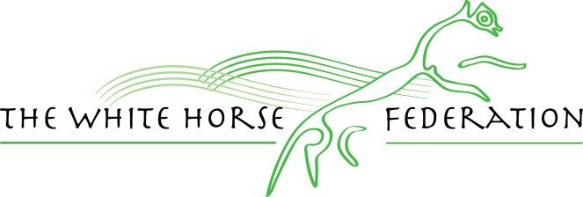

|  |  |  |  |
| --- | --- | --- | --- |
| Author: | James Mead | Approver: | Scott James |
| Owner: | Scott James | Version No.: | Version no 1 |
| Date: | September 2025 | Next review: | July 2027 |
| Ratified: | July 2024 |  |  |

Forest & Sandridge CE School

Uniform Policy

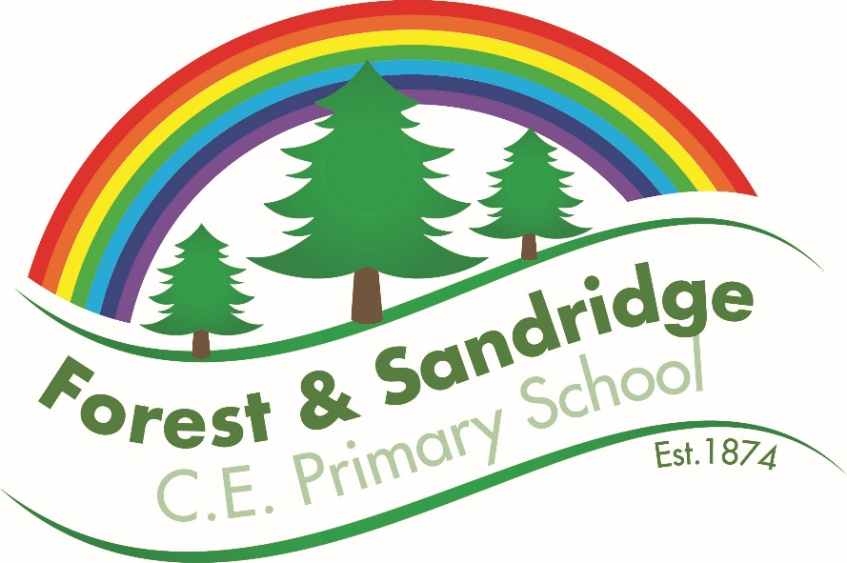

**Contents**

1. Aims 3

2. Our school’s legal duties under the Equality Act 2010 3

3. Limiting the cost of school uniform 3

4. Expectations for school uniform 4

5. Expectations for our school community 5

6. Monitoring arrangements 6

7. Links to other policies 6

# 1. Aims

This policy aims to:

* Set out our approach to requiring a uniform that is of reasonable cost and offers the best value for money for parents and carers
* Explain how we will avoid discrimination in line with our legal duties under the Equality Act 2010
* Clarify our expectations for school uniform

# 2. Our school’s legal duties under the Equality Act 2010

The [Equality Act 2010](https://www.legislation.gov.uk/ukpga/2010/15/contents) prohibits discrimination against an individual based on the protected characteristics, which include sex, race, religion or belief, and gender reassignment.

To avoid discrimination, our school will:

* Avoid listing uniform items based on sex, to give all pupils the opportunity to wear the uniform they feel most comfortable in or that most reflects their self-identified gender
* Make sure that our uniform costs the same for all pupils
* Allow all pupils to have long hair (though we reserve the right to ask for this to be tied back)
* Allow all pupils to style their hair in the way that is appropriate for school yet makes them feel most comfortable
* Allow pupils to request changes to swimwear for religious reasons
* Allow pupils to wear headscarves and other religious or cultural symbols
* Allow for adaptations to our policy on the grounds of equality by asking pupils or their parents to get in touch with Mr James, who can answer questions about the policy and respond to any requests

# 3. Limiting the cost of school uniform

Our school has a duty to make sure that the uniform we require is affordable, in line with statutory [guidance](https://www.gov.uk/government/publications/cost-of-school-uniforms/cost-of-school-uniforms) from the Department for Education on the cost of school uniform.

We will make sure our uniform:

* Is available at a reasonable cost
* Provides the best value for money for parents/carers

We will do this by:

* Carefully considering whether any items with distinctive characteristics are necessary
* Limiting any items with distinctive characteristics where possible.
* Avoiding specific requirements for items pupils could wear on non-school days, such as coats, bags and shoes
* Keeping the number of optional branded items to a minimum, so that the school’s uniform can act as a social leveler
* Avoiding different uniform requirements for different year/class/groups
* Avoiding different uniform requirements for extra-curricular activities where possible
* Considering alternative methods for signaling differences in groups for interschool competitions, such as creating posters or labels
* Making sure that arrangements are in place for parents to acquire second-hand uniform items
* Avoiding frequent changes to uniform specifications and minimising the financial impact on parents of any changes
* Consulting with parents and pupils on any proposed significant changes to the uniform policy and carefully considering any complaints about the policy

# 4. Expectations for school uniform

4.1 Our school’s uniform

The expected school uniform consists of:

Grey or black skirt, pinafore dress, tailored shorts, or trousers (no leggings, jogging bottoms, jogging shorts, tracksuit bottoms, jeans, or ‘school jeans’).

White polo shirt, blouse, or collared shirt (with or without the school logo).

Green and white checked or striped cotton dress (optional for summer).

Green sweatshirt or cardigan with or without school logo.

Plain green, black, grey, or white tights OR plain white, grey, or black socks (socks or tights must be worn). Sport socks with logos are not school uniform.

Plain black school shoes (No open-toed shoes or sandals, trainers or canvas shoes). Children may wear plain black ankle boots. Black trainers are not school uniform.

Hair accessories should be in keeping with school uniform: green, black, or white (novelty alice-bands, including alice bands with ears and oversized bows are not allowed).

Children should not wear jewellery to school other than a cheap watch or stud earrings. Smart watches are not allowed in school.

Outlandish hairstyles, coloured hair, nail varnish, fake nails and makeup are not allowed in school. If a child comes to school with nail varnish, fake nails or make up on, parents will be contacted and asked to make arrangements for it to be removed.

Please can long hair be tied back.

**We expect all uniform to be named.**

PE Kit

The expected sports kit consists of:

Plain black sports shorts, black skorts or black or navy sports leggings.

House-coloured t-shirt with or without the school logo (a plain white t-shirt can be worn instead).

Black indoor PE daps or indoor trainers.

Tracksuit bottoms and a plain sweatshirt (for outdoor PE in colder weather).

Outside trainers.

Every item of the sports kit should be in school at all times in a named PE bag. PE kit will be returned at the end of each term for washing.

There is also a black school hoody available to purchase.

________________________________________

Wellies

All children should have a pair of wellington boots in school at all times. Wellies should be clearly named and will be safely stored on class welly racks. Children will bring their wellies home at the end of each term with their PE kits.

Wellies will ensure that children have maximum opportunity to play on our school field in most weathers and will also ensure that we keep the inside of school as clean and tidy as possible.

________________________________________

4.2 Where to purchase it

# All our named uniform can be purchased at Sports Bug, Melksham High Street, or on their [website](http://www.sportsbug.co.uk/). You can contact them on 01225 791317. School hats, book bags, PE bags, coats, and fleeces are also available from Sports Bug. Alternatively, one of our parents runs a second-hand uniform shop via Facebook. Please ask in the office for further information.

# 5. Expectations for our school community

5.1 Pupils

Pupils are expected to wear the correct uniform at all times (other than specified non-school uniform days) while:

* On the school premises
* Travelling to and from school
* At out-of-school events or on trips that are organised by the school, or where they are representing the school (if required)

Pupils are also expected to contact Mr James if they want to request an amendment to the uniform policy in relation to their protected characteristics.

5.2 Parents and carers

Parents and carers are expected to make sure their child has the correct uniform and PE kit, and that every item is:

* Clean
* Clearly labelled with the child’s name
* In good condition

Parents are also expected to contact Mr James if they want to request an amendment to the uniform policy in relation to:

* Their child’s protected characteristics
* The cost of the uniform

Parents are expected to lodge any complaints or objections relating to the school uniform in a timely and reasonable manner.

Disputes about the cost of the school uniform will be:

* Resolved locally
* Dealt with in accordance with our school’s complaints policy

The school will work closely with parents to arrive at a mutually acceptable outcome.

5.3 Staff

Staff will closely monitor pupils to make sure they are in correct uniform. They will give any pupils and families breaching the uniform policy the opportunity to comply in the first instance with a message via Dojo. If the situation doesn’t improve, teachers will follow up with SLT who will make contact with you to see how we can support further. Ongoing breaches of our uniform policy will be passed to the Principal.

In cases where it is suspected that financial hardship has resulted in a pupil not complying with this uniform policy, staff will take a mindful and considerate approach to resolving the situation.

5.4 Governors

The governing board will review this policy and make sure that it:

* Is appropriate for our school’s context
* Is implemented fairly across the school
* Takes into account the views of parents and pupils
* Offers a uniform that is appropriate, practical and safe for all pupils

The board will also make sure that the school’s uniform supplier arrangements give the highest priority to cost and value for money, for example by avoiding single supplier contracts and by re-tendering contracts at least every 5 years.

# 6. Monitoring arrangements

This policy will be reviewed annually by Mr James - Principal. At every review, it will be approved by Governing Body.

# 7. Links to other policies

This policy is linked to our:

* Behaviour policy
* Equality information and objectives statement
* Anti-bullying policy
* Complaints policy