Geography Skills Progression
FS1 |  |  | FS2 |  | ELG
Maths  - Understand position through words alone. For example, “The bag is under the table,” – with no pointing.  - Describe a familiar route.  - Discuss routes and locations, using words like ‘in front of’ and ‘behind’.  Understanding the World  - Use all their senses in hands-on exploration of natural materials.  - Begin to understand the need to respect and care for the natural environment and all living things.  - Know that there are different countries in the work and talk about the differences they have experienced or seen in photos. |  |  | Understand the World  - Draw information from a simple map.  - Recognise some similarities and differences between life in this country and life in other countries.  - Explore the natural world around them.  - Recognise some environments that are different to the one in which they live. |  | Understanding the World - People, Culture and Communities  - Describe their immediate environment using knowledge from observation, discussion, stories, non-fiction texts and maps.  - Explain some similarities and differences between life in this country and life in other countries, drawing on knowledge from stories, non-fiction texts and (when appropriate) maps.  Understanding the World- The Natural World  - Know some similarities and differences between the natural world around them and contrasting environments, drawing on their experiences and what has been read in class.  - Understand some important processes and changes in the natural world around them, including the seasons.
Themes/Skills |  | Geographical Skills |  | Fieldwork Skills
Year 1
Term 1 | 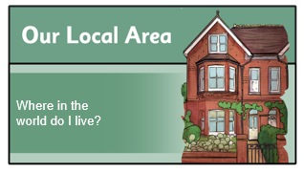 | I can devise a simple, messy map.  I can collect and record  simple data.  I can present simple data in a chart. |  | I can use simple fieldwork and observational skills to answer geographical questions.  I can use directional language to describe a route.  I can name and use cardinal directions.
Year 2
Term 3 and Term 4 | 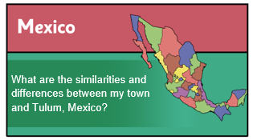 | I can use atlases and globes to discover the continents and oceans of the world.  I can use compass directions and locational and directional language to describe the location of features on a map.  I can use aerial photographs and plan perspectives to recognise landmarks and devise simple maps.  I can use a key. |  | I can use simple fieldwork and observational skills to study the school’s geography.
Year 3
Term 3 and Term 4 | 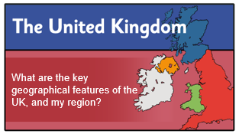 | I can use compass points, four-figure grid references, symbols and keys.  I can identify physical features on a map.  I can locate settlements on a map.  I can use maps and atlases to discover the United Kingdom. |  | I can devise a sketch map of my local area.
Year 4
Term 3 and Term 4 | 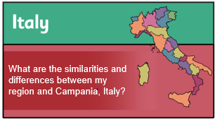 | I can use atlases, maps and globes to locate places and describe features studied. |  | I can use aerial photographs and plan perspectives to recognise landmarks and basic human and physical features.
Year 5
Term 1 and Term 2 | 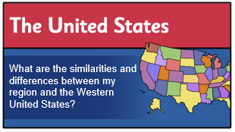 | I can use atlases, maps and globes to locate places and describe features studied. |  | I can use simple fieldwork and observational skills to study the … key human and physical features of its surrounding environment.
Year 6
Term 3 and Term 4 | 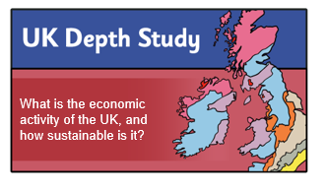 | I can use atlases, maps and globes to locate places and describe features studied. |  | I can collect data using a range of equipment.

