Music development plan summary:
Forest and Sandridge Primary School

Overview
Detail | Information
Academic year that this summary covers | 2025-2027
Date this summary was published | September 2025
Date this summary will be reviewed | August 2025
Name of the school music lead | Deputy Headteacher
Name of school leadership team member with responsibility for music (if different) | Headteacher
Name of local music hub | Wiltshire Music Service
Name of other music education organisation(s) (if partnership in place) | Peripatetic Music Teachers

This is a summary of how our school delivers music education to all our pupils across three areas – curriculum music, co-curricular provision and musical experiences – and what changes we are planning in future years. This information is to help pupils and parents or carers understand what our school offers and who we work with to support our pupils’ music education.

Part A: Curriculum music

This is about what we teach in lesson time, how much time is spent teaching music and any music qualifications or awards that pupils can achieve.

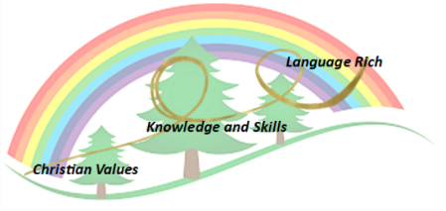
In order to achieve our whole school intent, we have identified 3 Golden Threads that weave through our curriculum and underpin everything we do. This means that in delivering our curriculum we are embedding our school Christian Values, developing knowledge and skills progressively over time with an ambitious and aspiring curriculum whilst immersing our children in language rich teaching.

Intent

At Forest and Sandridge we value music because it is a powerful and unique form of communication that can change and impact the way children feel, think and act. We believe that teaching music helps the body and the mind work together. Exposing children to music during early development helps them to learn the sounds and meanings of words. Dancing to music helps children build motor skills while allowing them to practice self-expression. We believe that every child should have the opportunity to develop their musical potential and we aim to nurture and encourage musical development across the school so they can flourish musically.
During their time at Forest and Sandridge we aim to ensure that all pupils:
- Produce creative work, exploring their ideas, recording and performing their experiences.
- Become proficient in expressing themselves through music.
- Evaluate and analyse different genres of music.
- Know about great musicians and understand the historical and cultural development of their art forms.
- Can use subject specific vocabulary to ‘talk like a musician’ to communicate their observations and preferences through language of evaluation.
Implementation

Our whole curriculum is shaped by our school vision, which aims to enable all children, regardless of background, ability, additional needs, to flourish to become the very best version of themselves they can possibly be. During the year, all children will have the opportunity to develop their understanding, skills and techniques in music. We are very proud of our musical achievements at Forest and Sandridge. We welcome parents to our annual music concert and productions throughout the year to share the musical ability we have at our school. Our peripatetic teachers who come into school to teach music lessons are giving opportunities for children to learn and develop their skills from an experienced specialist teacher. These teachers are; guitar, piano, drums and singing.
We use music as a form of worship on a daily basis.
How we use music in collective worship:
- To make the text special, ‘different’ from everyday speech.
- It is corporate, something we can all join in with, and encourages participation.
- It is memorable, and helps us to remember the words.
- It expresses feelings and emotions in a deeper way than words alone

The national curriculum is our starting point for deciding upon the knowledge and skills that children will be taught in each year group. Our curriculum, through the use of Charanga is designed to ensure that, where possible, learning is relevant to our diverse community and rooted in our rich heritage. In Music we have developed the scheme of Charanga to ensure there are fun and exciting opportunities to learn during each music lesson. Learning is sequenced to ensure that prior learning can support what comes next. The Charanga scheme helps non-specialist teachers and TAs to deliver good quality lessons with confidence.
In Music, the key language and vocabulary needed by children to communicate their learning is identified and explicitly identified on planning. Vocabulary is explicitly taught through a variety of active learning strategies using sentence stems . Teachers are encouraged to be passionate about language and model effective use of vocabulary within their teaching.
Planning

To ensure the delivery of the National curriculum and progression of skills and knowledge across the school we use ‘Charanga’ as a basis for our Music Curriculum.
Where appropriate every lesson will:
- Recap prior learning
- Review and introduce key vocab for the theme.
- Use sentence stems to support children speaking in full sentences.
- Review learning at the end of the lesson.

Example:
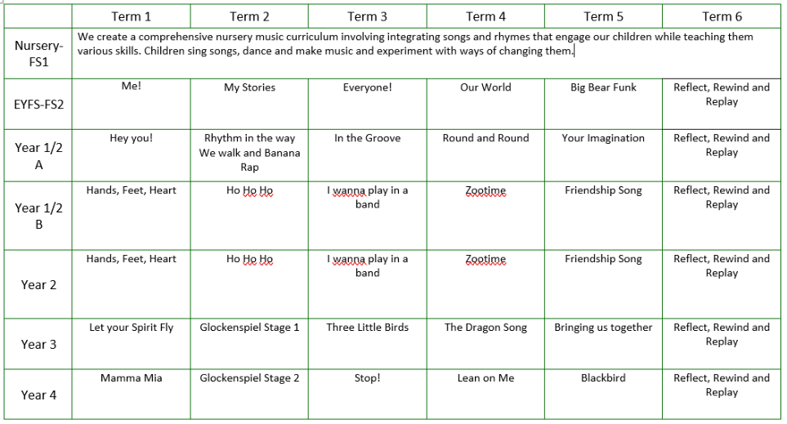

Impact- How do our Golden Threads work within this subject?

Christian Values
- Developing respect and compassion, by teaching children how to be in an audience.
- Striving to nurture confidence and courage by expecting children to be brave and perform in front of others.
- Have had the opportunity to experience music as a form of worship.
- Have had the opportunity to perform for an audience in church services, carol concerts, class led worships and special musical celebrations.
- Allow children to flourish by using visual language skilfully and convincingly to express emotions, interpret observations, convey insights and accentuate their individuality. As well as having independence, initiative and originality which they can use to develop their creativity.
- Developing a passion for and a commitment to the subject.
Knowledge and Skills
- Gaining new knowledge of how a range of different genres and instruments sound, work, and complement each other.
- Using knowledge and taught skills to create performances.
- Revising and deepening key aspects of music learnt from each unit of work.
- Having an in depth understanding of the different genres of music, which progress throughout a child’s learning journey.
- Exposing children to a range of artists, movements, different songs and recordings beyond Music.
- Providing children with the chance to learn through experimenting, practicing and then performing beyond the classroom.
Language Rich
- Embedding the use of vocabulary within lessons, through discussions and music appreciation.
- Teaching children to use the correct terminology when describing instruments.
- Confidently use language structures to evaluate.

Scaffolding/supporting SEND/lowest 20%: What do we do and how does this look?

Teachers try to identify potential barriers at the planning stage. In their planning, they consider ways of minimising or reducing those barriers.
Lesson design:
- Recapping learning from the previous lesson. Children may revisit their work from the last lesson to remember/improve/tweak/adjust.
- Consolidation is built in through curriculum design. Opportunities are provided for pupils to repeat and reinforce previously learnt skills and processes on a regular basis, in similar and different contexts.
- The curriculum is designed in a way that allows pupils to make links to the real world.
- Scaffolded tasks to support those need additional support.
- Whole class discussions (e.g. the teacher may do a mini plenary where common misconceptions are identified and discussed or where they share examples of pupil work on the board).

Environment
- Key vocabulary displayed on the board so children can use correct terminology in their discussions.
- Flexible seating options in case children need to move during the lesson.

Resources
- Adult support (e.g. additional modelling or explanation)
- Peer support
- Check list of steps to complete (e.g. on the flip chart or slides printed)

Part B: Co-curricular music
This is about opportunities for pupils to sing and play music, outside of lesson time, including choirs, ensembles and bands, and how pupils can make progress in music beyond the core curriculum.
The school has an active choir that performs at local events e.g. in local care homes at Christmas, Melksham Christmas light turn on and at events local to the school such as fetes and public events. The choir also perform in a national event every 2 years at Young Voices.
Singing in all worships and a special singing worship is also set aside on a weekly basis for singing. Children are introduced to new songs and enjoying practising, rehearsing and performing together.
We have close links with local music teachers allowing the time and space for pupils to learn instruments in school. These can be subsidised for pupils in receipt of pupil premium. This service provides additional, peripatetic music tuition in drumming, playing the piano, recorder and flute. Pupils enjoy performing music they have learnt at an end of year musical celebration showcase.

Part C: Musical experiences
This is about all the other musical events and opportunities that we organise, such as singing in assembly, concerts and shows, and trips to professional concerts.
- Assembly time for singing
- Rocksteady concerts
- Choir performances both locally and nationally
- Trips to musicals in year Reception and Year

In the future
This is about what the school is planning for subsequent years.
It is the intention of the leadership team to:
- Plan whole class music tuition as part of the curriculum beyond that offered by class teacher in recorders and glockenspiel.

