Reception LTP
Autumn 1 | /s/ as in sun /m/ as in mouse  /a/ as in apple /d/ as in dog  /t/ as in tap /g/ as in goat  /i/ as in insect /o/ as in octopus  /p/ as in pan /k/ as in cat  /n/ as in net /k/ as in kite  I, the, go, to, no, into
Autumn 2 | /k/ as in duck /f/ as in frog and cliff  /e/ as in elephant /l/ as in ladder  /u/ as in umbrella /l/ as in shell  /r/ as in rabbit /s/ as in dress  /h/ as in hat Double consonant letters  /b/ as in bat Two syllable words I, the, go, to, no, into
Spring 1 | /j/ as in jug /z/ as in bugs  /v/ as in van /k+w/ as in queen  /w/ as in web Consolidation  /k+s/ as in fox  /y/ as in yellow  /z/ as in zebra and fizzy  he, she, we, me, be, was, my, you, her, they, all, are
Spring 2 | /ch/ as in chick /igh/ as in light  /sh/ as in sheep /oa/ as in boat  /th/ as in thumb and feather short /oo/ as in book  /n+g/ as in ring long /oo/ as in moon  /ai/ as in train Consolidation  /ee/ as in bee  he, she, we, me, be, was, my, you, her, they, all, are
Summer 1 | /ar/ as in car /air/ as in chair  /or/ as in fork /y+oor/ as in manure  /ur/ as in purse schwa /uh/ as in hammer  /ou/ as in owl Consolidation  /oi/ as in coin  /eer/ as in ear  some, one, said, come, do, so, were, when, have, there, out, like, little, what
Summer 2 | /w/ as in wheel /ee/ as in shield  /f/ as in dolphin /ee/ as in peach  /ai/ as in crayon Consolidation  /ai/ as in cake  /ai/ as in acorn  /ee/ as in scene  some, one, said, come, do, so, were, when, have, there, out, like, little, what

Year one LTP
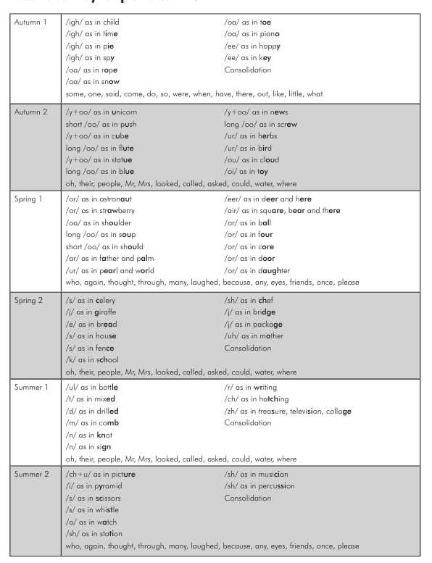

Year 2 LTP
