
TWHF Church School Spirituality Policy

Spirituality Policy

TWHF Church Schools

******,
TWHF Church Schools

1

Anna Willcox

Anna Willcox

PCSF Team

24.2.25

July 2025

July 2026

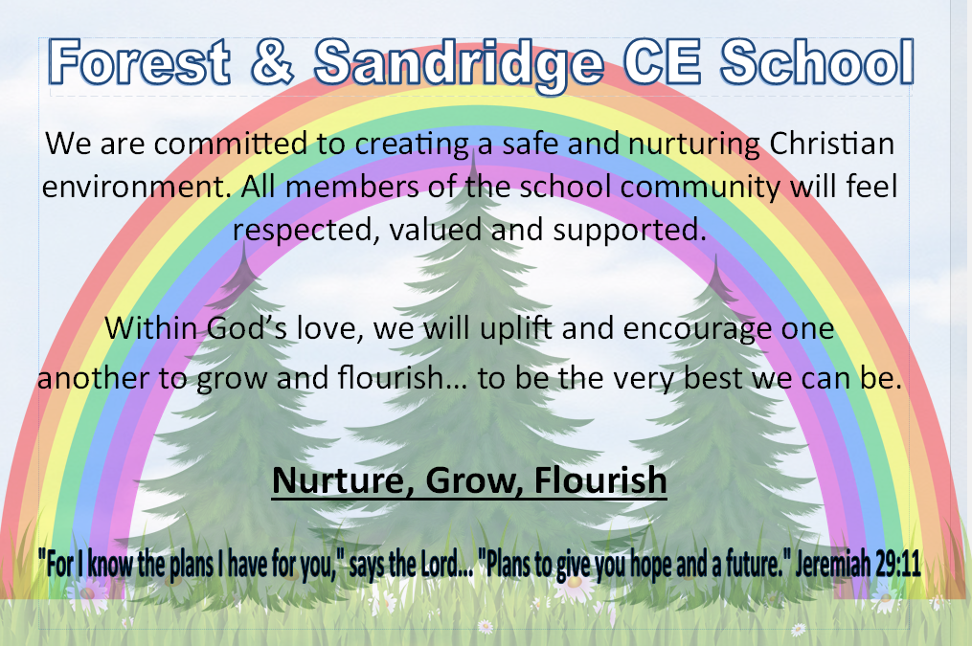
Our Vision

All we do at our school will be underpinned by the above vision. This policy should be read and understood from this perspective.
The White Horse Federation Mission Statement:
To inspire lives with greater opportunity and choice.
Delivering an excellent all-through education that seeks equity to secure social justice, so that all children flourish into adulthood.

Rationale
“Spirituality is like a bird; if you hold it too tightly it chokes; if you hold it too loosely, it flies away.” Rabbi Hugo Gryn
Spirituality in Schools - what do Ofsted and SIAMS expect?
Since 1944 schools have been required by law to provide for the spiritual development of pupils. Both Ofsted and SIAMS lay out within their frameworks the importance of spiritual development for pupils.
In the Ofsted 2024 framework it states:
237. All schools are also required to promote the spiritual, moral, social, cultural, mental and physical development of pupils at the school and of society; and prepare pupils at the school for the opportunities, responsibilities and experiences of later life.
- Inspectors will evaluate the effectiveness of the school’s provision for pupils’ spiritual, moral, social and cultural education. This is a broad concept that can be seen across the school’s activities, but draws together many of the areas covered by the personal development judgement.
- Provision for the spiritual development of pupils includes developing their:
  - ability to be reflective about their own beliefs (religious or otherwise) and perspective on life
  - knowledge of, and respect for, different people’s faiths, feelings and values
  - sense of enjoyment and fascination in learning about themselves, others and the world around them
  - use of imagination and creativity in their learning
  - willingness to reflect on their experiences
The SIAMS 2023 Framework, revised in 2024, includes the questions:
  - How does the school’s theologically rooted Christian vision enable pupils and adults to flourish?
  - How does the curriculum reflect the school’s theologically rooted Christian vision? Included the subquestion, ‘How is spiritual development an intrinsic part of the curriculum?’
  - How is daily collective worship enabling pupils and adults to flourish spiritually?

The Church of England Vision for Education is deeply Christian, with Jesus' promise of 'life in all its fullness' at its heart.

In line with the Church of England's role as the established Church, their vision is for the common good of the whole community.
Educating for wisdom, knowledge and skills: enabling discipline, confidence and delight in seeking wisdom and knowledge, and developing talents in all areas of life.
Educating for hope and aspiration: enabling healing, repair and renewal, coping wisely when things go wrong, opening horizons and guiding people into ways of fulfilling them.
Educating for community and living well together: a core focus on relationships, participation in communities and the qualities of character that enable people to flourish together.
Educating for dignity and respect: the basic principle of respect for the value and preciousness of each person, treating each person as a unique individual of inherent worth.
There is a clear the requirement for schools to have a shared understanding of what is meant by spirituality and spiritual growth. Also, for the provision in school to be planned and progressive and embedded across the school (and not just found in collective worship).
Alongside the requirement to promote and develop spiritual growth, nurturing this is proven to have profound benefits for both children and their families. The concept is studied in Dr Lisa Miller’s book, ‘The Spiritual Child’ where she explores the fact that every child is born with an inherent capacity for spirituality, a ‘spiritual birthright’. She suggests that spiritual practices can have a positive impact on brain health, enhancing resilience and emotional well-being:
‘The spiritual child is a child who is in touch with their sense of wonder, curiosity and connection….
When we practice our spiritual life, we literally strengthen our brain.’ Dr Lisa Miller

Our Diocesan Boards of Education understanding of spirituality:
Salisbury Diocesean Board of Education (SDBE) do not have a shared or expected understanding of spirituality because this is so unique to individual schools. They expect, and support where required, schools to develop their own understanding.
The SDBE’s approach to spirituality is as follows:
‘Spirituality: we promote it, plan provision for it and prepare our purpose for life with it, seeking an enriching positive impact.
The tangled uncharted journey of spirituality will be inclusive, invitational and inspiring, honouring but not limited by the expectations of Church school collective worship and RE: embracing deeper connections wherever they can be found.
Spirituality will become a confidently used unifying force, unlocking a fuller and healthy understanding of self, relationships and of something bigger. Holistic growth will be commonplace, spirits will flourish and not be crushed.
Our schools will be places where souls can sing and this singing will be well celebrated.’
Oxford Diocesan Board of Education’s (ODBE) approach to spirituality is as follows:
‘While collective worship provides opportunity for spiritual exploration, spirituality itself has a much broader compass than this. Our lives are shot through with spiritual experiences which range from reflection on art or the feel of wind on the cheek to religious reflection on creation through prayer.
Curriculum, ethos and school environment have the potential for promoting spiritual development.
The ways in which we both appreciate and express our spiritual nature is very varied and the ways in which spirituality is presented and explored will be driven by the vision of the school. This takes spirituality beyond the suggestions given in the Ofsted handbook.
Recent research found pupils’ own understanding of spirituality to include:
- the development of self
- community: a connection with other people
- a deepening understanding of faith
- a relationship with God’

Our TWHF Shared understanding of Spirituality
Linking with both of the above approaches, we have a shared understanding of spirituality across our schools:


Look in, Look out, Look up

Within our TWHF Church schools we aim to give all children opportunities to think about themselves, others, beauty and creation and the world beyond. We encourage children to become independent thinkers and wonderers. We model an environment of inclusion and respect. We allow children the space, process, imagination, relationships, intimacy and trust to be spiritual beings.

We use simple language to help children to understand this and to enable them to enter into opportunities for spiritual development with security and confidence.


Looking in
Reflecting on Ourselves
How do you feel about yourself? Are you confident, happy in your own skin and do you feel empowered, or do you sometimes feel unsure and not enough? Looking inward means exploring your thoughts, beliefs, and feelings.

Why Look In?
- Self-Discovery: Understand your values, aspirations, and how you want to be treated.
- Empowerment: Build self-confidence and recognise your strengths.
Personal Growth: Positive self-reflection fosters success and resilience, helping you overcome challenges.
By looking inward, we recognise our potential and acknowledge our worth, allowing us to be the best version of ourselves.


Looking out

Connecting with Our Community
Our world is filled with opportunities to make a difference. Looking out means understanding the thoughts and views of others, accepting and celebrating difference, understanding the world around us, caring for others and contributing positively to our community.

Why Look Out?
- Community Service and an understanding of justice: Engage in acts of kindness and service. Challenge injustice.
- Positive Impact: Help create a thriving, supportive environment for everyone.
- Shared Responsibility: Understand our role in building a compassionate and just society.
By looking outward, we strengthen relationships, the bonds of community and embody our vision and values in action.


Looking up
Seeking Something Greater
Spirituality involves connecting with something beyond ourselves—a search for meaning and purpose. Looking up means embracing life’s bigger questions and seeking guidance from a higher power if this is what you choose.

Why Look Up?
- Connection: Find meaning in something transcendental such as your relationship with God, a higher power or whatever each individual chooses.
- Reflection: Ask deep, philosophical questions about life and purpose.
- Growth: Align your character and actions with values that transcend daily life.
Whether through prayer, silence, meditation, music, reflection or any other chosen means, looking up helps us understand our role in the world and aligns our actions with the values that shape our character.

How we promote spirituality at TWHF Church schools
We plan purposefully and strategically across the curriculum, in collective worship and with special activities to nurture children’s spirituality. We also provide opportunities for spontaneous spiritual experiences.
We do this through:
- Environment - We think carefully about how we value space when providing opportunities for spiritual development. We use images, sounds, symbols to create sacred spaces. Each classroom should have a designated reflection space. We use symbols and colours when creating worship spaces. We use familiar beginnings (gathering) and endings (sending out) to frame worship and help pupils understand that the impact of worship goes beyond the time together. We use the local church as a sacred space. We seek to use the natural environment as much as we can providing spaces for quiet reflection around the school grounds. We also provide emotional space –giving children time and space to explore emotions and give that space to each other.
- Creativity - Jesus taught in stories, parables and imagery. We plan to give children opportunities to explore and think about themselves, others, the world and God/the transcendent in an imaginative and open-ended way. We enable children to explore images, music, space, opportunities without always having a learning intention or fixed achievement point – but instead let them explore freely and use imagination.
- Relationships - We aim to create authentic models of relating to each other as part of a family and nurturing our own relationship with God. We model mixed age relationships within school – using buddies, volunteers and visitors and the church community. We have a listening and respectful ethos within the school which equally values all views and contributions
- Safety - Spirituality if often about coming closer to things, then delving deeper and taking risks. We give time and space for people to present opinions that are personal and sacred to them. We create safe spaces in classrooms and collective worship where all contributions are valued equally rather than seeking a “correct” answer.
- Trust - We have to trust and become comfortable with different kinds of knowing. Trust is also essential in getting to know God/higher power as individuals choose, particularly when life is hard and we experience change. We need to let go of always having to offer the “right” answer, and be prepared to share our own beliefs, unknowing and perhaps doubts. We trust that the community can bring answers to difficult questions as well as trusting our feelings if there are no clear answers.
- Celebration – We celebrate spiritual moments and growth; changes that are made to individuals as a result of these. Staff model celebration of spiritual growth just as they do with curriculum areas and the principles of effective teaching and learning.

How do we nurture spirituality?
- Planned opportunities across the curriculum
- In collective worship
- Through our school’s Christian vision and values
- Through our natural environment
- Through relationship with our community and the church
- Through one off experiences eg. Reflection areas in schools, Experience Easter, Stations of the Cross
- Advent and Lent Reflections
- Our approach to behaviour and with negative behaviour
- Through displays and images in the school
- Through our relationships with one another
- Through classroom pace. We create space for spiritual opportunities within every day school life.

How do we monitor spirituality?
- Through PCSF visits and Church school reviews
- Through governor monitoring activities
- Through pupil and teacher feedback and assessment
- Through worship/prayer councils
- Through an annual review of our policy
- Through SIAMS inspections

Review
This policy will be reviewed every 2 years.

