Design and Technology Subject Overview
In order to achieve our whole school intent, we have identified 3 Golden Threads that weave through our curriculum and underpin everything we do. This means that in delivering our curriculum we are embedding our school Christian Values, developing knowledge and skills progressively over time with an ambitious and aspiring curriculum whilst immersing our children in language rich teaching.
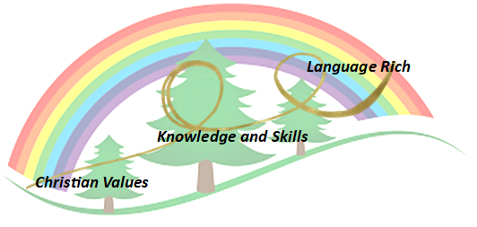
Intent

At Forest and Sandridge, children receive a design and technology curriculum which allows them to exercise their creativity through designing, making and evaluating whilst being immersed in technical knowledge and vocabulary. The children are taught to combine their skills with knowledge and understanding in order to design, make and evaluate a product. Skills are taught progressively to ensure that all children are able to learn and practice in order to develop as they move through the school. Evaluation is an integral part of the design process and allows children to adapt and improve their product, this is a key skill which they need throughout their life. D&T allows children to apply the knowledge and skills learned in other subjects, particularly Maths, Science and Art. Children’s interests are captured through some units of theme learning, ensuring that links are made in a cross curricular way, giving children motivation and meaning for their learning. Children will learn basic cooking skills.

Implementation
Christian Values Driver: Our whole curriculum is shaped by our school vision, which aims to enable all children, regardless of background, ability, additional needs, to flourish to become the very best version of themselves they can possibly be. The design, make and evaluate cycle provides children with essential skills that they can transfer to everyday life.

Knowledge and Skills: We teach the National Curriculum, supported by a clear skills and knowledge progression. This ensures that skills and knowledge are built on year by year and sequenced appropriately to maximise learning for all children. All teaching of D&T should follow the design, make and evaluate cycle. Each stage should be rooted in technical knowledge. The design process should be rooted in real life, relevant contexts to give meaning to learning. While making, children should be given choice and a range of tools to choose freely from. To evaluate, children should be able to evaluate their own products against a design criteria.

Language-rich Driver: Each of these essential steps are rooted in technical knowledge and vocabulary. D&T should be taught to a high standard, where each of the stages should be given equal weight. Teachers are encouraged to be passionate about language and model effective use of vocabulary within their teaching whilst relating to real life contexts.

The key skills we teach the children are:
• sewing and textiles
• cooking and nutrition
• electrical and mechanical components
• Structures and using materials

D&T will be taught weekly and in short blocks accordingly to timetabling across the school.
Planning
To ensure the delivery of the National curriculum and progression of skills and knowledge across the school.
 | Unit 1 | Unit 2 |  | Unit 3
EYFS FS1 | Children will be exploring how to create using a variety of joining skills with materials such as wood, fabric and hardboard. Children will use tools such as hammers, screw drivers, hand drill and sand paper. Children will be taught how to use these tools and materials safely.
EYFS FS2 | Children will be learn how to use different types of wood to create desired outcome. For example balsa and pine. Children will use palm drills, hammers, screw fixers, small pull saws. Children will be taught how to use these tools and materials safely.  For further information please see our Woodwork progression.
Year 1/2 Year A 2026-2027 | Structures  Pencil pots | Mechanisms  Moving Parts |  | Cooking and Nutrition:  Smoothies
Year 1/2 Year B 2027-28 | Mechanisms  Wheels and Axels  Fairground wheels | Structures  Baby Bear’s Chair |  | Textiles /Bunting
Year 2 | Mechanisms  Wheels and Axels Fairground wheels | Structures  Baby Bear’s Chair |  | Textiles Pouches/Bunting
Year 3 | Structures  Pavilions | Cooking and nutrition  Adapting a Recipe |  | Digital World  Wearable Technology
Year 4 | Mechanisms  Making a slingshot car | Textiles: Ancient Egypt |  | Electrical Systems  Torches
Year 5 | Cooking and nutrition  Come Dine with Me | Digital World  Monitoring Devices | Structures  Bridges
Year 6 | Textiles  Stuffed Toys | Mechanisms  Automata Toys |  | Electrical Systems  Steady Hand Game

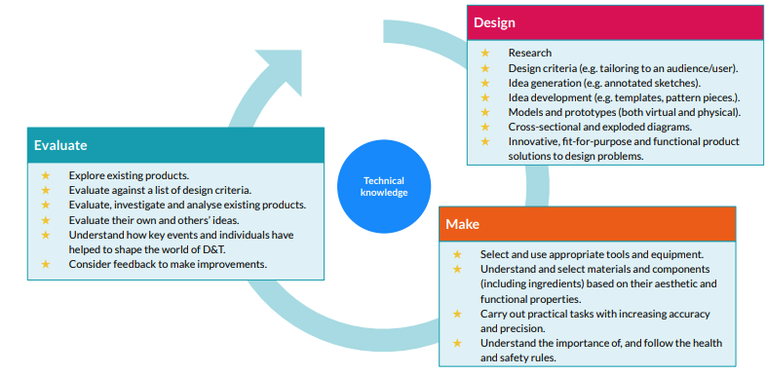

Where appropriate every lesson will:
- Recap prior learning
- Review and introduce key vocabulary
- Use stem sentences to support children speaking in full sentences.
- Review learning at the end of the lesson

Impact- How do our Golden Threads work within this subject?

Christian Values
- Developing Respect, by teaching children about how to use a range of age-appropriate equipment safely.
- Developing Courage, by expecting children to solve problems and create high quality content, though the use of a range of different materials.
- The ability to use time efficiently and work constructively and productively with others.
- Developing confidence through secure progression from skill to skill.

Knowledge and Skills
- Gaining new knowledge about systems, processes and physics that can be applied to solving problems
- To develop their courage in learning and developing different skills.
- A thorough knowledge of which tools, equipment and materials to use to make their products.
- Having a greater understanding of a different products and how they are made. The ability to apply mathematical knowledge and skills accurately.
- By developing other subject knowledge, such as electronics, forces and pulleys and levers.
- The ability to manage risks exceptionally well to manufacture products safely and hygienically.

Language Rich
- Planning contains a wide range of key vocabulary which will develop children’s knowledge.
- Highlighting key words and technical language within the subject.
- Providing children with technical names for tools, equipment and processes.
- Explaining subject specific language for gears, levers, structures and other areas of the curriculum.

Scaffolding/supporting SEND/lowest 20%: What do we do and how does this look?

Teachers try to identify potential barriers at the planning stage. In their planning, they consider ways of minimising or reducing those barriers.

Lesson design:
- Recapping learning from the previous lesson. Children may revisit their work from the last lesson to remember/improve/tweak/adjust.
- Consolidation is built in through curriculum design. Opportunities are provided for pupils to repeat and reinforce previously learnt skills and processes on a regular basis, in similar and different contexts.
- The curriculum is designed in a way that allows pupils to make links to the real world.
- Scaffolded tasks to support those need additional support.
- Whole class discussions (e.g. the teacher may do a mini plenary where common misconceptions are identified and discussed or where they share examples of pupil work on the board).
- Support and supervision with the physical skills.

Environment
- Key vocabulary displayed on the board so children can use correct terminology in their discussions.
- Flexible seating options in case children need to move during the lesson.

Resources
- Adult support (e.g. additional modelling or explanation)
- Peer support
- Check list of steps to complete (e.g. on the flip chart or slides printed)

