Geography Subject Overview
In order to achieve our whole school intent, we have identified 3 Golden Threads that weave through our curriculum and underpin everything we do. This means that in delivering our curriculum we are embedding our school Christian Values, developing knowledge and skills progressively over time with an ambitious and aspiring curriculum whilst immersing our children in language rich teaching.
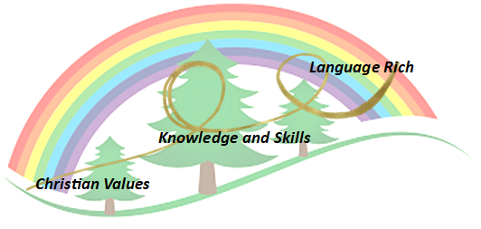
Intent
Geography is about understanding the world we live in. It helps to provoke and provide answers to questions about the physical and human aspects of the world. At Forest and Sandridge, children are encouraged to develop a greater understanding and knowledge of their world, as well as their place in it. At Forest and Sandridge, our intent, when teaching Geography, is to inspire in children a curiosity and fascination about the world and people within it; to promote the children’s interest and understanding of diverse places, people, resources, changes over time and natural and human environments, together with a deep understanding of the Earth’s key physical and human processes. Our lessons are intended to improve children’s geographical vocabulary, map skills and geographical facts and provide opportunities for consolidation, challenge and variety to ensure interest and progress in the subject. It is our intent to we equip children with the language they need to be able to compare.
Implementation

Christian Values Driver:
Our whole curriculum is shaped by our school vision which aims to enable all children, regardless of background, ability and additional needs, to flourish to become the very best version of themselves they can possibly be.

Knowledge and Skills based Driver:
We teach the National Curriculum, supported by a clear skills and knowledge progression. This ensures that skills and knowledge are built on year by year and sequenced appropriately to maximise learning for all children.
It is important that children develop the skills of a geographer by fully immersing them in all areas of the subject. The local area is fully utilised to achieve desired outcomes, with opportunities for learning outside the classroom embedded in practise. School trips and fieldwork are provided to give first hand experiences, which enhance children’s understanding of the world beyond their locality. Through revisiting and consolidating skills, our lessons help children build on prior knowledge alongside introducing new skills and challenge.

Language rich Driver:
In Geography, key vocabulary and language is explicitly taught to ensure children to develop their understanding of new vocabulary and concepts. Children are given opportunities to learn new words and their meanings in a variety of contexts. Teachers carefully plan new vocabulary to teach, and display in the classroom in order for children to access independently. We support children to use the language of comparison using sentence stems.

Planning
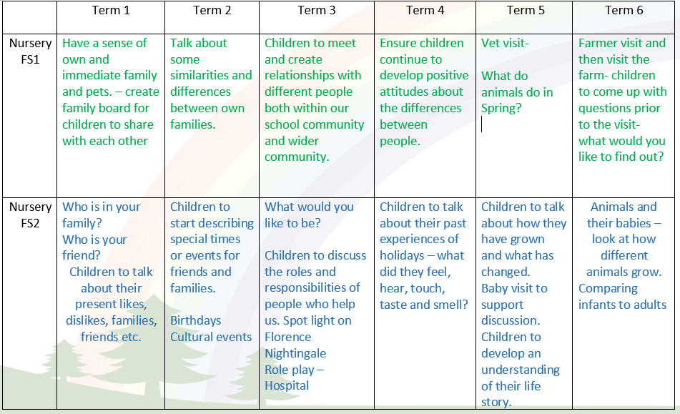
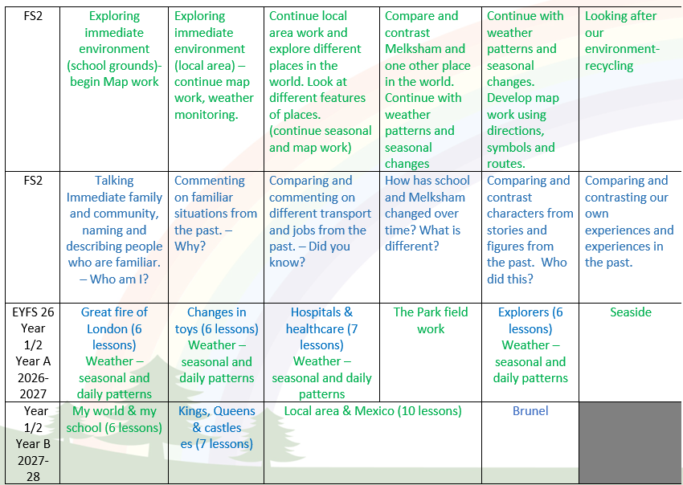

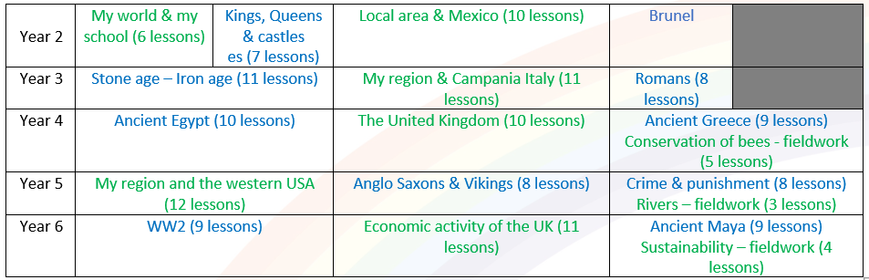

Impact- How do our Golden Threads work within this subject?

Christian values –
- Have a love of Geography which encourages curiosity about the world.
- Respect themselves and their potential ensuring they have high expectations of their own achievement.
- Have the courage to make choices about how we live in this world, developing a positive commitment to the environment and the future of the planet.
- Develop cultural awareness and respect for the variety of cultures we have in the world.
- Have the courage to speak confidently about their Geographical learning, skills and knowledge.

Knowledge and skills –
- Use Geographical vocabulary accurately.
- Understand the different strands of Geography, with a deep understanding of the Earth’s key physical and human processes
- Be competent in collecting, analysing and communicating a range of data gathered.
- Make relevant links to other subjects, such as Science, History and PSHE.
- Use enquiry skills and inquisitiveness about the world to understand their impact.

Language rich -
- Interpret a range of sources, geographical information and communicate geographical information in a range of ways.
- Be able to explain the meaning of the new vocabulary learnt each year which is taught progressively.
- Confidently use language structures to make comparisons within their geography learning.

Scaffolding/supporting SEND/lowest 20%: What do we do and how does this look?

Teachers try to identify potential barriers at the planning stage. In their planning, they consider ways of minimising or reducing those barriers.

Lesson design:
- Recapping learning - children may revisit their work from previous lessons to remember/improve/tweak/adjust.
- Pre-teaching – children may be exposed to key vocabulary and learning outcomes prior to the lesson to allow access to whole class teaching.
- Consolidation is built in through curriculum design. Opportunities are provided for pupils to repeat and reinforce previously learnt skills and processes on a regular basis, in similar and different contexts.
- The curriculum is designed in a way that allows pupils to make links to the real world.
- Scaffolded tasks are provided to support those with additional needs.
- Whole class discussions to address misconceptions and move learning forwards.

Environment
- Key vocabulary is displayed on the board or displays.
- The use of engaging and inspiring images.
- Flexible seating options in case children need to move during the lesson.

Resources
- Adult support
- Peer support
- Check list of steps to complete
- Adapted physical resources e.g. larger, colour coded or simplified maps

