History Subject Overview
In order to achieve our whole school intent, we have identified 3 Golden Threads that weave through our curriculum and underpin everything we do. This means that in delivering our curriculum we are embedding our school Christian Values, developing knowledge and skills progressively over time with an ambitious and aspiring curriculum whilst immersing our children in language rich teaching.
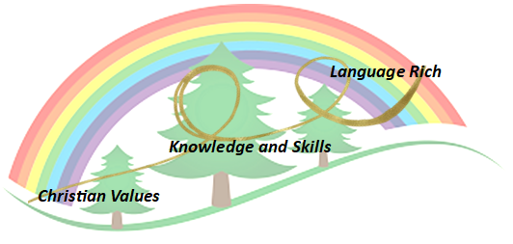
Intent

The study of History ignites children’s curiosity about the past in Britain and the wider world. Through finding out about how and why the world, our country, culture and local community have developed over time, children understand how the past influences the present. History enables children to develop a context for their growing sense of identity and a chronological framework for their knowledge of significant events and people. What they learn through history can influence their decisions about personal choices, attitudes and values.

At Forest and Sandridge, History is integral to ensuring children develop an appreciation and understanding of the past, using a range of primary and secondary source in order to give an insight in how people around the world used to live. We encourage children to use their knowledge and experiences to make sense of the world around then, as well as to critically evaluate sources and understand how these can interpreted differently. Our curriculum supports our historians to develop a coherent, chronological narrative, from the earliest times to the present day. This enables children to develop a context for their growing sense of identity and a chronological framework for their knowledge of significant events and people. We intent for children to be able to speak ‘like a Historian’ by using the language of deduction.

Our key themes of Chronology, Evidence and Interpretation, Cause and Consequence, Change and Continuity, Similarities and Difference and Historical Significance run throughout our curriculum ensuring progression throughout the school. We also use local resources to ensure our children are able to gain understanding of how historical events affected their local area, ensuring they can reflect on the past and make meaningful links to the present day.

Implementation

Christian Values Driver: Our whole curriculum is shaped by our school vision which aims to enable all children, regardless of background, ability, additional needs, to flourish to become the very best version of themselves they can possibly be. Children have a deep understanding of our school values of Respect, Courage, Humility and Compassion in which teachers are able to make links to where appropriate within the curriculum, and children reflect upon in order to further understand what life was like in the past. This ensures children develop a balanced understanding of historical events and significant people within the past, and can identify how this has shaped their lives today.

Skills and Knowledge Driver: We use the National Curriculum as our starting point, supported by a clear skills and knowledge progression. This ensures that skills and knowledge are built on year by year and sequenced appropriately to maximise learning for all children. It is important that the children develop progressive skills of a historian throughout their time at Forest and Sandridge and do not just learn a series of facts about the past. In History, pupils at Forest and Sandridge, find evidence, weigh it up and reach their own conclusion. To do this successfully, as historians, they need to be able to research, interpret evidence, including primary and secondary sources, and have the necessary skills to argue for their point of view, a skill that will help them in their adult life.

Language-rich Driver: In History, key vocabulary and language is explicitly taught to ensure children to develop their understanding of new vocabulary and concepts. Children are given opportunities to learn new words and their meanings in a variety of contexts. Teachers carefully plan new vocabulary to teach, and display in the classroom in order for children to access independently. We support children to use the language of deduction using sentence stems.

Planning

Planning is carefully sequenced to ensure knowledge and skills are taught progressively throughout the school. Teachers may block units where appropriate in order to immerse children into the subject, resulting to high engagement and interest.

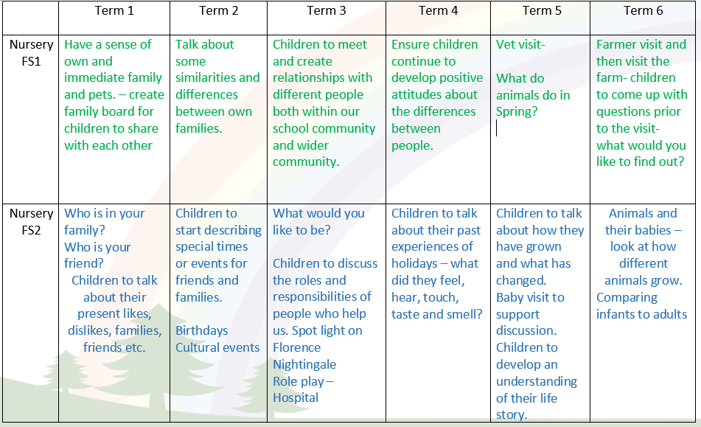
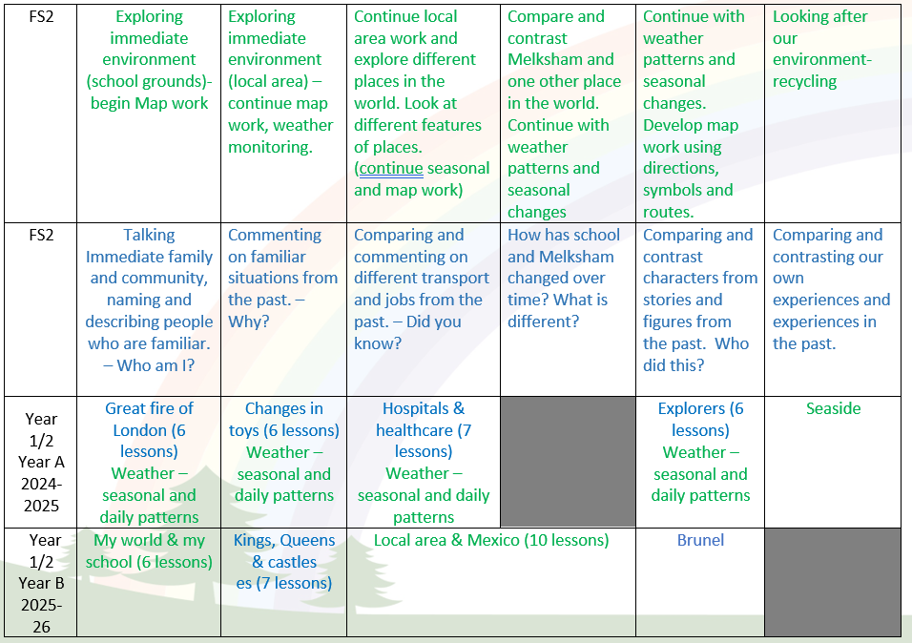

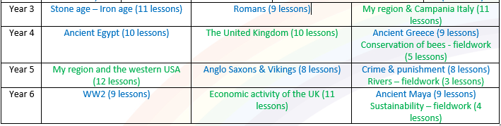

Where appropriate every lesson will:
- Recap prior learning
- Review and introduce key vocab for the theme.
- Use sentence stems to support children speaking in full sentences.
- Review learning at the end of the lesson.
Impact- How do our Golden Threads work within this subject?

Christian Values Driver
- Developing compassion and respect, by teaching children about the values of different cultures and points of view.
- Developing Courage by encouraging a desire to embrace challenging activities, including opportunities to undertake high-quality research across a range of history topics.
- Developing Humility by learning about events of the past that we can learn from in the future E.g. world war, black History.

Knowledge and skills-based Driver
- A secure knowledge and understanding of people, events and contexts from the historical periods covered.
- The ability to consistently support, evaluate and challenge their own and others’ views using detailed, appropriate and accurate historical evidence derived from a range of sources.
- The ability to think, reflect, debate, discuss and evaluate the past, forming and refining questions and lines of enquiry.
- A passion for history and an enthusiastic engagement in learning, which develops their sense of curiosity about the past and their understanding of how and why people interpret the past in different ways.
- A respect for historical evidence and the ability to make robust and critical use of it to support their explanations and judgements.
- A respect for historical evidence and the ability to make robust and critical use of it to support their explanations and judgements.

Language-Rich Driver
- Highlighting and exploring key vocabulary for children to learn in increasing depth as they develop.
- The ability to think critically about history and communicate confidently in styles appropriate to a range of audiences.
- Allowing children opportunities to use key vocabulary to demonstrate their learning.
- Confidently use language structures to deduct information making assumptions based on previous historical knowledge and understanding.

Scaffolding/supporting SEND/lowest 20%: What do we do and how does this look?

Teachers try to identify potential barriers at the planning stage. In their planning, they consider ways of minimising or reducing those barriers.

Lesson design:
- Recapping learning from the previous lesson. Children may revisit their work from the last lesson to remember/improve/tweak/adjust.
- Consolidation is built in through curriculum design. Opportunities are provided for pupils to repeat and reinforce previously learnt skills and processes on a regular basis, in similar and different contexts.
- The curriculum is designed in a way that allows pupils to make links to the real world.
- Scaffolded tasks to support those need additional support.
- Whole class discussions (e.g. the teacher may do a mini plenary where common misconceptions are identified and discussed or where they share examples of pupil work on the board).

Environment
- Key vocabulary displayed on the board so children can use correct terminology in their discussions.
- Flexible seating options in case children need to move during the lesson.

Resources
- Adult support (e.g., additional modelling or explanation)
- Peer support
- Check list of steps to complete (e.g., on the flip chart or slides printed)
- Widget /word mats

