PSHEE Subject Overview
In order to achieve our whole school intent, we have identified 3 Golden Threads that weave through our curriculum and underpin everything we do. This means that in delivering our curriculum we are embedding our school Christian Values, developing knowledge and skills progressively over time with an ambitious and aspiring curriculum whilst immersing our children in language rich teaching.
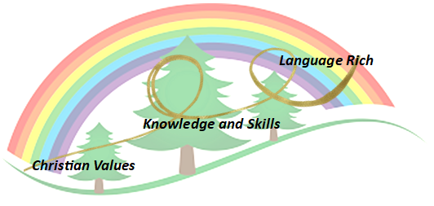
Intent

At Forest and Sandridge CE Primary School, PSHEE is at the core of what we do and enables our children to become independent, confident, healthy and responsible members of society, as well as developing the “whole child” intellectually, morally, socially and spiritually. Through our whole-school approach to PSHEE, it is our belief that excellence in these areas will lead to excellence across the curriculum and beyond in later life. PSHEE is taught across the school from FS1- Year 6 on a weekly basis and as a school, we follow the Jigsaw PSHEE scheme. Our PSHEE curriculum equips children with relevant and meaningful content, which is supported through a strong emphasis on emotional literacy, building resilience and nurturing mental and physical health. With an ever-changing society, we are able to provide our children with a strong understanding of the diverse world around them and support them in playing a positive role in contributing to the school and the wider community. Weaving through the heart of our PSHEE teaching, is a commitment to enhancing and promoting our core Christian Values; Compassion, Respect, Courage and Humility.

Implementation

Our whole curriculum is shaped by our school vision which aims to enable all children, regardless of background, ability, additional needs, and to flourish to become the very best version of themselves they can possibly be.

We teach the National Curriculum, supported by a clear skills and knowledge progression. This ensures that skills and knowledge are built on year by year and sequenced appropriately to maximise learning for all children.

Jigsaw PSHEE directs our aim on developing the “whole child” through a spiral curriculum approach to developing knowledge, skills and understanding in the areas of;

- Being Me in My World
- Celebrating Difference
- Dreams and Goals
- Healthy Me
- Relationships
- Changing Me

Planning

We follow the Jigsaw scheme to support our planning. We use core language that weaves from FS1 right up to Year 6, allowing our children to learn and understand the subject and we work with children’s particular need and the cohorts, helping us to address ‘real life’ scenarios that link to our PHSEE areas. We are adaptable within our PSHEE lessons to allow us to address some ‘tricky’ situations and we always allow time within the lesson to talk.
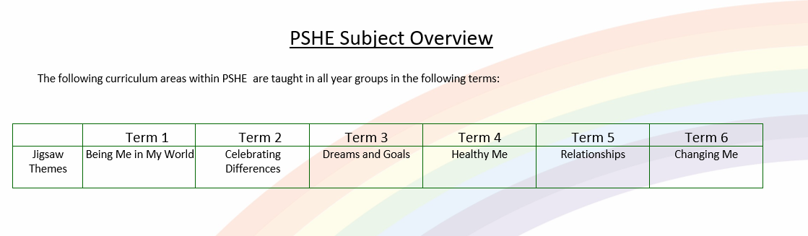

Impact- How do our Golden Threads work within this subject?

Christian Values
All children have a ready willingness and ability to try new things, push themselves and persevere.
Have a good understanding of how to stay safe, healthy and develop good relationships.
Have an appreciation of what it means to be a positive member of a diverse, multicultural society and will have a respect and understanding towards others.
Children have a strong self-awareness, interlinked with compassion of others.
Supported by good PSHE teaching, children will flourish into kind, caring individuals.
Our children are encouraged to develop their sense of self-worth by playing a positive role in contributing to school life and the wider community.

Knowledge and Skills
Have an appreciation of what it means to be a positive member of a diverse, multicultural society.
All children understand the importance of PSHE, RE, SMSC and British Values and the effects it can have on life in and out of school.
By teaching pupils to stay safe and healthy, and by building self-esteem, resilience and empathy, an effective PSHE programme can tackle barriers to learning, raise aspirations, and improve the life chances of the most vulnerable and disadvantaged pupils.
The skills and attributes developed through PSHE education are also shown to increase academic attainment and attendance rates, particularly among pupils eligible for free school meals, as well as improve employability and boost social mobility. By the time they leave our academy, personal, social and health education (PSHE) enables our learners to become healthy, independent and responsible members of a society. It helps them understand how they are developing personally and socially, and tackles many of the moral, social and cultural issues that are part of growing up. Our curriculum allows pupils to learn about rights and responsibilities and appreciate what it means to be a member of a diverse society.

Language Rich
Children will have a broad range of vocabulary available to them enabling them to communicate their thoughts and feeling effectively and respectfully.
They will be able to equipped to talk about big issues without causing offence.

Scaffolding/supporting SEND/lowest 20%: What do we do and how does this look?

Teachers try to identify potential barriers at the planning stage. In their planning, they consider ways of minimising or reducing those barriers.

Lesson design:
- Recapping learning from the previous lesson. Children may revisit their work from the last lesson to remember/improve/tweak/adjust.
- Consolidation is built in through curriculum design. Opportunities are provided for pupils to repeat and reinforce previously learnt skills and processes on a regular basis, in similar and different contexts.
- The curriculum is designed in a way that allows pupils to make links to the real world.
- Scaffolded tasks to support those need additional support.
- Whole class discussions (e.g. the teacher may do a mini plenary where common misconceptions are identified and discussed or where they share examples of pupil work on the board).

Environment
- Key vocabulary displayed on the board so children can use correct terminology in their discussions.
- Flexible seating options in case children need to move during the lesson.

Resources
- Adult support (e.g. additional modelling or explanation)
- Peer support
- Check list of steps to complete (e.g. on the flip chart or slides printed)

