Physical Education Subject Overview
In order to achieve our whole school intent, we have identified 3 Golden Threads that weave through our curriculum and underpin everything we do. This means that in delivering our curriculum we are embedding our school Christian Values, developing knowledge and skills progressively over time with an ambitious and aspiring curriculum whilst immersing our children in language rich teaching.
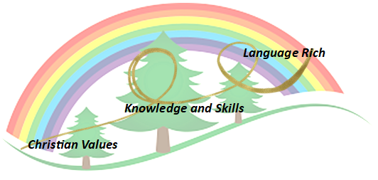
Intent

At Forest and Sandridge the intent of teaching Physical Education is to give children the tools and understanding required to make a positive impact in their own physical health and well-being. We want all children to experience a wide variety of sports and physical skills which will enhance life-long fitness and life choices. PE can challenge and promote self-esteem through the development of physical confidence and problem solving. It can teach children to cope with both success and failure in competitive, individual and team based physical activities. Within dance it will allow children to explore their personal and spiritual identity. We want children to be able to talk like an athletic using the language structures of explanation.

Implementation

PE at Forest and Sandridge is taught by a combination of class teachers, PE specialists and qualified sports coaches. Children have equal opportunities to take part in a range of sports and physical activities within a supportive environment where effort as well as success is recognised. Children are encouraged to participate in exercise through-out the day during PE lessons, clubs, outdoor learning, lunch provision and special events. Our Christian values of respect, compassion, courage and humility are intertwined and reinforced throughout their P.E. experiences.

At Forest and Sandridge the PE curriculum is structured to provide a range of sports experiences during which every child participates to develop their skills and learning through competitive, team and individual sports. Through our provision children can aim to flourish at sports in which they have a particular interest or flair for. Children with additional needs are provided with appropriate support to enable them to take part and gain confidence in skills, understanding and motivation.

Children gain experience of a variety of fundamental skills from the moment they start in EYFS through to the end of KS2. There is a focus participation, agility, balance, co-ordination and fitness. Children take part in individual skills, group skills and team games, using PE equipment appropriate for their age.

During KS2 children will have a series of structured swimming sessions. This involves children attending blocks of swim lessons at the Melksham Campus. Children are taught water confidence, swim strokes and water safety.
During EYFS children are taught according to the Early Years framework. They also take part in ‘Bikeability’ sessions which develop crucial co-ordination and balance skills. Year 5 children attend The Wiltshire School of Gymnastics for a block of 5 weeks and are led by qualified Gym instructors using the resources at the site.

Planning
At Forest and Sandridge we teach the National Curriculum, supported by a clear skills and knowledge progression from Primary P.E. planning. This is an on-line planning tool which the school subscribes to on an annual basis. This ensures that skills and knowledge are built on year by year and sequenced appropriately to maximise learning for all children. Sports Coaches also follow the focus of each unit whist adding elements to enrich the children’s learning and provide CPD for teaching staff. Staff use the vocabulary provided in each unit and children are aware of what the learning focus is through use of written teaching points or verbal discussions and film clips which are provided in the planning resources.
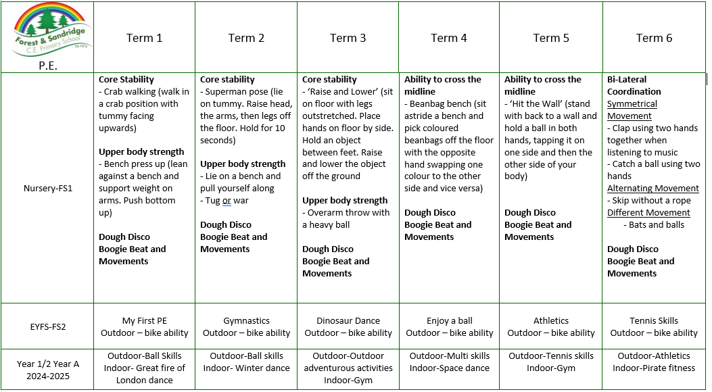

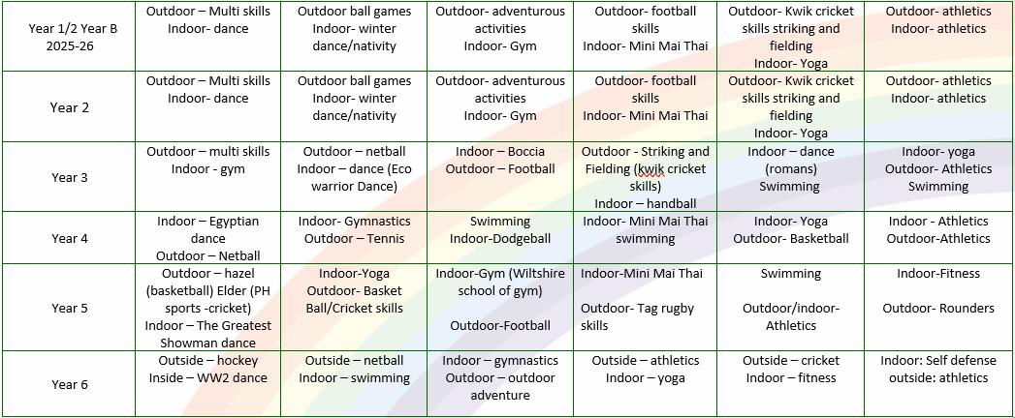

- NB- There are occasions when units may be switched due to access to the gym/pool/hall etc

Impact- How do our Golden Threads work within this subject?

Christian Values
- Develop respect by teaching children to follow instructions within specific aspects of games and sports. Being honest and show integrity through understanding rules and regulations linked to sports.
- Develop compassion whilst working as part of a team and be able to encourage and support others who need it.
- Strive to nurture confidence by expecting children to be brave, show courage and perform increasingly challenging physical skills.
- Begin to understand the need to show humility when dealing with the ups and downs during competitive and non-competitive sports activities.
- Allow children to flourish by developing independence, initiative, creativity and flair which they can use to develop within particular sports, including Dance and Gymnastics.
- Developing a passion for and a commitment to the subject.

Impact- Knowledge and skills
By the time our children leave Forest and Sandridge we aim for them to:
- The ability to acquire new knowledge and skills exceptionally well and develop an in-depth understanding of PE. And to have a firm understanding of the vocabulary within various areas of P.E.
- The willingness to practise skills in a wide range of different activities and situations, alone, in small groups and in teams and to apply these skills in chosen activities to achieve exceptionally high levels of performance.
- Increased levels of physical fitness.
- A healthy lifestyle, achieved by eating sensibly, avoiding smoking, drugs and alcohol and exercising regularly.
- The ability to remain physically active for sustained periods of time and an understanding of the importance of this in promoting long-term health and well-being.
- The ability to take the initiative and become excellent young leaders, organising and officiating, and evaluating what needs to be done to improve, and motivating and instilling excellent sporting attitudes in others. Children in KS2 are encouraged to peer-support and give positive feedback to encourage others in their performances.
- Exceptional levels of originality, imagination and creativity in their techniques, tactics and choreography, knowledge of how to improve their own and others’ performance and the ability to work independently for extended periods of time without the need of guidance or support.
- A keen interest in PE. A willingness to participate eagerly in every lesson, highly positive attitudes and the ability to make informed choices about engaging fully in extra-curricular sport.
- The ability to swim at least 25 metres before the end of Year 6 and knowledge of how to remain safe in and around water.
- A Sports Ambassador group develops in-school events linked to sports and help with informing others of Sporting events and achievements through newsletters, assembly inputs and a school notice board situated in the central area for easy access by all children.

Impact- Language Rich
- Embedding the use of vocabulary within lessons, through discussions and PE observations.
- Teaching children to use the correct terminology when describing sports equipment and skill focuses.
- Using subject specific vocabulary to describe sports skills progressively.
- Confidently use language structures to explain.

Scaffolding/supporting SEND/lowest 20%: What do we do and how does this look?

Teachers try to identify potential barriers at the planning stage. In their planning, they consider ways of minimising or reducing those barriers.

Lesson design:
- Recapping learning from the previous lesson. Children may revisit their work from the last lesson to remember/improve/tweak/adjust.
- Consolidation is built in through curriculum design. Opportunities are provided for pupils to repeat and reinforce previously learnt skills and processes on a regular basis, in similar and different contexts.
- The curriculum is designed in a way that allows pupils to make links to the real world.
- Scaffolded tasks to support those need additional support.
- Whole class discussions (e.g. the teacher may do a mini plenary where common misconceptions are identified and discussed or where they share examples of pupil work on the board).

Environment
- Key vocabulary displayed on the board so children can use correct terminology in their discussions.
- Flexible seating options in case children need to move during the lesson.

Resources
- Adult support (e.g. additional modelling or explanation)
- Peer support
- Check list of steps to complete (e.g. on the flip chart or slides printed)

