Religious Education Subject Overview
In order to achieve our whole school intent, we have identified 3 Golden Threads that weave through our curriculum and underpin everything we do. This means that in delivering our curriculum we are embedding our school Christian Values, developing knowledge and skills progressively over time with an ambitious and aspiring curriculum whilst immersing our children in language rich teaching.
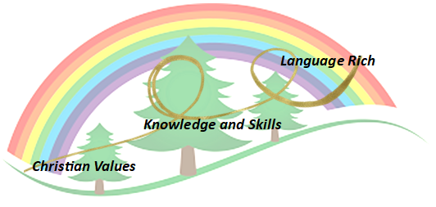
Intent
As a Church of England School, the Christian faith forms the foundations of everything that we do at Forest & Sandridge. Our Christian faith influences not only what we teach, but how we teach, and we promote an environment where all children feel known, accepted, and valued as individuals, within a caring community. The teaching and learning of Religious Education offers opportunities to promote respect for others, to challenge stereotypes and to build understanding of other cultures and beliefs. This contributes to a positive and inclusive school ethos that champions diversity, responsibility, spirituality. We encourage children to develop an array of skills that will enable them to make their own positive influence in our global society, including:

- To provoke challenging questions about the ultimate meaning of life, beliefs about God, the nature of reality and morality.
- To develop pupils’ knowledge and understanding of Christianity, other principal world religions, religious traditions and world-views, which offer answers to ultimate questions.
- To encourage pupils to develop their sense of identity and belonging, in order to flourish within communities, as responsible citizens in society and global communities.
- To teach pupils to develop respect for others and their beliefs and helps to challenge prejudice.
- To prompt pupils to consider their responsibilities to themselves and to others, and to explore how they might contribute to their communities and to wider society encouraging empathy, generosity and compassion.
- For children to be confident ‘retelling’ within the context of RE using the language structures.

Implementation

Christian Values Driver:
At Forest and Sandridge, we believe that it is fundamental for our children to belong to a safe and nurturing community, founded on strong Christian values. Our RE curriculum promotes a strong knowledge of core Christian ideologies, and the learning opportunities provided equip children for a future rooted in the safety, purpose and eternal hope that the Christian Faith offers. Through our broad curriculum design, strong community links and tangible sense of spirituality, our pupils can flourish and grow regardless of background, ability or additional needs; confident in the knowledge that there is a great purpose in their lives. This is framed by our deeply embedded Christian vision “For I know the plans I have for you,” says the Lord….”Plans to give you a hope and a future” affirming that there is a greater plan and purpose awaiting all children in their future.

The Statement of Entitlements lays out the rights of all children to receive a high-quality Religious Education which supports them in all aspects of their learning, explaining “Religious education in a Church school should enable every child to flourish and to live life in all its fullness. (John 10:10).” We ensure that we fully meet the requirement of the statement of entitlement for Church school through delivering a curriculum rich in key knowledge and skills.
Our RE teaching is informed by two different teaching schemes; Understanding Christianity and Discovery RE. By using these schemes alongside each other, we are ensuring children are given the opportunity to become religiously literate.
Understanding Christianity is based upon seven core Christian concepts. Children will explore the different concepts in a range of inspiring activities as they move through the school, starting in Foundation Stage and developing a great depth of understanding by the time they reach Year 6.
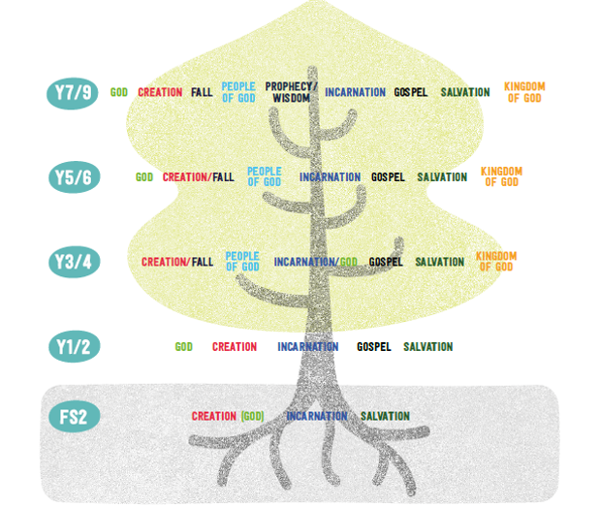
Understanding Christianity believes that not only should children show an understanding of the religious text and teachings but they should also demonstrate a deepened and more thoughtful approach to their learning and how this influences day to day life. Therefore is based upon a three step enquiry model of teaching.
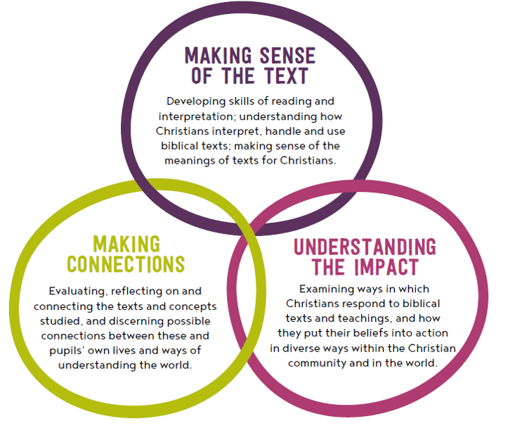

Discovery RE is used alongside Understanding Christianity to ensure that children are given opportunities to explore a wide range of different religions throughout their time in Primary School. It is through using these two schemes alongside each other that we are providing children with a holistic and balanced RE curriculum.
We use a variety of teaching methods including art, music, discussion, the development of thinking skills, drama, the use of artefacts, pictures, stories, and the use of reflection.

Planning

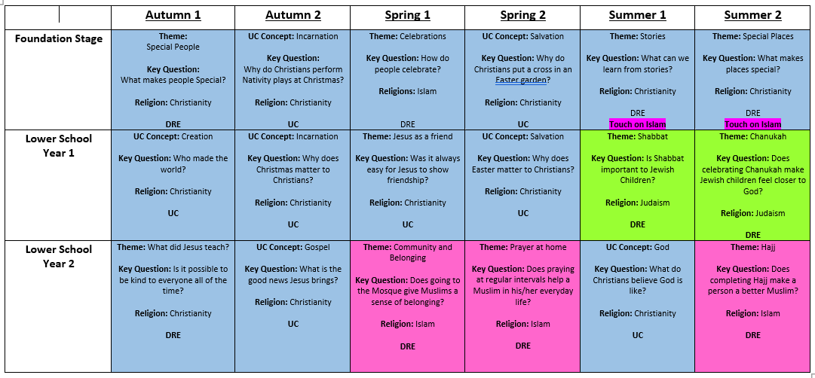

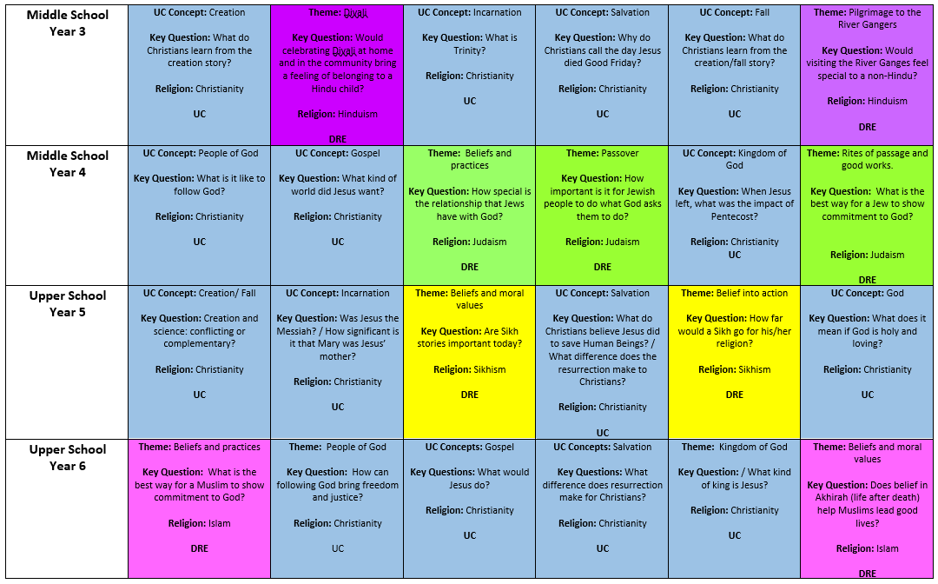

Impact - How do our Golden Threads work within this subject?

Christian Values
- Ask and offer possible answers to challenging questions about the meaning of life, beliefs, nature of reality and morality.
- Have a sense of self, identity and belonging to flourish within the community and be responsible citizens.
- Show respect, tolerance and understanding of all religions and beliefs.
- The ability to exemplify the School’s Christian values in all aspects of life that are rooted in the teachings of the Bible.

Knowledge and Skills
- Have a strong understanding of how the beliefs, values, practices and ways of life within any religion come together.
- Have a secure understanding and knowledge of the religions studied and be confident to answer ultimate questions.
- The ability to link the study of religion and belief to personal reflections on meaning and purpose.

Language Rich
- Have the ability to ask significant and reflective questions about religion and demonstrate a good understanding of issues relating to the nature, truth and value of religion.
- Be confident and articulate within RE using the language of ‘retelling’.
Scaffolding/supporting SEND/lowest 20%: What do we do and how does this look?

Teachers try to identify potential barriers at the planning stage. In their planning, they consider ways of minimising or reducing those barriers.

Lesson design:
- Recapping learning from the previous lesson. Children may revisit their work from the last lesson to remember/improve/tweak/adjust.
- Consolidation is built in through curriculum design. Opportunities are provided for pupils to repeat and reinforce previously learnt skills and processes on a regular basis, in similar and different contexts.
- The curriculum is designed in a way that allows pupils to make links to the real world.
- Scaffolded tasks to support those need additional support.
- Whole class discussions (e.g. the teacher may do a mini plenary where common misconceptions are identified and discussed or where they share examples of pupil work on the board).

Environment
- Key vocabulary displayed on the board so children can use correct terminology in their discussions.
- Flexible seating options in case children need to move during the lesson.

Resources
- Adult support (e.g. additional modelling or explanation)
- Peer support
- Check list of steps to complete (e.g. on the flip chart or slides printed)

