Science Subject Overview
In order to achieve our whole school intent, we have identified 3 Golden Threads that weave through our curriculum and underpin everything we do. This means that in delivering our curriculum we are embedding our school Christian Values, developing knowledge and skills progressively over time with an ambitious and aspiring curriculum whilst immersing our children in language rich teaching.

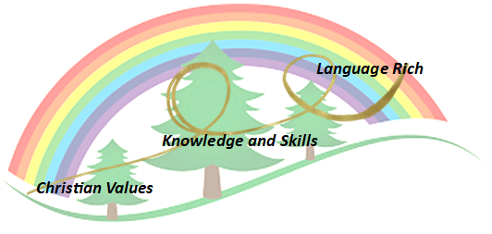
Intent

At Forest and Sandridge School, we aim to prepare our children for their future with a “hands–on”, inquiry-based science curriculum that enables them to confidently explore and discover the world around them. We will motivate and actively engage our children, to nurture and grow their curiosity. Carefully sequenced core scientific knowledge and skills is taught through direct teaching, experimentation and exploration. Our intent is for all our children to be life-long learners who are inquisitive, independent thinkers, confident to ask ‘Big Questions’ and who are well-prepared for their future in the ever-changing world. Our primary aim is to foster curiosity, challenge, imagination, excitement, confidence, self-motivation and enjoyment in the pursuit of Science.

Through high quality teaching, we are continually developing:
- The acquisition of knowledge, concepts and skills within science.
- Children’s ability to explain their own thinking to others and articulate their understanding in a range of different situations.
- The use of scientific contexts to develop and consolidate cross-curricular links.
- Inquisitive minds and positive attitudes towards science.
- Extensive scientific vocabulary and the ability to articulate scientific concepts clearly and precisely
- Respect for the environment and care for living things.
- An understanding of the different aspects of scientific enquiry.
- The ability to work scientifically by predicting, questioning, observing, planning, measuring, carrying out and evaluating investigations
- Opportunities for children to question the world around them and become independent learners, when exploring possible answers to their own scientific based questions.
- Children’s ability to ‘talk like a scientist’ through the language of prediction.

Implementation

Our whole curriculum is shaped by our school vision, which aims to enable all children, regardless of background, ability, additional needs, to flourish to become the very best version of themselves they can possibly be.
We teach the National Curriculum, supported by a clear skills and knowledge progression. This ensures that skills and knowledge are built on year-by-year and sequenced appropriately to maximise learning for all children.

Planning
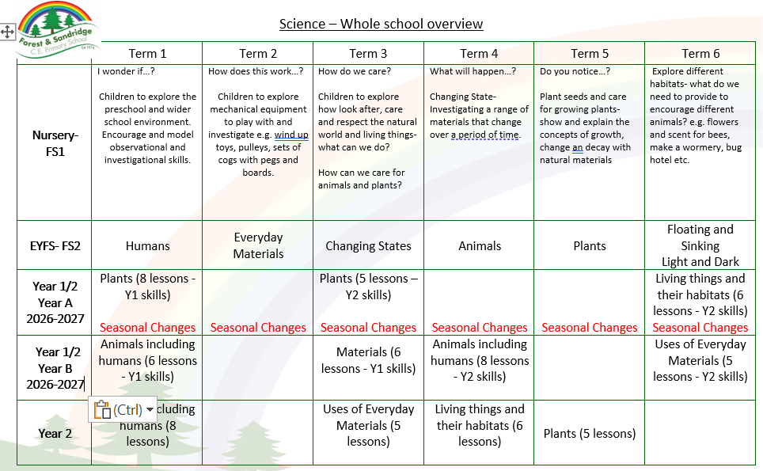
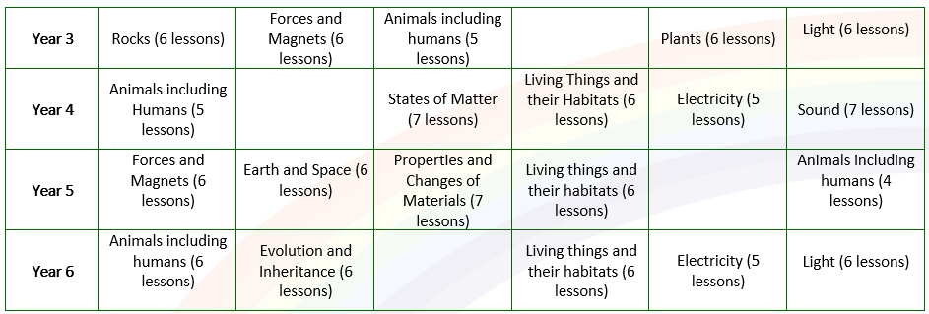

We use a range of resources to plan from, including Grammarsaurus and Bath TAPS resources.

Specific Science units are taught in each year group, building on from previously taught units and skill coverage. Teachers are free to change the order areas are taught to make cross-curricular links as long as long as all areas are covered over the year. When planning, teachers include key scientific vocabulary and previous learning links. Teachers include scientific investigative opportunities in lessons wherever possible, to make the lessons interesting and exciting. This allows children to make predictions and to investigate these, and then making observations and evaluations. Working walls are updated regularly to support children with their learning, whilst also asking key questions and displaying our key vocabulary and learning. There are quizzes at the end of each unit to monitor and track understanding in the subject.

Impact- How do our Golden Threads work within this subject?

Christian Values
This subject supports our Christian Values by…
- Developing confidence, by allowing pupils to step out of their comfort zone of writing and ‘being taught’, instead learning through practical enquiry.
- Developing respect, by instilling respect for the equipment and others ideas/suggestions and conclusive results.
- Developing kindness, through understanding that their scientific enquiries may conclude different results.

Knowledge and Skills
This subject provides children with age-appropriate knowledge by…
- Making links between science and everyday living, how has this invention/creation/finding impacted our lives?
- Making observations within investigations and concluding their findings with the knowledge learnt.
- Providing children with the knowledge to be able to plan, predict, test and analyse observations and results in a range of contexts.

Language Rich
This subject supports children’s language use and acquisition by…
- Exploring key vocabulary during sessions to reflect the learning.
- Highlighting key language and having the opportunity for pupils to use this confidently in their writing/explanations/conclusions.
- Providing children with texts/reading opportunities to support ongoing topics of the curriculum and refer to when in lessons.
- The use of sentence stems allows the pupils to articulate their findings/make confident explanations.
- Through our language structure children will be confident in talking like a scientist and be able to use the language of prediction.

We intend for our children to think independently, and to ask and answer questions about the world around them. In addition, for them to be life-long learners who are enthused, curious and inquisitive, confident to ask ‘Big Questions’ and who are well-prepared for their future in the ever changing world.

Formative assessment takes place throughout each lesson to ensure children’s understanding. Elicitation of children’s conceptions and, importantly, misconceptions is achieved by questioning, observations, discussions and written work (varied dependent on the child, class and topic).

Scaffolding/supporting SEND/lowest 20%: What do we do and how does this look?

Teachers try to identify potential barriers at the planning stage. In their planning, they consider ways of minimising or reducing those barriers.

Lesson design:
- Recapping learning from the previous lesson. Children may revisit their work from the last lesson to remember/improve/tweak/adjust.
- Consolidation is built in through curriculum design. Opportunities are provided for pupils to repeat and reinforce previously learnt skills and processes on a regular basis, in similar and different contexts.
- The curriculum is designed in a way that allows pupils to make links to the real world.
- Scaffolded tasks to support those need additional support.
- Whole class discussions (e.g. the teacher may do a mini plenary where common misconceptions are identified and discussed or where they share examples of pupil work on the board).

Environment
- Key vocabulary displayed on the board so children can use correct terminology in their discussions.
- Flexible seating options in case children need to move during the lesson.

Resources
- Adult support (e.g. additional modelling or explanation)
- Peer support
- Checklist of steps to complete (e.g. on the flip chart or slides printed)

