Year 11 Taster Day 2023 – Politics
What will the course look like?
Ideologies
- Liberalism
- Conservatism
- Socialism
- Feminism
UK Politics
- The Constitution
- Parliament
- PM and executive
- Relations between the branches
UK Politics
- Democracy and political participation
- Political Parties
- Electoral Systems
- Voting behaviour and the media

Comparative Politics: Global
- Power and development
- Regionalism and the EU
- Global governance: human rights and environmental
Comparative Politics: Global
- The state and globalisation
- Global governance: political and economic
- Comparative theories

How will you be assessed?
3 separate papers with equal weighting, each lasting for two hours
- Paper 1: UK Politics with core ideologies
- Paper 2: UK Government with non-core ideology
- Paper 3: Comparative Politics – Global

Preparation for September:
- Get organised: Purchase a ring binder folder and a set of file dividers to organise Y12 content. There are 8 areas to be covered in Y12 so you will need one for each of these (please see above). Download the BBC News app and set up notifications.

- Read through the Edexcel Politics Specification (Y12 content only) here: https://qualifications.pearson.com/content/dam/pdf/A%20Level/Politics/2017/Specification%20and%20sample%20assessments/A-level-Politics-Specification.pdf

- Read through the How Parliament works booklet to develop your understanding of political processes – ensuring you are taking notes throughout – please see the section below.
Democracy
Elections and Voting
Referendums
The UK Constitution
The House of Commons
The House of Commons
Committees
Legislation
Political Parties
Campaigning

- Then complete debate tables on the following topics – this should be from information in the booklet as well as your own research.
Should First Past the Post be replaced with Proportional Representation?
Advantages of First Past the Post | Advantages of Proportional Representation

Should the UK hold more referendums?
Advantages of First Past the Post | Advantages of Proportional Representation

Should the House of Lords be reformed or abolished?
Advantages of unelected House of Lords | Disadvantages to unelected House of Lords

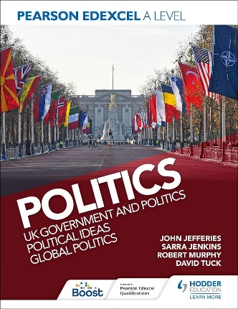
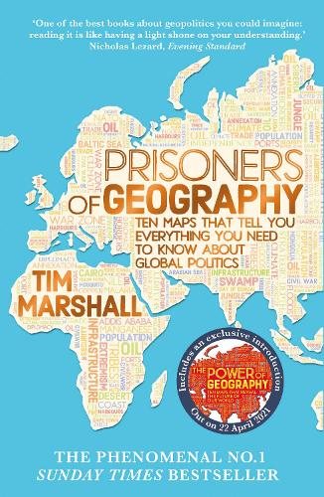
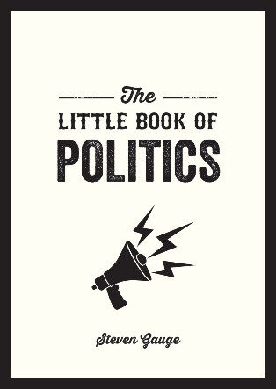
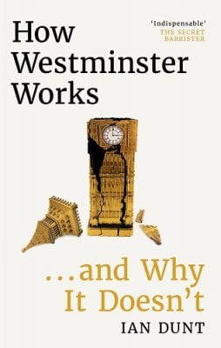
Optional reading list:

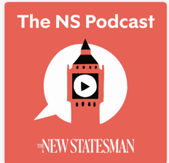

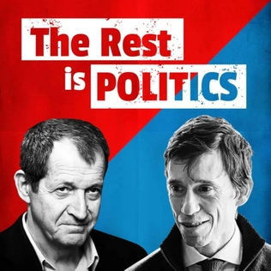
Excellent podcasts:

