**Nottinghamshire EHC Hub**



**Frequently Asked Questions (FAQs)**



Contents

Introduction 2

FAQs 2

**Co-ordinator 2**

**SENCo 3**

**Headteacher 3**

**Contributor 4**

**Parent (including parent, carer, guardian, young person or family advocate) 5**

**Health 5**

**Miscellaneous** **7**

Contact us 8

# 

# 

# Introduction

This document includes frequently asked questions (FAQs), with their answers, and is intended for users of the Education, Health and Care Hub (EHC Hub).

FAQs are grouped by user role; Co-ordinator, SENCo, Headteacher, Contributor, Parent and Health.

# FAQs

## Co-ordinator

**Q. Which child or young person’s details can I view?**

A. Any case where you are the named case co-ordinator, any case where there is no named case co-ordinator or any new request for assessment. An additional ‘manager’ role can be granted by an administrator which provides access to all cases on the EHC Hub.

**Q. Can I download a request for assessment?**

A. Yes, a download option is available at the “Request” stage once the case progresses to the first “Decision” stage.

**Q. How do I use the EHC Hub to notify parents of a request for assessment made by an education setting?**

A. Adding the parent(s) to the case sidebar will automatically send an email inviting them to register an account and give them access to the request and case in full.

**Q. How do I use the EHC Hub to notify an education setting of a request for assessment made by a young person, parent, carer, guardian or advocate?**

A. Adding the education setting and/or SENCo to the case sidebar will automatically send an email notifying them that they have access to the request and case in full.

**Q. How are due dates calculated and can they be changed?**

A. Due dates are automatically calculated according to the Children and Families Act 2014 and SEND Code of Practice 2015:

* Due dates in the assessment and planning pathway are calculated based on the date of request and are not able to be changed.
* A case co-ordinator can amend a next review due date if the next review has not yet begun. Any change to this date is recorded on the case timeline for purposes of audit.
* Due dates in the review pathway are calculated based on the meeting date and only change if the meeting date is changed by the meeting organiser during the pathway.

**Q. Can I preview a decision letter before the decision has been published?**

A. This is not currently possible on a case-by-case basis. However, anyone with a system administrator role, can edit and preview the letter template via the admin area.

**Q. Why is the option to progress from “Assessment” to “Decision” not available?**

A. To progress from “Assessment” to “Decision”, there must be at least one request for advice made at the “Assessment” stage and all requests must be completed (Response received) or closed (by co-ordinator or team manager).

**Q. Can anyone see the contents of a draft plan before it has been shared?**

A. No, a draft plan must be shared before it can be viewed by anyone else with access to the case. However, a co-ordinator that has the ‘manager’ permission can view the plan detail before it is shared to accommodate internal QA processes.

## SENCo

**Q. Which child or young person’s details can I view?**

A. Any case where the case co-ordinator has granted access to you, by name, or to your education setting.

**Q. Can a draft request for assessment be transferred from one person to another?**

A. No, a request for assessment that has not yet been submitted is only visible to the person who started the request. However, if a request has been started but is no longer required, it can be deleted.

**Q. Do I retain access to a request for assessment after it has been submitted?**

A. There will be a period immediately after submitting a request when it will not be visible to the requester. However, this is just to allow the Local Authority to process the request and allocate a case co-ordinator. Access to the request and case details can then be granted by the case co-ordinator.

**Q. Can a parent edit information that I enter under identified areas of need?**

A. No, but they will be able to read what is entered.

**Q. If a child or young person, or their parent, carer or guardian, are unable to provide views to support a request or assessment for themselves, can I enter their views or upload documents or images on their behalf?**

A. Yes. At the request stage, assessment stage and during a review, there is space to provide their views.

## Headteacher

**Q. Which child or young person’s details can I view?**

A. Any case where the case co-ordinator has granted access to your education setting.

**Q. Can I manage a review of an EHC Plan and submit the report of recommendations?**

A. Yes, provided the case co-ordinator has given your education setting access to the child or young person’s case.

**Q. Can I be requested to provide advice towards an assessment or views ahead of a review?**

A. No, this is specific to the SENCo role. For a Headteacher that is actively engaged in contributing information during either assessment and planning or review processes, it is recommended they be set up with the SENCo role within the EHC Hub.

## Professional Contributor

**Q. Which child or young person’s details can I view?**

A. Any case that meets at least one of the following conditions:

* Where you have been asked to provide advice towards an assessment which you have not yet completed
* Where you have provided advice towards an assessment and until a period after the EHC Plan has been issued (the period, or ‘grace period’, is normally 60 days but can vary by Local Authority)
* When you have been invited to a review meeting and the review process is in progress
* Where you have been asked to provide views ahead of a review meeting which you have not yet completed
* Where you have been asked to provide views ahead of a review meeting, the EHC Plan is amended at the end of the review and until a period after the EHC Plan has been amended (the period, or ‘grace period’, is normally 60 days but can vary by Local Authority)

**Q. If I’m requested to provide advice towards an assessment, when is the advice due?**

A. Six weeks from the date of the request. If allocated to provide advice within a team, the deadline remains six weeks even if the allocation within the team is completed later than the date of the request for advice.

**Q. Will I be reminded of the deadline?**

A. Yes, a notification will be provided to the individual and team within the EHC Hub and by email if advice is not provided after four weeks. A further notification is provided if the request becomes overdue.

**Q. How are team requests for advice at the assessment stage and team requests for information ahead of a review meeting allocated to team members?**

A. Designated “managers” within the team can log in to the EHC Hub and choose one or more team member(s) to provide advice on behalf of the team.

**Q. How can a team see requests for advice at the assessment stage and team requests for information ahead of a review meeting that require allocation?**

A. Designated “managers” have access to a “Team Cases” work tray and includes a filter for “Awaiting Allocation” to quickly access those requests that require attention.

**Q. Can I read responses from other teams or individuals who has been requested to provide advice at Stage 2 of the assessment or review?**

A. Yes, provided you have first submitted your own response, you can read other responses.

**Q. Can I download a copy of advice or information that I have submitted?**

A. Yes, advice and information can be downloaded before and after it has been submitted to the Local Authority.

**Q. Who can read the advice and information that I submit on the EHC Hub?**

A. Everyone with access to the child or young person’s case will be able to read your submitted advice and information for that child or young person. The case co-ordinator, education setting, SENCo(s) and young person, parent, carer, guardian or advocate are listed in the case sidebar. Other professionals across education, health and social care will be listed under requests for advice (Assessment stage) or requests for information (Contribute Views stage of review) depending on the case’s current stage.

## Parent (including parent, carer, guardian, young person or family advocate)

**Q. Do I need an account on the EHC Hub to request an assessment?**

A. No, a request for assessment can be submitted to the Local Authority without an EHC Hub account. Once you’ve made a request, and provided you’ve included your email address, the Local Authority will invite you to register an account to contribute further information and track the progress of your request.

**Q. Will I receive updates on my child’s case?**

A. Yes, you will receive an email whenever a stage is complete, or you’re requested to provide information or views.

**Q. Do I have to use the EHC Hub?**

A. Not if you do not wish to. Your views, contributions and all other available information and details of progress can be provided with the assistance of the SENCo in your child’s education setting or the case co-ordinator within the Local Authority.

**Q. Is the EHC Hub secure and who can see my child’s details?**

A. The EHC Hub is secured by two factor authentication and offers the same level of protection as would be expected of online banking services. Access to any child or young person’s details is by invitation only and controlled by the Local Authority. When viewing your child’s information, you can see the names of all other parties that have been invited to view or contribute towards the case.

**Q. How do I know what should be happening next and by when?**

A. Next steps and key dates are clearly displayed in the EHC Hub at all stages of the process.

**Q. If my child already has a plan, can we use the EHC Hub?**

A. Yes. Your child’s plan will be reviewed using the EHC Hub so you can contribute and track progress.

## Health

**Q. Do EHC requests have to be made through the EHC Hub?**

A. We would really love all children, young people and their families to engage with the EHC Hub, however, this will always be their choice. A request can be made directly to the ICDS Assessment Team, using the contact details at the end of the document. Nevertheless, the EHC Hub will still be utilised by the ICDS Assessment Team on their behalf and support given to further engage parties to be able to use the EHC Hub.

**Q. Can I submit my report by email, rather than through the EHC Hub?**

A. If you require training or guidance on submitting documents electronically you can request support from the Annual Review Service Organiser (Annual Reviews) or Locality Duty Workers (EHC Assessments). If the process has moved on and you are no longer able to upload the report digitally, you can email the report to the case coordinator who can add the report to the next section on your behalf.

**Q. Can I attach a clinic letter, rather than writing a report?**

A. Lawfully, information provided needs to clearly identify; needs, outcomes, and provision. Completing a report on the EHC Hub is the best way to make sure these are clearly identified and can be included correctly in the EHCP. You can attach clinic letters in addition to support the assessment/review.

**Q. How do I attach a document?**

A. At the bottom of each section you will find an ‘add file’ box; attachments can be uploaded here including word documents, photos and videos

**Q. How can a request be re-assigned if a worker is on leave or has left the service?**

A. The SPA can re-assign a case in the ‘invite’ stage, the Add Professional button is available to the SPA team until the case has moved on past the point of assessment/review.

**Q. What are the statutory deadlines in the EHCP Assessment process?**

A. For further advice and guidance from Independent Provider of Special Education Advice (IPSEA) can be found here: [What happens in an EHC needs assessment | IPSEA](https://www.ipsea.org.uk/what-happens-in-an-ehc-needs-assessment)

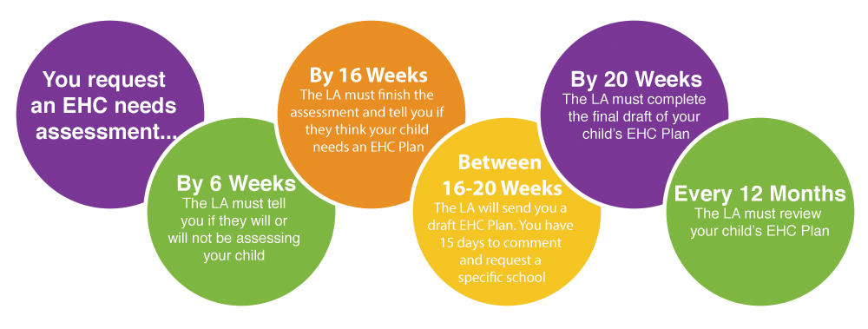

**Q. Do I need to provide information at Stage 1?**

A. No, Health do not need to contribute advice at Stage 1. A parent may provide health reports or documents as part of the request which can be uploaded to the Stage 1.

**Q. I have received a notification that a case has been updated, but when I log onto the EHC Hub, I can’t see anything?**

A. There are several reasons you may no longer be able to see the case such as; There has been a decision of no to assess or plan, moved out of county, cease decision or moved past contribute views and you have not responded in time.

**Q. How long is the draft plan visible to contributors on the EHC Hub?**

A. A draft plan should be finalised after 15 days and then visible from 60 days once finalised.

**Q. I have viewed the draft plan and my advice is not correctly included, what should I do?**

A. Please contact the case co-ordinator whose name and email are visible on the left side of the screen.

**Q. I have missed the 6-week statutory deadline for submitting my advice, what should I do?**

A. Initially please contact the case co-ordinator, depending on the progress of the case it may be possible for your report to be added.

**Q. Where can I find more information regarding EHCPs and support available in schools?**

A. Lots of information and guidance can be found on the [Nottinghamshire Local Offer](https://www.nottshelpyourself.org.uk/kb5/nottinghamshire/directory/site.page?id=mjHuZeCQAY4)

**Q. Where can we find the date the report needs to be completed by?**

A. The dates the report was requested, due and completed can be found in the *Assessment* or *Contribute Views* sections. The report should be submitted and available at least two weeks before the meeting.

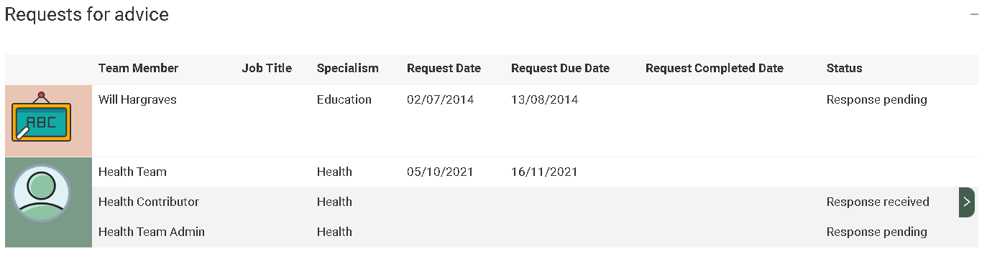

**Q. How do you request an extension?**

A. There are very few lawful reasons an extension can be requested. However, should you be unable to complete your report on time you must raise your concerns through senior leadership and contact the case co-ordinator.

**Q. How can training be accessed?**

A. Training and support can be accessed through the help button at the top of the EHC Hub. The Annual Review Service Organiser can also support with training and individual case troubleshooting.

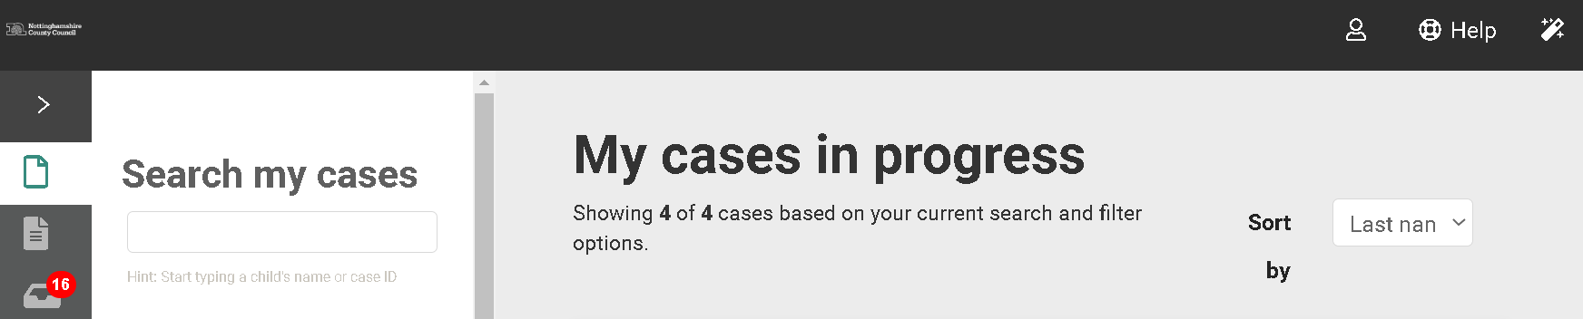

## Miscellaneous

**Q. I have not used the EHC Hub before - how do I log on?**

You can access a video on how to register an account here:

<https://openobjects.vids.io/videos/a09dddb71f19e2c728/ehc-hub-account-registration>

**Q. What happens if I forget my password?**

A. There is a link on the EHC Hub’s homepage to securely reset your password at any time.

**Q. How do I access my account if I change, or lose, the device that I use for two factor authentication?**

A. An administrator of the EHC Hub can reset your two factor authentication settings, these contacts can be found at the end of this document. Next time you log in to your account, you shall be prompted to set up two factor authentication with your new device

**Q. Can individuals be blocked from accessing the EHC Hub? For example, a person changes job which means they should no longer have access.**

A. Yes, an administrator of the EHC Hub can suspend a user’s account which prevents that person from being able to log in. Suspended accounts can be reactivated, if needed.

**Q. Who can edit a system template (email notifications, letters and the EHC Plan)?**

A. An administrator of the EHC Hub can make changes to system templates. Any change that is applied to a template and saved will take effect from the next time that template is used.

**Q. Can a person’s given role in the EHC Hub be changed?**

A. Unfortunately not. This is because the permissions that are integral to how a person can search for and engage with cases is controlled by the type of role that is assigned to a person’s account in the EHC Hub. However, a person requiring a different role can be set up with a new account. This requires contact the ICDS and setting up a new user account with a different email address,

# Contact us

**Bassetlaw and Newark & Sherwood areas:** [icdsehcBandNSlocality@nottscc.gov.uk](mailto:icdsehcBandNSlocality@nottscc.gov.uk)

**Mansfield and Ashfield areas:** [icdsehcMandAlocality@nottscc.gov.uk](mailto:icdsehcMandAlocality@nottscc.gov.uk)

**Broxtowe, Gedling and Rushcliffe areas:** [icdsehcBGRlocality@nottscc.gov.uk](mailto:icdsehcBGRlocality@nottscc.gov.uk)

**Post 16 Team:** [icdsehcpost16@nottscc.gov.uk](mailto:icdsehcpost16@nottscc.gov.uk)

**Annual Review Service Organiser:** [serviceorganiser.annualreview@nottscc.gov.uk](mailto:serviceorganiser.annualreview@nottscc.gov.uk)