

|  |  |  |
| --- | --- | --- |
|  | **First time access to an External SharePoint Site –** |  |

In order to access the site, you will first be sent an invitation to the e-mail address you have provided which will need to be verified. Once verified you will not be required to follow these steps again whilst using that account. This document explains the verification process required for your first login.

Whilst efforts have been made to discuss all the potential options for users to sign into the site, the experience may differ for some users/organisations. If users have difficulty accessing the site or creating an account, please contact bsso.team@nottscc.gov.uk for further information.

**Please Note**:   
The invitation you have been sent is unique to your account and will not allow other users to gain access to the site. If there are additional members of your organisation that would like access to the site, please contact a member of the Service you are working with for additional invitations.

**Step 1: Receipt of the e-mail**

You will be notified by a member of Nottinghamshire County Council that an invite is on its way and when to expect this. The e-mail will be from SharePoint Online (see image below). Please check your Junk email folder if the email does not appear in your Inbox as expected.



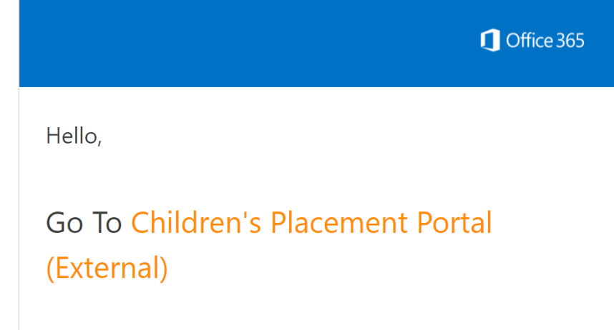The email content will look similar to this image, with the name of the site displaying in the Go To section.   
*Please note the name of the Site may differ to the example shown.*

**Step 2: Accessing the site**

To access the site, you will need to click on the site name (shown in orange text) in the email you have received.

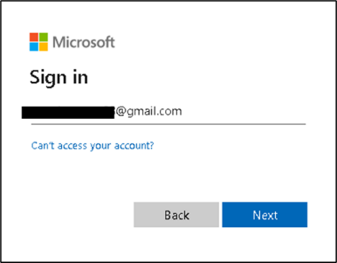**Step 3: Sign-In and Verification**  
You will now be required to enter your email address, which

will be the same address the invitation was originally sent to.

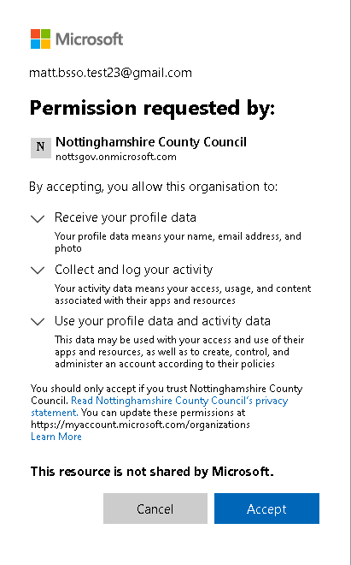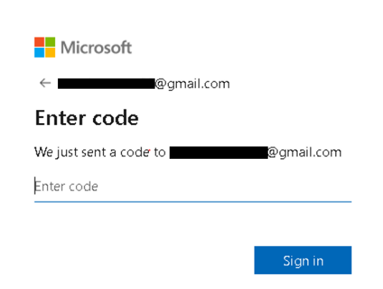A Verification code will now be sent to this email address. You will need to enter this in the box provided to verify your account.  **Step 4: Accept Terms and Conditions**To continue, accept the Nottinghamshire County Council data terms and conditions.

**Step 5: Set up 2 factor authentication**Occasionally users may be asked to set up 2 factor authentication to access a site. You may be asked to provide a mobile phone number to receive a text message code that will need to be entered to verify your account.  
  
This number can be a personal or works mobile number.  
  
Select **Receive Text Message** from the options at the top of the screen.  
Select United Kingdom from the country code drop-down menu.   
When entering the mobile number please ensure the first 0 of the number is removed and that only 10 numbers are entered. This will prevent issues with sending the message.  
  
Once the text is received enter the code into the field provided to verify your account.   
  
 **Step 6: Access to the Site**  
Once your account is verified you will be taken directly to the SharePoint site. On subsequent visits you can use the link in the invitation email to gain access or bookmark the page to your internet browser.  
  
If you set up 2 factor verification you may be required to enter a one-time code when you access the site on future visits.