September 2024

Dear Parent/Carers,

Re: Pupil Premium / Pupil Premium Plus

As you may be aware Pupil Premium funding is additional money given to schools and Academies in England to raise the attainment of eligible pupils and narrow the gap between their attainment and their peers. Children who are eligible for Free School Meals (FSM), Looked After Children (LAC) and children with parents in the Armed Forces attract Pupil Premium funding.

A new addition to the criteria from April 2014 (Pupil Premium Plus), was that Schools/Academies receive £2300 per eligible child, per year for children:
- that were adopted from care on or after 30 December 2005 (under the Adoption and Children Act 2002);
- that left care under a Special Guardianship Order on or after 30 December 2005 (under the Children Act 1989);
- that left care under a Residential Order on or after 14 October 1991 (under the Children Act 1989);

Parents and guardians will need to provide evidence to the Academy, such as their Adoption Order / a letter from the local authority that originally looked after the child. The Academy will then use this information to complete our DfE Census return (January 2021).

Information on an Adoption Court Order is sensitive and includes information you may not want to share with the Academy. Parents and guardians can photocopy the child's Adoption Order and conceal information about birth parents before they present it to the Academy.
It is crucial that Foxwood can clearly see the child's name (since they were adopted), the date on which they were adopted and the Agency they were originally adopted from.

Further information is available on our website or should you have any queries please do not hesitate to contact either myself or Julie Malkinson at the Academy.

Yours faithfully,
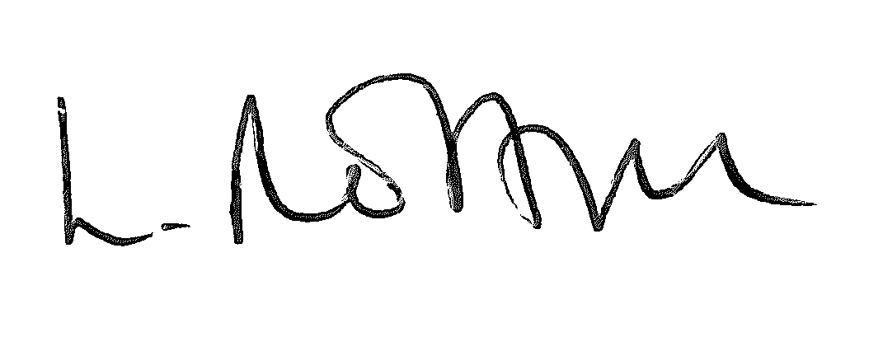
Miss Lindsey Norton
Deputy Headteacher

