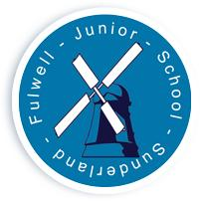
FULWELL JUNIOR SCHOOL

Sea Road

Fulwell
Sunderland

SR6 9EE

Tel : 0191 549 3333

Web: www.fulwelljunior.co.uk

E-Mail : Fulwell.junior@schools.sunderland.gov.uk

Head Teacher : Mr Peter Speck

Chair of Governors : Mr Ben Young
______________________________________________________________

Respect, Aspire, Achieve – Be the best that you can be
18/10/2024
Dear Parents/Carers,

Year 4’s weekly homework will be as follows:
- Play at least 25 minutes on Times Table Rock Stars and contribute to the year group tournament.
- Log into Fiction Express. Read one chapter of one of the LIVE BOOKS and complete the end of chapter quiz. PLESE NOTE – to check which books are live.
- Spelling practice. Spelling tests will take place on Fridays- they will include words from a spelling strand and either words from the statutory list, topic words or ‘tricky’ words identified through marking.

Children have been given their log-ins to TTRS and Fiction Express by their teacher.

If you have lost any log ins, please contact your child’s class teacher and we can provide you with new ones. Thank you for your support.

Many thanks,
The Year 4 Team.

Spellings:

IDENTIFIED WORDS
Pressure
Assure
Ensure
Exposure
Closure

PREFIX WORDS
Circle
Decide
Woman
Women
Often

