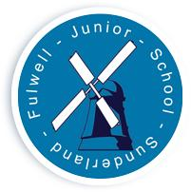
FULWELL JUNIOR SCHOOL

Sea Road

Fulwell
Sunderland

SR6 9EE

Tel : 0191 549 3333

Web: www.fulwelljunior.co.uk

E-Mail : Fulwell.junior@schools.sunderland.gov.uk

Head Teacher : Mr Peter Speck

Chair of Governors : Mr Ben Young
______________________________________________________________

Respect Achieve – Be the best that you can be
18.10.2024

Year 3’s homework this week will be as follows:

- Play for 30 mins (We suggest approx 5 minutes per day) on Times Table Rock Stars.

- Reading- pupils are to complete a chapter of their own choice of book on FictionExpress.

- Spelling practice. Spelling tests will take place on Fridays- pupils will learn the same rule over 2 weeks.
Spelling Homework-

Our spelling pattern this week is adding the suffix ous
E.g:
Famous, mysterious, dangerous

Children will also be tested on these 5 common exception words:
answer
thought
regular
group
history

Many thanks,
Miss Anderson and the Year 3 Team.

