ALL ABOUT DERWENT HILL!!
We are going to derwent hill and we are all so exited and can’t wait!! 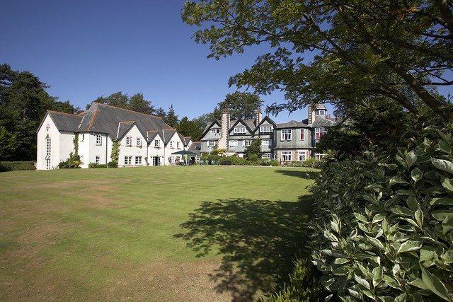
In my dorm I am hoping to have Hollie-A, Hollie-M, Callie and Jess. In my day group I am hoping to have the same people plus Thom. In the dorms you ussualy have a couple of bunk beds here is a picture of one.

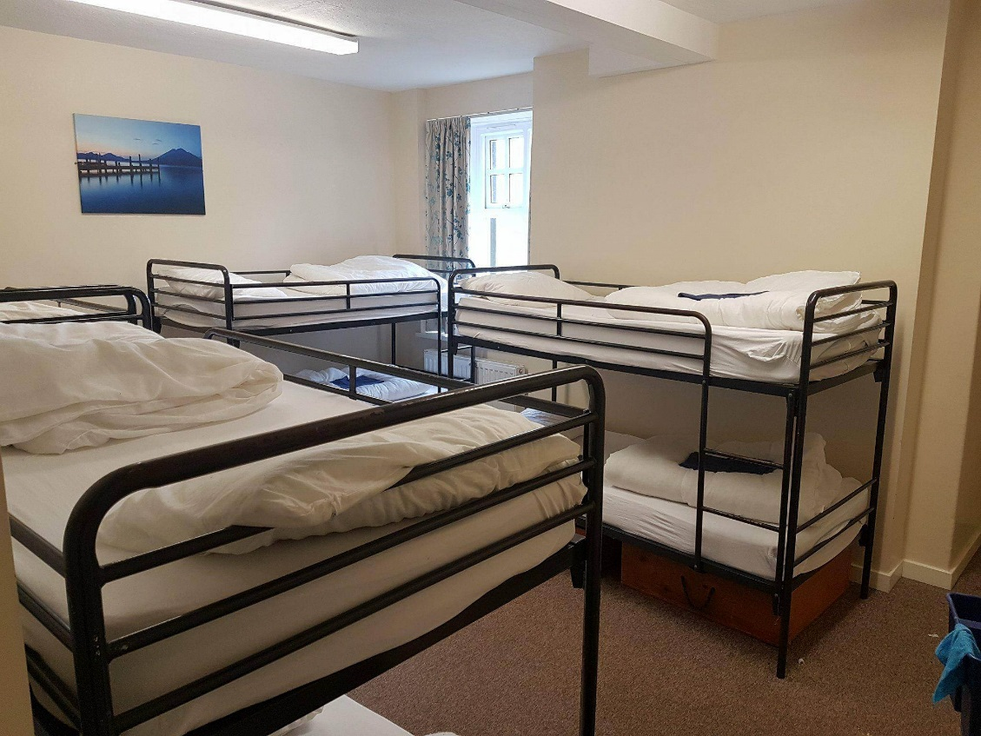
There are also ones which are single and double beds. 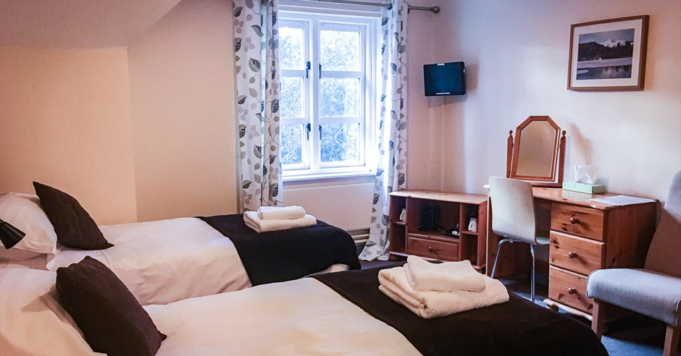
This is a more luxurios room with single and double beds.
We get to do really fun activitys such as: canoeing , kayaking , George walking , swimming in lakes , going on things such as the death swing and climing walls and much more. 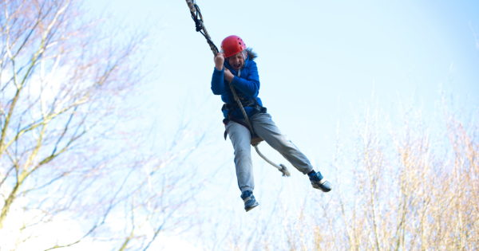
This looks like so much fun I can’t wait to go!!!

