Faculty Focus and Money Matters
Monday afternoons continue to be dedicated to Faculty Focus, which is our unique take on personal development and employability skills. Autumn Term’s focus is the Faculty of Communication. So far this year, children have worked on their presentation skills, asking questions and positive listening behaviours. In Money Matters, children have learned about the role of banks and how we can earn interest on our money.
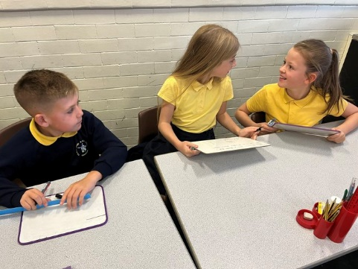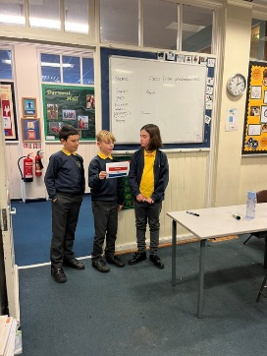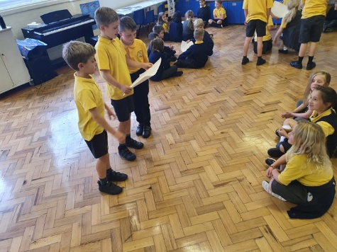
Rubikon
To launch our Wheels In Motion project in style, we were given an awesome demonstration of skateboarding skills and were then given the opportunity to try it for ourselves! It was a great way to experience wheels as part of our physical education.
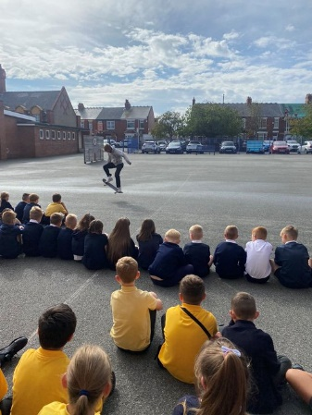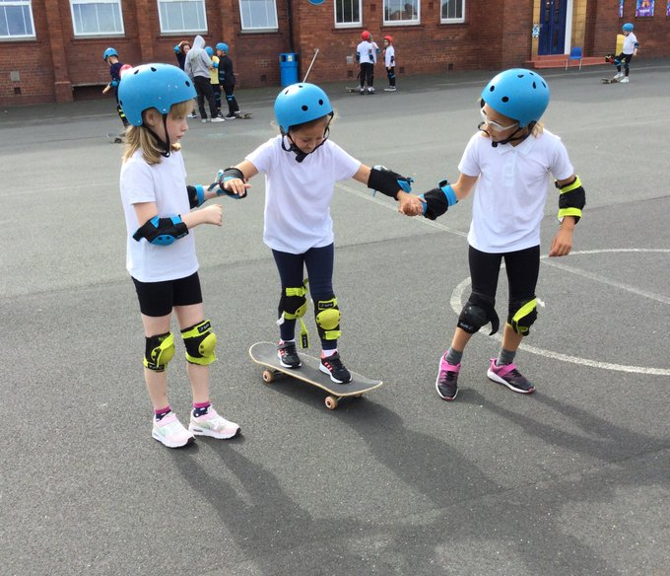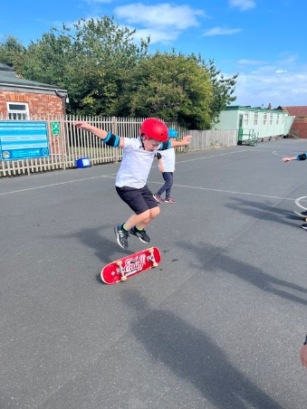
The Word Masterclass
As part of this year’s Wheels In Motion project, a group of children were taken to The Word to complete a masterclass in 3D printing. This showed our children how careers in Art and STEM can work together, as they designed their own products and then used the technical equipment to make them out of plastic.
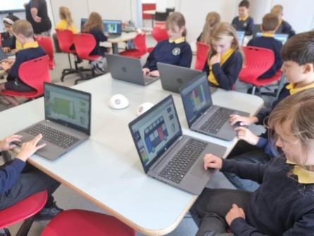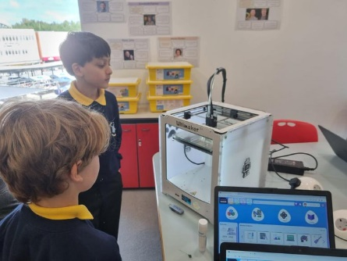

RAF Lieutenant
Children were given an assembly from John Richardson, an RAF Lieutenant. He spoke to the children about his career path, his experience of working in the Armed Forces and also how our school values link to a range of jobs within the RAF. He brought a lot of equipment in to show the children, and they used their questions skills that they had been working on in the Faculty of Communication to ask his brilliant questions.
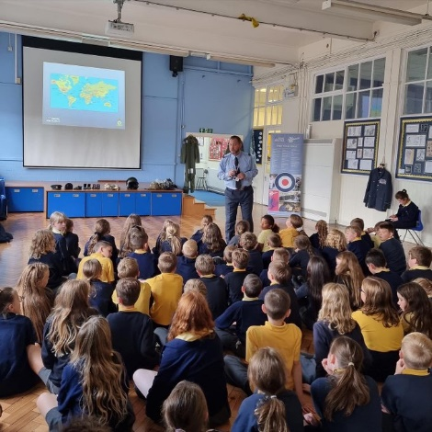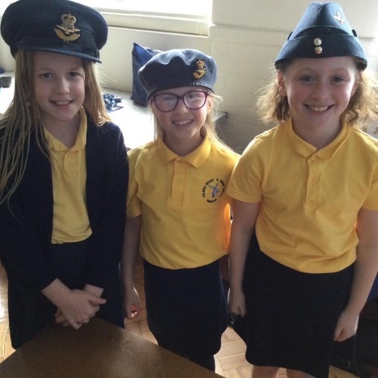
Parent-Pupil Green Skills Safari
FJS were the first school to experience the Green Skills Safari with Re:Gen and Re:Geon. These companies are trying to address the skills shortages in sustainable jobs by increasing the awareness of future jobs in net-zero construction for both primary school children and their parents, and gave our children another great opportunity to visit a workplace.
