Faculty Focus and Money Matters
Our Faculty Focus this term has been Critical Thinking, which is such an important skill that really challenges us! We know that we tend to use our critical thinking skills a lot in school, particularly in Maths and Science, but we need to use it in the wider world as well. We have worked on finding different solutions to a single problem (because our best idea is rarely our first), the links between cause and effect and making logical justifications behind our thinking. In Money Matters, we have been thinking about the link between jobs and money, and Year 5 worked on calculating deductions from a payslip! Unfortunately, it was more than we thought it would be!
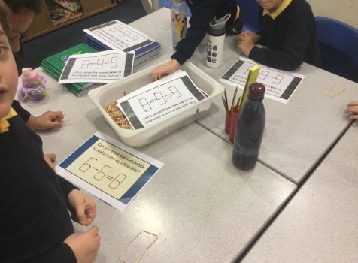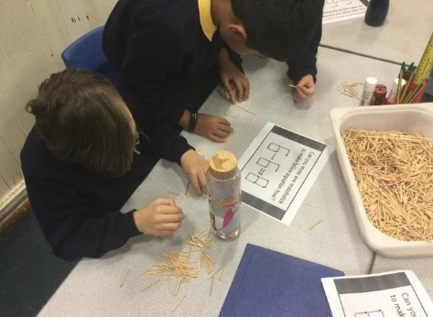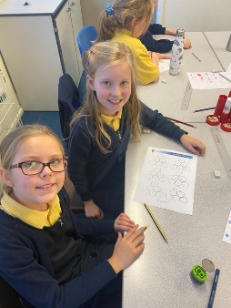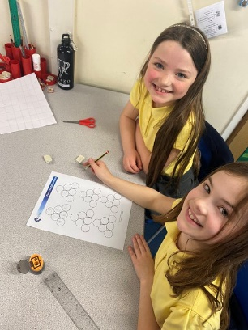
Canford
In Year 4, we have been working hard on our Science topic of “sound” this term, learning all about how sound is made from vibrations and how pitch and volume can be altered. Not only did we carry out some fascinating investigations linked with this topic, but we were also visited by a company called Canford Audio, who are based in Washington. During their visit, they told us all about what careers there are in this field, and allowed us the opportunity to interact with some of their hi-tech equipment. Canford Audio were then kind enough to invite a small group of Year 4 children to their workplace.
During their visit, these children had a tour of Canford where they were able to see a variety of equipment that is made there, like "level limited" headphones which make a sound if the volume is turned up to high, forcing the user to turn it down - the BBC actually buy lots of them. They also make recorders for the police , and camera cables for Formula 1 and bands like Coldplay. Thanks for having us, Canford!
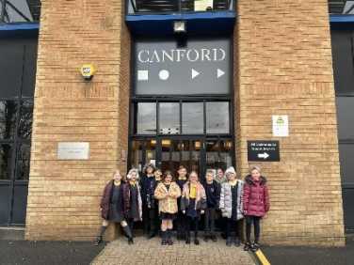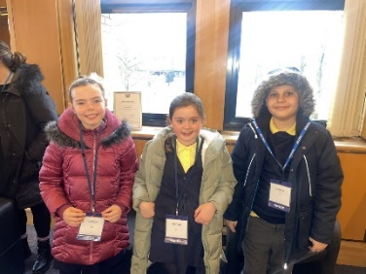

Sunderland University - Microscopes
During our Art focus week earlier in the year, we had the opportunity to use some microscopes in school to help us to really “zoom in”. Some children were really interested in this, and so they got the opportunity to spend the day at Sunderland University. The University Ambassadors gave them a tour of City Campus and spoke to them about what university life is like, and then they got to spend some time in the Bioscience department. They learned all about how microscopes work, why microscopes are so important in Healthcare Science and how they are used to identify things like blood disorders and meningitis. It was fascinating!
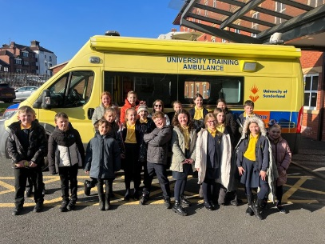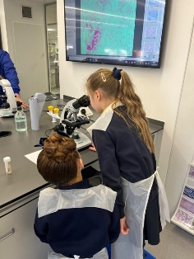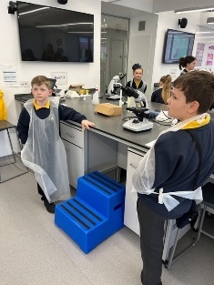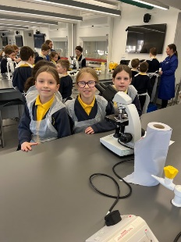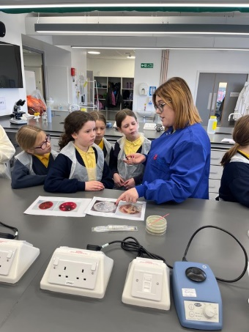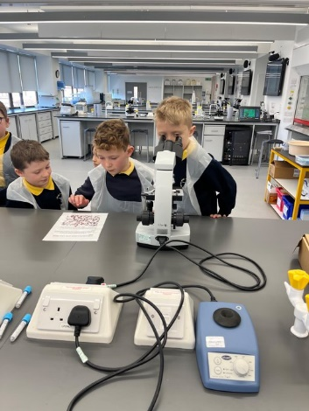
Careers Week
On 6th March, we celebrated Careers Week. There are so many options available to us in our futures, and we were lucky enough to have some visitors into school to share their exciting careers with us! Year 3 met Detective Lauren, who talked about her former career as a response officer and her current career of a detective! Some of the children even got to try on some of her uniform! Year 4 were visited by Greg, who is a Senior Crown Prosecutor and Year 5 were visited by Richard and Debra, who run their own businesses and told the children all about what it’s like to work for yourself!
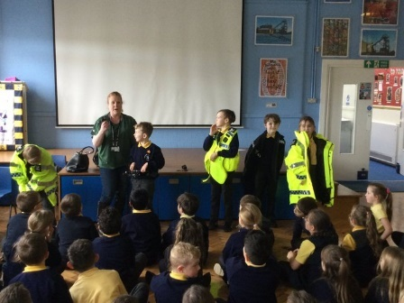
Northern Rail
As part of our DT focus week, in which we made our own train carriages, we were visited by Northern Rail to learn all about careers in the rail industry. We couldn’t believe how many roles there are – Northern Rail alone employ 6,500 people. Be it a train driver, a conductor, an engineer or even a finance specialist, there’s something for everyone!
