Faculty Focus and Money Matters
Our Faculty Focus this term has been Collaboration, in which we have been learning about the importance of working together to achieve something. We have been playing games and completing STEM challenges that involve using working as a team, and then reflecting on how we may not have been as successful if we hadn’t been working together. Although we have been focused on developing our ability to work collaboratively, we have also been bringing in our learning from the Faculties of Communication and Critical Thinking, and applying them to demonstrate that these skills all work alongside each other.
In Money Matters, children in Year 5 have been learning about debt (including student finance!) and how banks can lend, and people can borrow, responsibly.
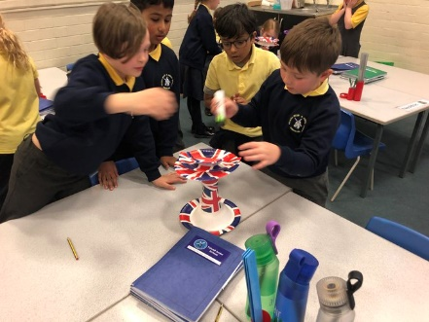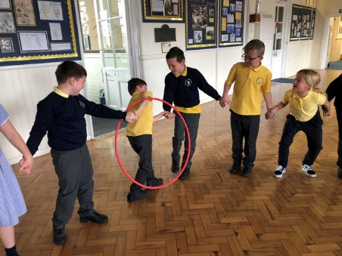
Careers in Finance
Not only are we beginning to understand how to manage our own money in the future, but we are also learning that there are a broad range of careers in finance too, from accountants to brokers. Children in years 3 and 4 were visited by Jamie Bell, who is the Finance Director from the DfE. She talked about her career path, and how she prioritises how the government spends its education budget to benefit everyone as much as possible. It was great to hear Jamie talk about not only the important communcation and critical thinking skills she uses in her job, but also the importance of Maths in her career.
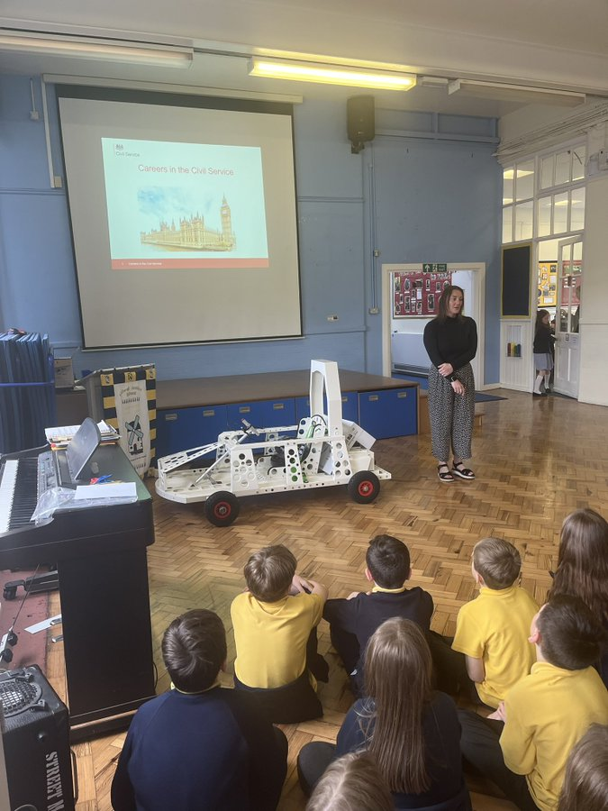

Step Into The NHS
This year, not only were some of us visited by Joanne Ford, who is a Neonatal Nurse, but we were also immersed in a range of specific jobs within the NHS. We were lucky enough to be able to use actual medical resources, such as blood pressure monitors, stethescopes and pulse oximeters to allow us to explore careers such as Nurses, Paramedics and Physiotherapists.
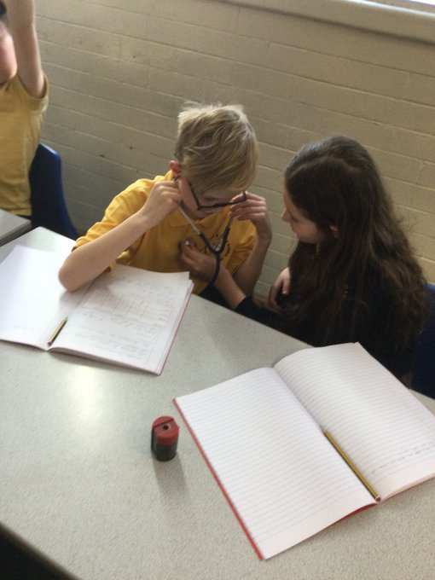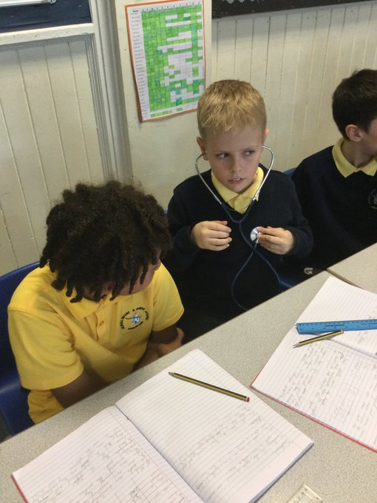
Armed Forces Careers
Following an Armed Forces Career event that Mrs Haswell took a select group of children to, we took the opportunity showcase the range of jobs within the Armed Forces, from Infantry Soldiers and Engineers to Chefs, and even Musicians - there really is something for everyone! We linked the Army’s vision of “Be The Best” with our own – “Be the best that you can be”, and we were able to explain what the Army means to us – with many children saying the Army makes us feel safe and protected.
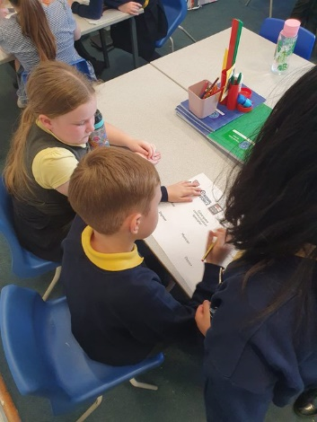
Career talks
Year 4 have been learning about the different types of teeth and their functions in Science, and so we invited Fearne’s Mum, who is a Dental Nurse, into school to talk about her career.
Year 4 were also lucky enough to receive a visit from Indie’s grandad, who is a fifth generation Foyboatman on the River Wear. He told us all about how his job has changed over time, and how technology has developed over time to make this job more efficient – for example, he was able to show us the app that he uses on his phone to tell him when the ships are due in.
