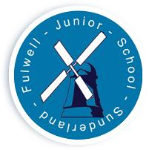
FULWELL JUNIOR SCHOOL

Sea Road

Fulwell
Sunderland

SR6 9EE

Tel : 0191 549 3333

Web: www.fulwelljunior.co.uk

E-Mail : Fulwell.junior@schools.sunderland.gov.uk

Head Teacher: Mr Peter Speck

Chair of Governors: Mr Ben Young
______________________________________________________________

Respect Aspire Achieve – Be the best that you can be

Tuesday 9th May 2023

Celebrating Success

At Fulwell Junior School we recognise that as well as being successful in the classroom, our children achieve amazing things outside of school.
As a result, we want to celebrate those successes in a more formal way by providing a regular opportunity for children to share their achievements with their teachers and peers. This may be a sporting achievement, such as a swimming certificate or a musical success, such as a piano grading. Any achievement that children have been recognised for outside of school that they are proud of and want to share.

Every Friday we will be giving children the opportunity to share their amazing successes with us. We will then celebrate their achievements via social media and on our celebrating success display in school. This will commence from Friday the 12th May 2023.

Many thanks

Mr Remmer

