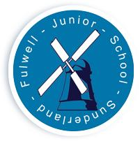
FULWELL JUNIOR SCHOOL

Sea Road

Fulwell
Sunderland

SR6 9EE

Tel : 0191 549 3333

Web: www.fulwelljunior.co.uk

E-Mail : Fulwell.junior@schools.sunderland.gov.uk

Head Teacher : Mr Peter Speck

Chair of Governors : Mr Michael Hartnack
______________________________________________________________

Respect Aspire Achieve – Be the best that you can be
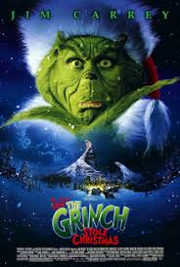
2nd December 2022

Dear Parents,
‘The Grinch’ Movie Night - Year 5 and Year 6
Wednesday 14th December from 4.15pm to 6.15pm (arrival 4pm)

Our fantastic Teaching Assistant team are going to hold a special festive, fundraising Christmas Movie night for children in Years 5 and 6.

The film is ‘The Grinch’ – based on the famous Dr Seuss book, the movie tells the tale of The Grinch and his loyal dog, Max, who live a solitary existence inside a cave on Mount Crumpet. The Grinch’s main source of aggravation comes during Christmas when his neighbours in ‘Whoville’ celebrate the holidays with a bang. When the Whos decide to make Christmas bigger and brighter, the disgruntled Grinch realizes there is only one way to gain peace and quiet! With help from Max, the green grump hatches a scheme to pose as Santa Claus, steal Christmas and silence the Whos' holiday cheer once and for all!

The hall will be decorated in festive frippery and there will be special festive treats for all children.

We are happy for children to come dressed in festive jumpers and accessories.

This is a ticketed event and tickets cost £3.00. All proceeds go towards hosting the event with any surplus income donated to our School Fund, which subsidises other ventures across the year.

For their ticket fee, children will receive snack & a drink to enjoy during the film.

If your child would like to attend, please return the slip printed below with £3.00 in a clearly named, sealed envelope by Thursday 8th December. Please indicate ‘Movie Night’ on your child’s envelope so that it doesn’t get mixed up with other funds. NB : This is a school fundraising venture, so please DO NOT pay on-line for a ticket.

Tickets will be given to children on Monday 12th December.

Continued over page…

Children should return to school at 4.00pm to main reception. On arrival, we will need to tick children off as they enter the building so please form an orderly queue! (We love queuing in this country anyway, don’t we….it will feel just like Christmas! ☺)

All children must be collected by an adult at 6.15pm from the front yard.

Thank you for your kind support and we look forward to this festive fundraiser!

C. Donoghue
Business Support Assistant

---------------------------------------------------------------------------------------------------------

‘The Grinch’ Movie Night - Year 5 and Year 6
Wednesday 14th December from 4.15pm to 6.15pm (arrival 4pm)

- I would like a ticket for my child ……………………………………………………... of Class ………... to attend Movie Night and I enclose £3.00 for the ticket.

- I will arrange to bring them to school for 4pm and to collect them at 6.15pm from the front yard.

Signed ………………………………………………………………………….. Relationship to child ……………….…..

