Cookie run kingdom!
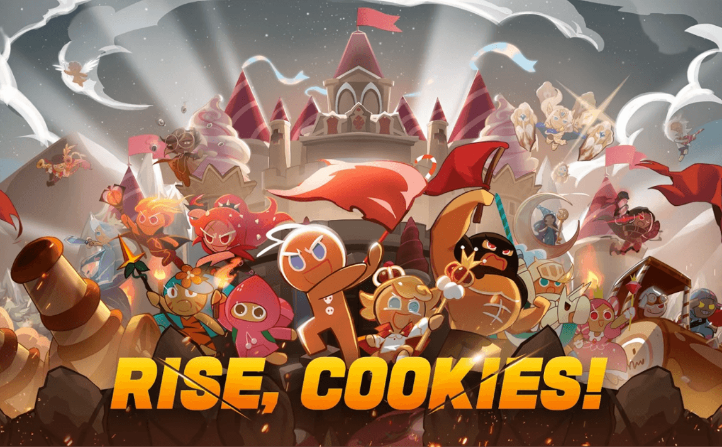

Cookie run kingdom is a combat game were you have 3 main characters ginger brave, strawberry cookie and wizard cookie. Were you create the cookies is the gacha, your first cookie will be chilli pepper cookie. These are some of the cookies you can collect!
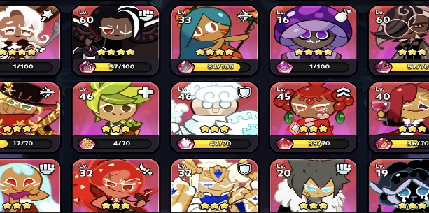

In cookie run kingdom you create a kingdom from scratch and collect axes, rivers and buildings. Your currency is gems and coins and in the winter you can collect snowflakes. There are special events at the gacha every holiday such as Halloween and Christmas. During Christmas when you collect snowflakes you can go to the frost gacha and try to get frost queen cookie

