Cristiano Ronaldo
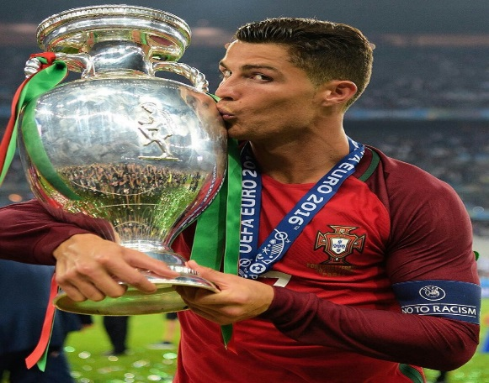
Cristiano Ronaldo is a Portguese football player that currently plays for Manchester united and was born on the 5th Febuary 1985 and is now 37 years old .And started playing football in 1990 so at 5 years old he has won 32 to trophies in his carer playing football and 7 league title.he has scored 450 goals playing for real Madrid ,101 for Juventus ,127 for Manchester united,115 for Portugal. He has scored over 790 goals in his official senior football career . Ronaldo left Juventus because he thought that it was his turn to join a new club and just a few hours after Ronaldo told his head coach he didn’t want to play for Juventus anymore Juventus announced that Cristiano Ronaldo was leaving the club.
