Football players
MESSI
MESSI is a really cool football player and his and his skills are really sick.
RONALDO
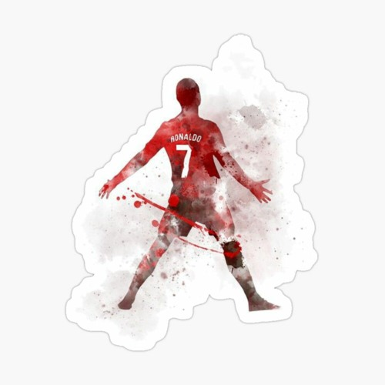
Ronaldo is really cool to because of his celebrations which is known as suiiii.
He looks like a robot
And he scores class goales.

