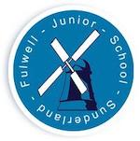
Fulwell Junior School Alumni

Name:
Years attended Fulwell Junior School:
Is there anything you’d like to share about your time at Fulwell Junior School?

What were your favourite subjects at school? Do these subjects have any links to your job/career now?

What is your current job/career? What does it involve day-to-day?

What qualifications are necessary for your job? Did you go on to study at college/university, or did you train in another way (e.g. apprenticeship)?

What skills are necessary for your job? (It would be great if you could link the skills you use to our school values: academic excellence, wonder of discovery, confidence, endeavour, respect, integrity, resilience, teamwork, sense of duty – or our Faculties: Communication, Critical Thinking, Collaboration)

What do you like most about your job?

What advice could you give to any of our children who would like to follow in your footsteps?

