Autumn 2021:
Here are some of the experiences our children have taken part in this half term. In order to really enrich our “Take Flight” project and develop aspirations of those children who have shown an interest in the field of flight, we gave children the opportunity to engage with a range of career options throughout the half term.

Falconer
We welcomed Chris, a falconer from SMJ Falconry, into school to talk to us about his career in falconry. He told us about the skills and experience he needed in order to become successful, and encouraged our wonder of discovery with a flight display of the birds he brought with him!
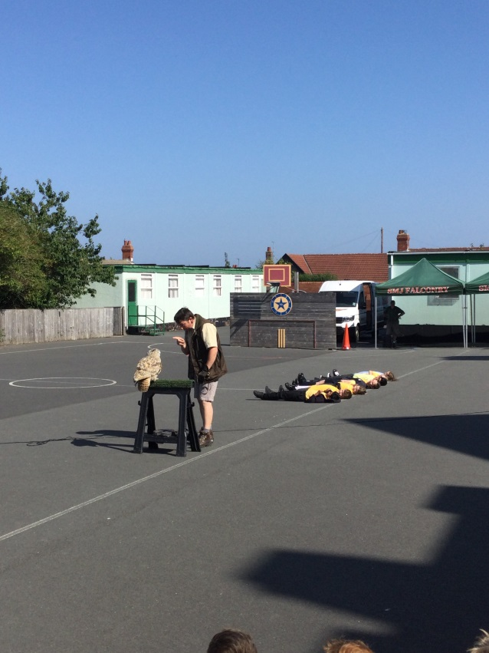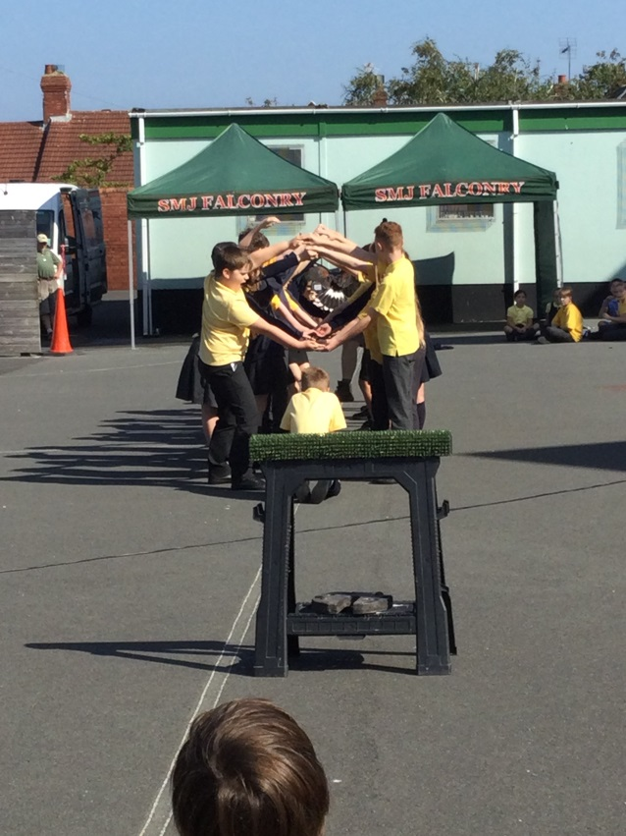
Pilot
We were visited by David, a pilot who works for Jet2. He talked to us all about his training, his career path in aviation and what his day as a pilot looks like. He inspired so many of us by telling us all about the different roles involved in aviation, from captains to cabin crew!
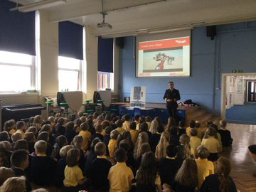
Tattoo Artist
Because some of us enjoyed creating our own observational drawings of birds, we got the chance to take part in an Art master class with Ben, an artist who specialises in drawing birds. He shared with us his experience of studying Art at university, and explained how he went on to develop a successful career as a tattoo artist.
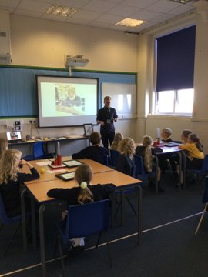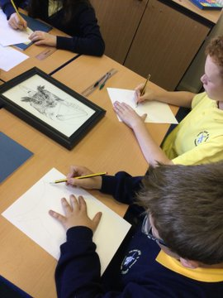
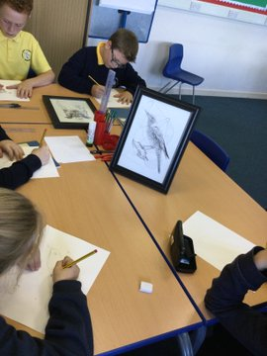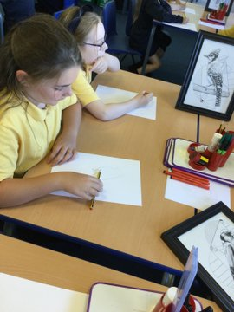
Chief Operating Officer for Gravity Industries
We were extremely fortunate to have had a virtual meeting with Maria Vildavskaya, who is the chief operating officer for Gravity Industries - a company that makes human jetpacks! We used our knowledge from our 'Take Flight' project, our developed scientific enquiry and our questioning skills from our faculty sessions to pose questions to Maria. This helped further our understanding about her career, the company itself and the process of making the jet packs.
Our children asked some phenomenal questions and to quote Maria;
'Thank you so much for having me on today - fantastic questions and so so insightful! A real pleasure for me!'
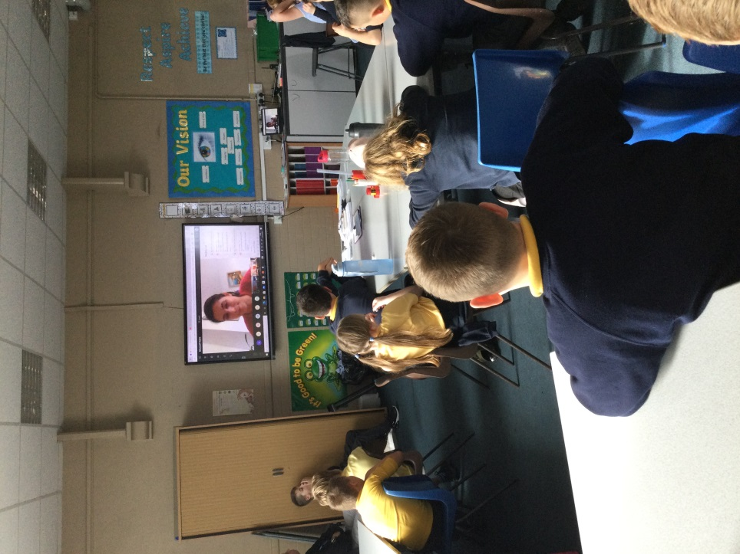
Kite Artist
In order to develop our understanding of flight further, we decided we were going to try and make our own kites. We invited Pauline, a kite artist, into school so share her knowledge and skills with us. She also shared her career – her role as an artist means that she shares her expertise to help withers be successful, which was a career in art that some of us hadn’t thought of! Once we had made our own kites, Pauline came back to give us feedback and she was so impressed with what we had achieved!
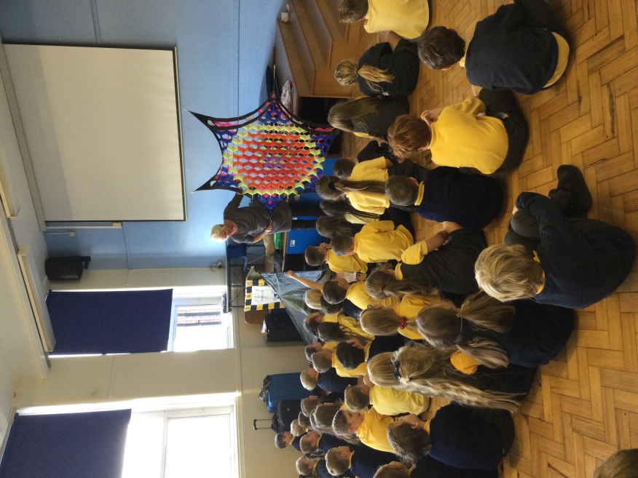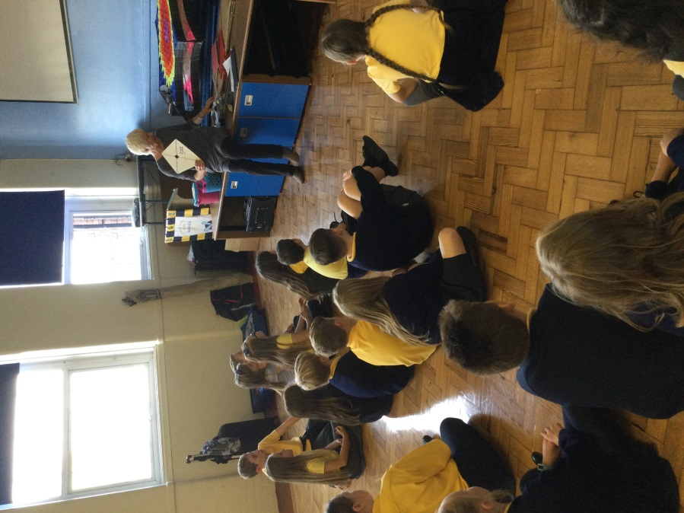
Oncec
Trip to North East Land, Sea and Air Museum
30 children across the school, who had shown an interest in the science of flight and careers in aviation during Take Flight week, were given an amazing opportunity to visit the North East Sea, Land and Air Museum! They learned about different types of RAF aircrafts and careers, explored different Army vehicles and even made their own model helicopters. All the children loved getting to stand beneath the Vulcan aircraft, which was huge! They even found a model of Claude Alward Ridley, who was actually from Fulwell!
