GOOD PLACES TO GO ON HOLIDAY.
TURKEY!
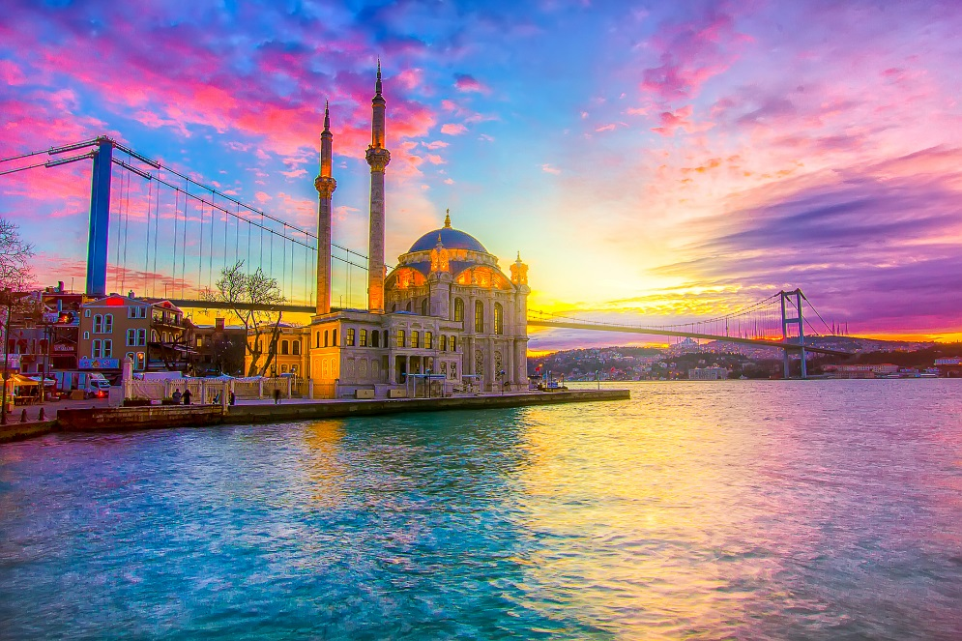I would like to go here because it will be really hot and get a sun tan.
SPAIN’S BEACH!
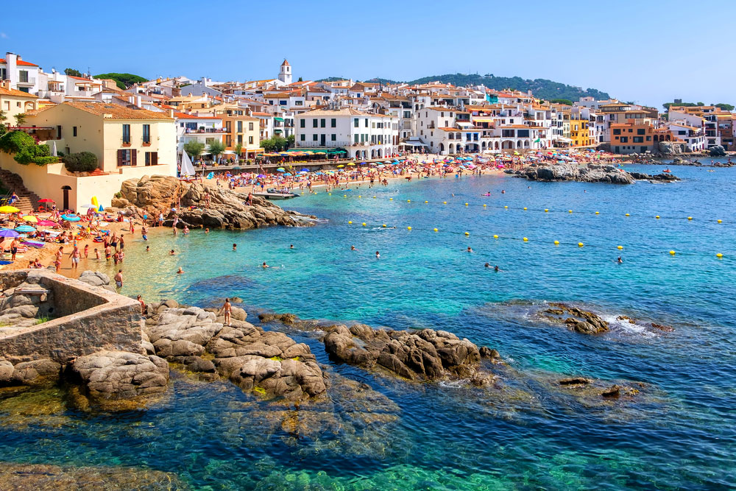 Iwould like to go here because I would like days out at the beach going swimming and building sand castles.
GREECE!
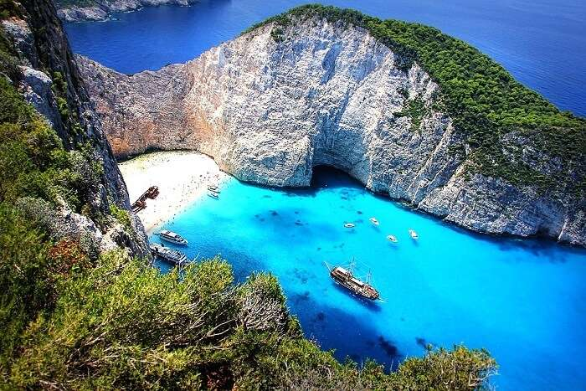
I would like to go to Greece to go and jump off clifs and jump into the water and go on a boat that has a water slide or a cruise.
ITALY!
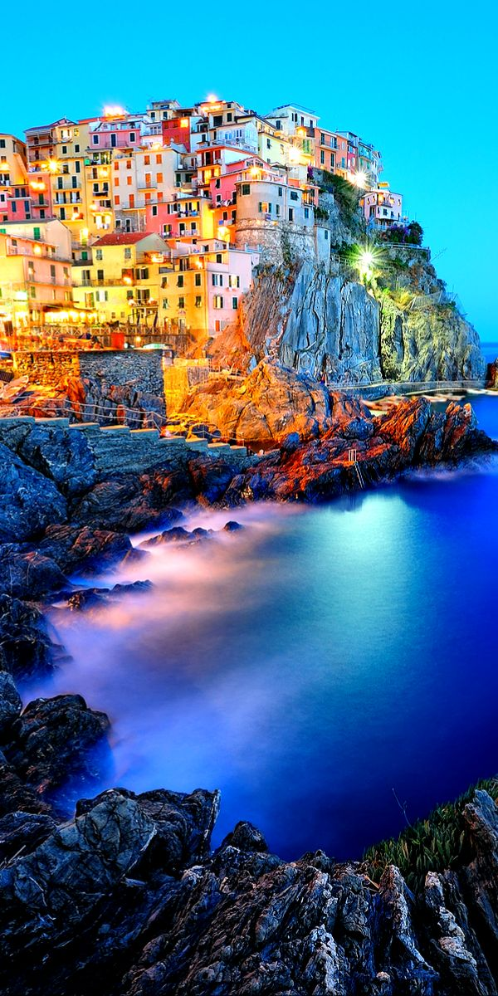Iwould liketo go here because I like the view and the scenery looks really nice and I have never been to live in a house in Italy.
FRANCE!
I would like to go here to see the team PSG play a football match live and I would like to come here for to go up the Eiffel tower and go to Disney land.

