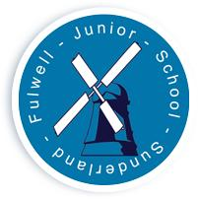
FULWELL JUNIOR SCHOOL

Sea Road

Fulwell
Sunderland

SR6 9EE

Tel : 0191 549 3333

Web: www.fulwelljunior.co.uk

E-Mail : Fulwell.junior@schools.sunderland.gov.uk

Head Teacher : Mr Peter Speck

Chair of Governors : Mr Ben Young
______________________________________________________________

Respect Aspire Achieve – Be the best that you can be

04.10.22

Spooktacular!

Dear Parent

Halloween is coming to Fulwell Junior School early this year. On Friday 21st of October children are invited to come to school in fancy dress (optional) to enjoy a fun filled day of Halloween themed lessons and activities. Please note that fake weapons e.g. knives etc., fake blood and masks are discouraged.

As an extra spooky treat children will receive a Halloween themed biscuit from our lovely school kitchen staff in the afternoon session of the school day. Please note, if your child has any food allergies can you please inform the school office asap.


Thank you

Miss Cook

