Hill climb racing 2
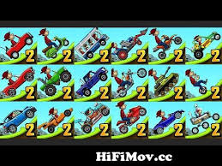
In hill climb racing 2 there are lots of vehicles.
Once you start playing you will get a tutorial that tells you how to drive and keep your balance while doing it. Once you get the hang of it you will compete in tournaments and unlock new vehicles and soon become legendary. Hold on and fasten your seatbelt your destination is set.

