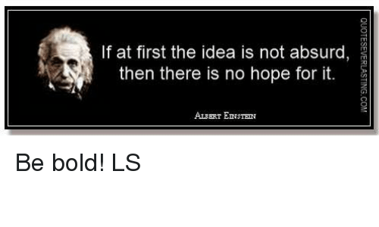

On Monday 14th February, all children will take part in an engineering enrichment day:

**‘If you were an engineer, what would you do?’**

We would like children to have the opportunity to **consider** this question and **discuss** it at home with friends and family over the course of this week.

Children should **observe**, watch people’s **habits**, look for **patterns**, decide what people are grumbling about or having **difficulty** with.

**Talk** to people and find out what day-to-day activities they find frustrating.

During next week’s session, children will have the opportunity to think of a **problem** and design a **solution**. This is part of a national competition called the ‘Primary Leaders’ award. We are hoping to enter children across all year groups for their innovative **engineering** ideas.

*If you’re idea seems a little crazy, maybe you are on to something incredible!*

**Key** – think about the grumpy grandad: *‘If necessity is the mother of invention, grumpy grandad could be her closest relative!’*

Think about the everyday things that people complain about. Such as: how things work, how we travel, how we eat/drink. The idea is to listen, observe and solve.