JARROW HALL

WHAT WAS LIFE LIKE IN THE ANGLO-SAXON ERA? In Jarrow hall we met Catherine, who told us what we needed to know. We were all fizzing with excitement!
First she showed us the cows, they plough and you can use them for leather clothes and paper for monks. Pigs are useful for the meat like bacon, ham, pork and gammon. Ducks are useful for quills, pillow /mattress, meat. Goats are for milk and drinking horns and sheep are for wool.
Next, we told stories and riddles around the fire, this was my favourite bit of the trip because it was dark and mysterious as the only light was the light of the fire.
Finally, we made an amulet out of Anglo Saxon runes. Catherine gave us an illness and we tried to heal them. After that, we held Anglo Saxon chainmail, sword, spear, helmet and shield.
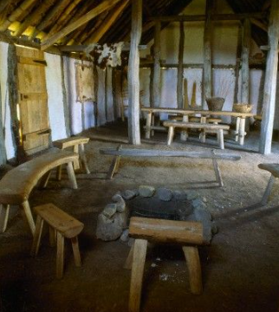
Over all I learned
a lot.

