Jokes of the week!

Knock knock
Isabel
Isabel who
Isabel not working
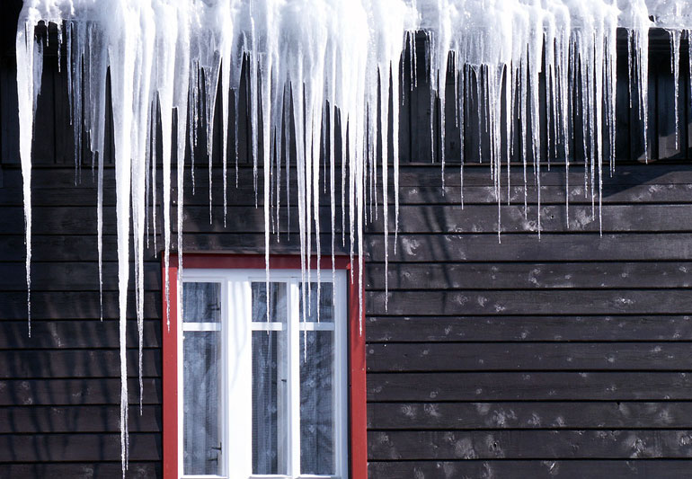
Knock knock
Who’s there?
Icy
Icy who
Icy you there

Why is a koala not a bear?
Because it doesn’t have the right koalafications

