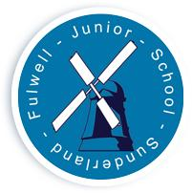
FULWELL JUNIOR SCHOOL

Sea Road

Fulwell
Sunderland

SR6 9EE

Tel : 0191 549 3333

Web: www.fulwelljunior.co.uk

E-Mail : Fulwell.junior@schools.sunderland.gov.uk

Head Teacher : Mr Peter Speck

Chair of Governors : Mr Ben Young
______________________________________________________________

Respect Aspire Achieve – Be the best that you can be

Fulwell Junior PTA
Logo Competition

Dear Parents/ Carers,
Welcome back to our final half term of the year! Before the half term holiday, the school’s newly formed PTA met for the first time and began planning our very first event (letter to follow soon) and wanted to get our children involved from the very beginning.

This week, your child will have had a discussion in class about what a PTA is and what they do. They will have also been given the opportunity to begin to design and create a logo for our PTA. This will be a logo that will be used for any events that we hold. It needs to be easy to identify, bright and colourful and represent our wonderful school and community.

All children that wish to enter this competition will need to hand their designs to Miss Birch by Thursday 8th June. The PTA will then choose a final 4 entries and the responsibility will then be in the community’s hands. We will be running a poll on our school’s Instagram and twitter account as well as the school website to decide on our final design. The child with the winning design will receive a prize as well as the other finalists.

If you have any questions, please contact the school office.

Thank you for your support,

Fulwell Junior School PTA

