PICTURS OF BOXER DOGS!!!
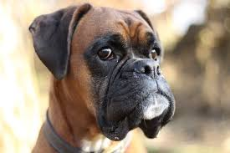
I HAVE A BOXER DOG HER NAME IS ELSIE.

