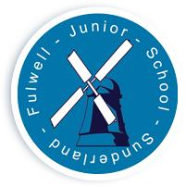**FULWELL JUNIOR SCHOOL :**

**DERWENT HILL PHOTOGRAPHY/SOCIAL MEDIA STATEMENT**

**Residential Visit : 17th June- 21st June**

**Name of Child………………………………………………………………………………………… Class……………………….**

* I give permission for FJS staff to take photographs of my child whilst at Derwent Hill and for the images to be sent back to the school office;
* I agree to the images being used on the school website.
* I agree to the images being used on the schools social media platforms.

Signed………………………………………………………………………………..

Relationship to child:………………………………………………………..

**Important Information – Please read before signing:**

Due to the location of Derwent Hill, the internet signal is often intermittent. We like to keep parents as informed of the day’s events and a photograph of the group will be uploaded on to the schools twitter account. Any other photos will be uploaded sporadically on the schools Instagram account and as a celebration a collage of photos will be collated after they return on a YouTube site.

By signing this agreement, the School assures parents that the images will be used ***ONLY FOR THE SPECIFIED PURPOSE*** whilst the children are at Derwent Hill and deleted immediately after transfer back to the school.

If any parents DOES NOT wish for their child’s image to be shared in this manner, or for the images to be used on the school website, please sign the disclaimer below.

* I **DO NOT** want my child to be photographed for the purposes of the school website.
* I **DO NOT** want my child to be photographed for the purposes of the social media platforms.

Signed…………………………………………………………………………. Relationship to Child…………………………………..