Shakespeare performance
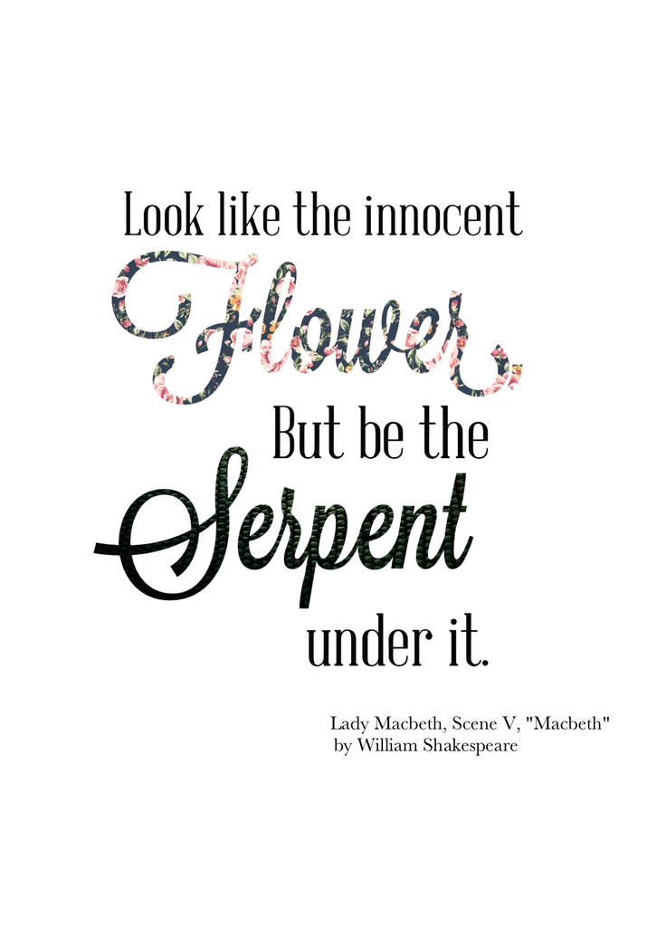
We were in a Macbeth performance and we were performing in front of 500 people we were very nervous but we did really well we loved everything about it . We had a lot of fun, we couldn’t have done it without the teachers helping us.
I was the role of Malcom the king’s son my brother was Donalbane / my best friend Sophia. It was really fun we left school at 12:30 and we got there about 20 minutes later. It was really fun backstage because we could see all of the fun stuff people do it was a great experience!!!!!!
I was partners with joseph on the bus I drew in my book and joseph read his book backstage was really really good because there was a lot of costumes and we got face paint , not a lot of it though but I still loved it in there end I was KINGGG 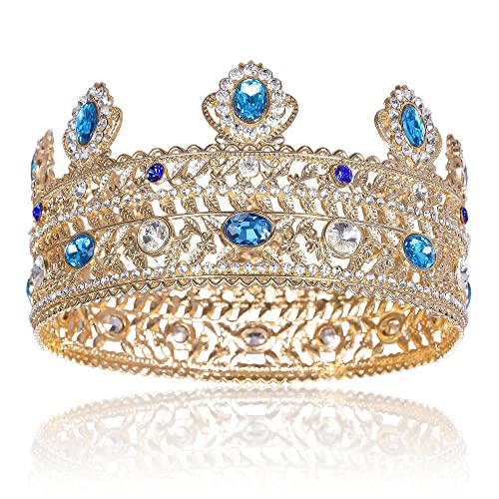I LOVED BEING KING !!!!!!!!!!!!!!!!!!!!!!!!
At the end

