The queen’s jubilee
The queen is 96 years old! And she has been in rein ever since she was 27 years old.
This is her now:
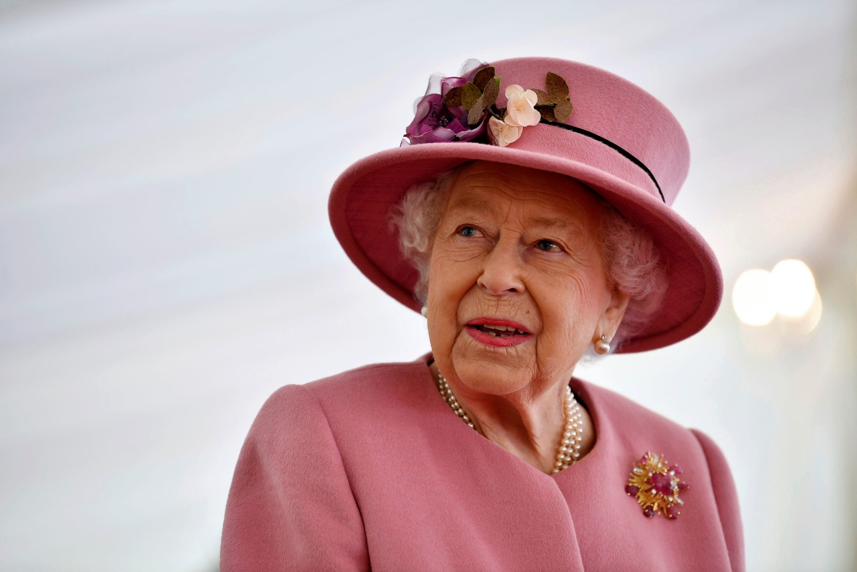
Verses her back then:

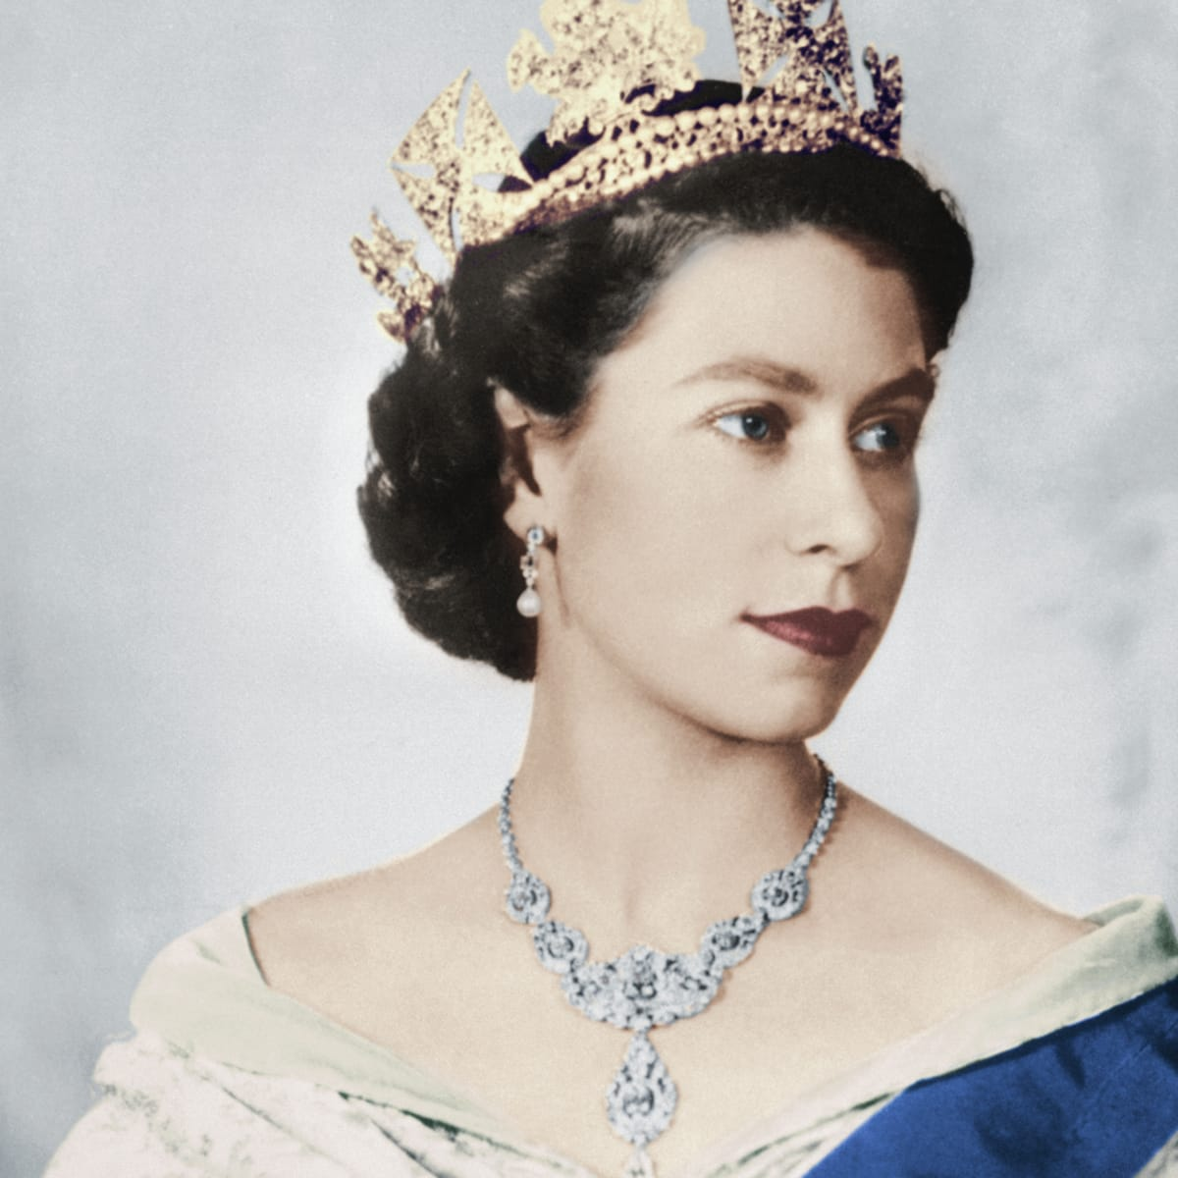
The queen has been in rein for 70 years! She is so close to beat the longest reigning monarch who is King Louis the 14 Th who was 72 years. The queens celebration for her platinum jubilee will started on the 2nd of June as she was crowned queen on the 2nd of June. People will celebrate by putting up bunting and wearing red, blue and white.
Hear at Fulwell juniors we are celebrating on Friday 27th
As we are going on our half term break. MAKE SURE YOU CELEBRATE!!!!

