The holiday I am going on in august is … gran Canaria
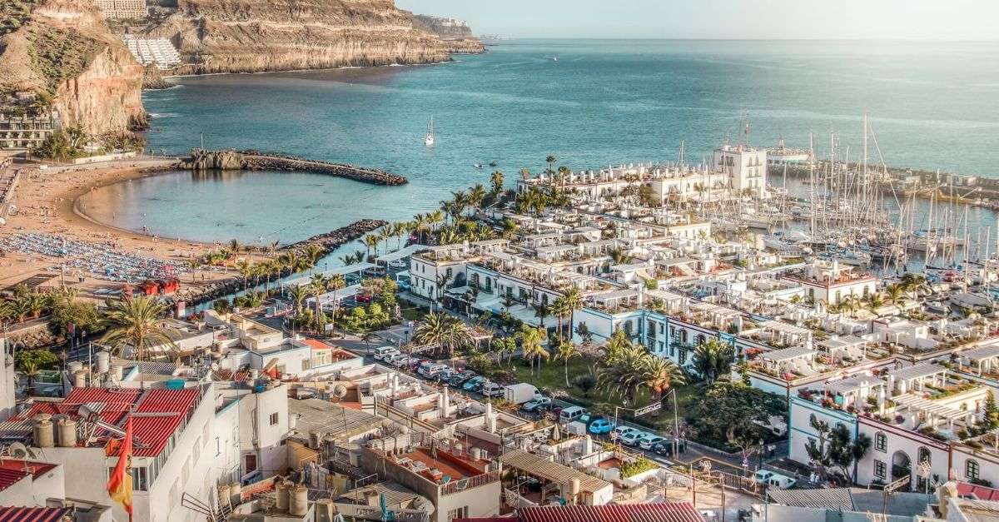 I have never been before but my parents have it seems amazing. It’s an island in Spain with loads of little houses in a village and has loads of lovely people. Also has loads of nice hotels, pubs and restraints. Like.
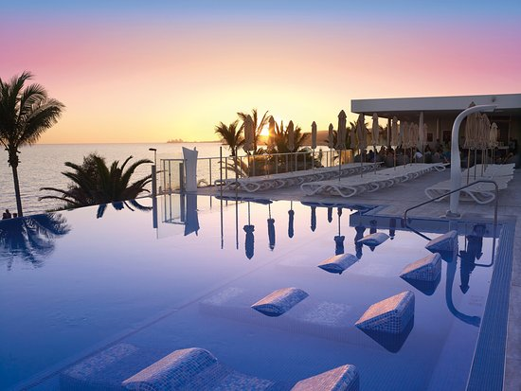
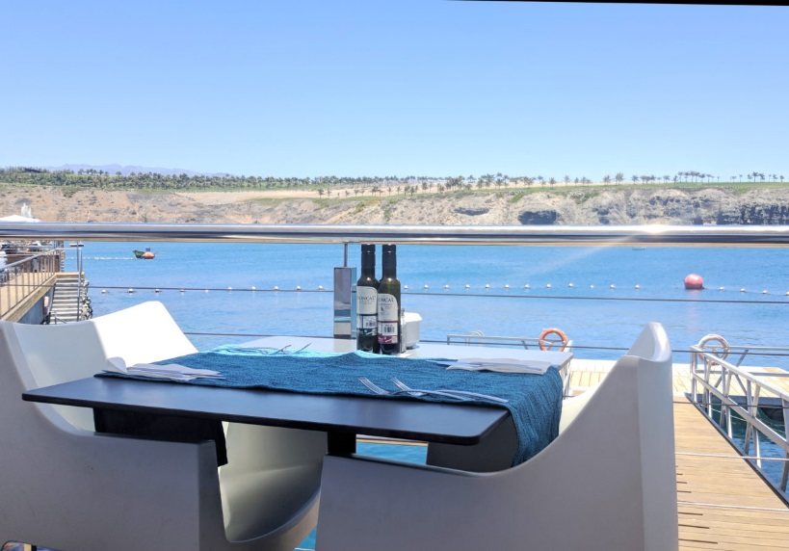these.

