Things to look forward to do at derwent hill
The Derwent Hill Experience
- canoeing.
- bushcraft.
- orienteering.
- rock climbing.
- mine exploration.
- orienteering.
- ghyll scrambling.
- a full day's hill-walk.

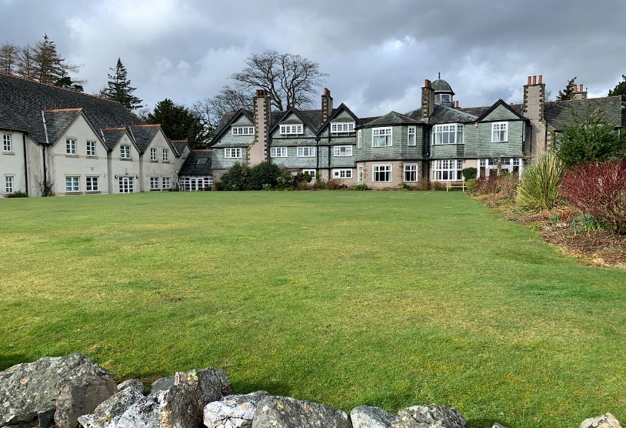
That was what it looked like from the outside but let’s have a look at the inside like the dorm rooms ,the food court and the down stairs were you will have fun on the night.
This is the one of the dorm rooms.
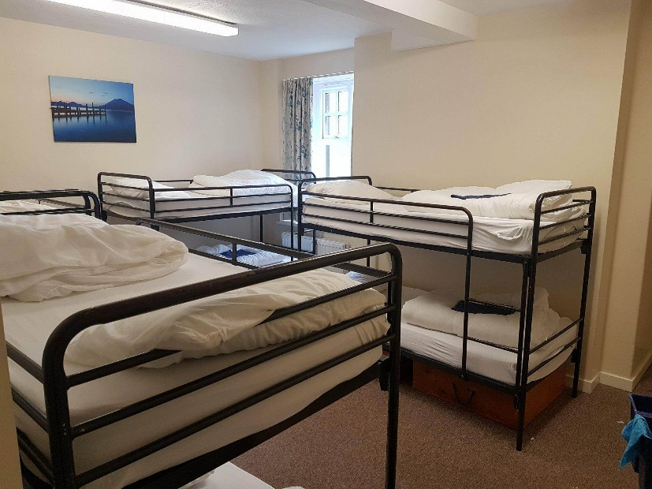
This is the food court.
This is the game room .
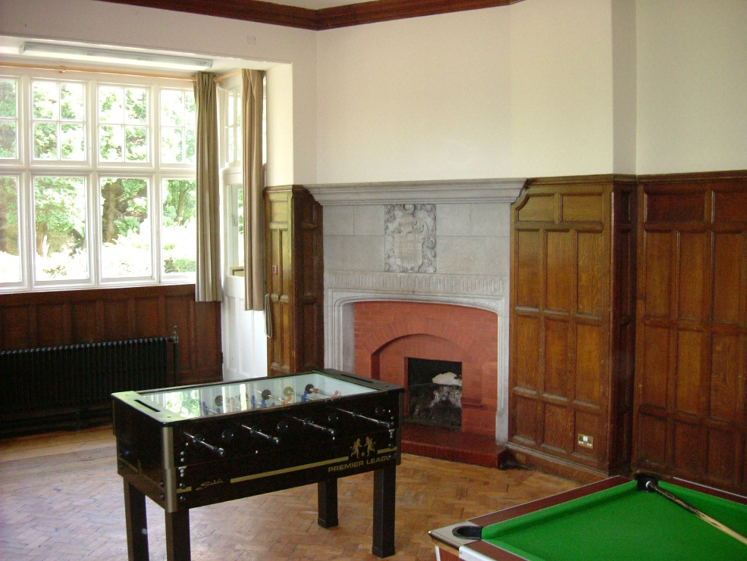
And the thing I’m most exited for is the … DEATH SWING APARENTLY ITS REALLY FUN AND SCARY BUT ITS ESPECIALLY FUNNY TO WATCH YOUR FRIENDS SCREAM THERE HEAD OF AND IF SOMEONE TAKES A VIDEO OF YOU AND YOU WATCH IT OVER. HAVE A GOOD DAY BYEEEEEEE .

