Video game info 2022!

Hello, video game lovers and it’s me Finley Ellis and Logan m and Welcome to video game info 2022!

Top games of 2022!

Adventures of Pip
3.5 Good
Tic Toc Games' Adventures of Pip is a side-scrolling, action-platforming game that has an interesting premise: evolving and devolving a pixel-based hero between his 1-bit and 16-bit forms to fight through level after level of goons and bosses. The unique premise, rich environments, and fun gameplay combine to form a title with a lot of heart and charm, despite the limited scope of its weapons and power-ups.
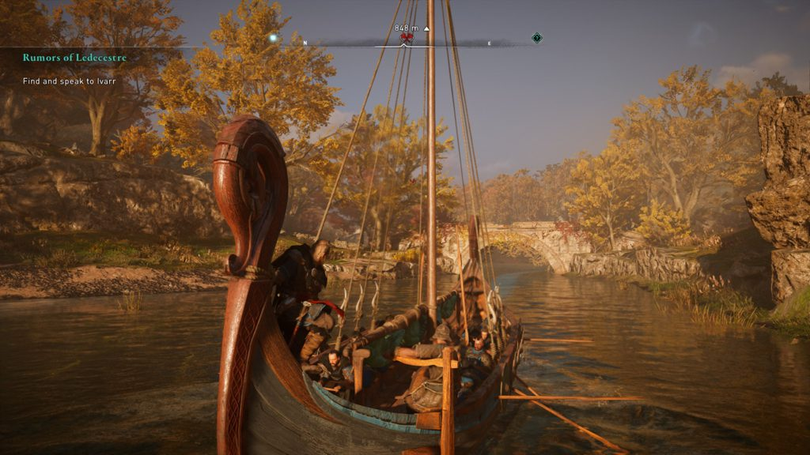

Assassin's Creed Valhalla
4.5 Excellent
The Assassin’s Creed series has taken us to numerous historical settings since its 2007 debut, including Ancient Greece, Renaissance Italy, and Revolutionary War-era America. The newest installment, Assassin’s Creed Valhalla, details the Viking invasion of 9th Century England from the perspective of history’s most notorious raiders. Though Valhalla doesn’t introduce anything wholly new to the series, it's an excellent PC game that follows in the footsteps of its equally exceptional predecessors, Origins and Odyssey.
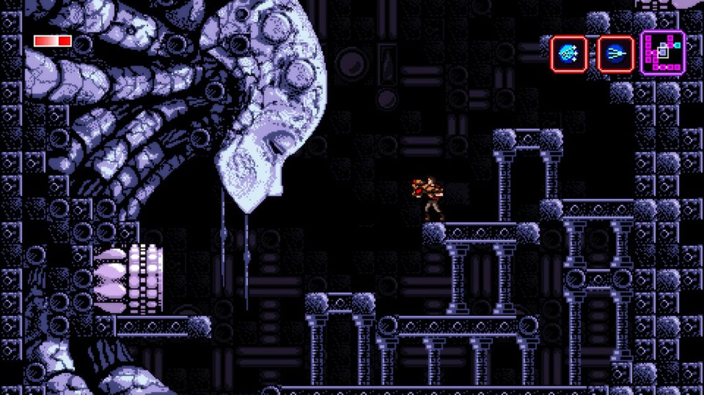

Axiom Verge
3.5 Good
Developer Tom Happ, who is known for his work on EA Sports' Tiger Woods PGA Tour and NFL Street franchises, has gone indie and crafted a delightful tribute to the exploratory action (AKA Metroidvania) genre. This 2D platformer combines the best aspects of classic side-scrollers like Castlevania: Symphony of the Night and Metroid to deliver a refined experience for newcomers of the genre and seasoned vets alike. Axiom Verge is a fun, engaging title, but plodding story elements and seemingly pointless weapons mar the experience a bit.
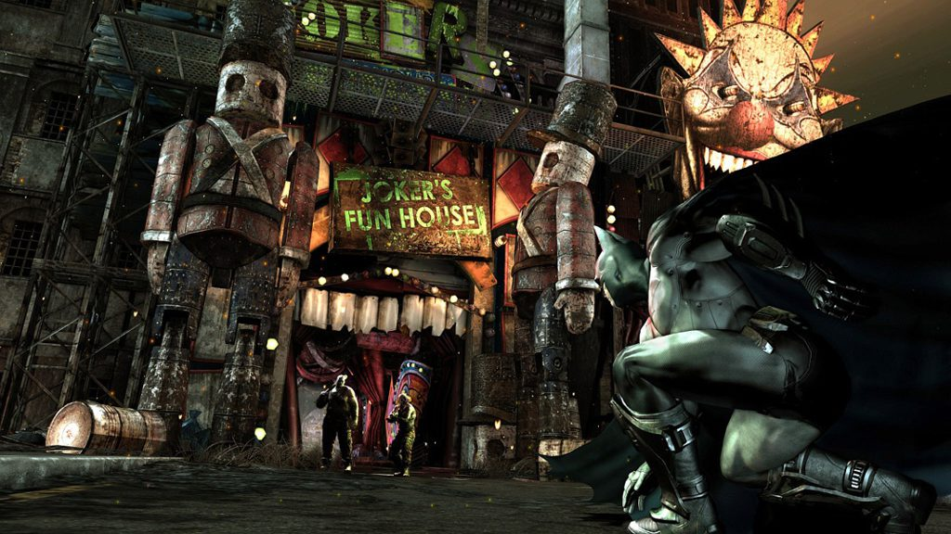

Batman: Arkham City
4.0 Excellent
"If you liked X, you'll love Y!" might be the cheapest of critical plaudits, but sometimes nothing else will do. So here goes: If you liked Batman: Arkham Asylum, you'll love Batman: Arkham City. Developer Rocksteady Studios borrows everything from Asylum that worked (thrilling fighting, excellent voice acting), though it delivers far less innovation. This makes Arkham City derivative, but the game's packed with enough goon-busting fun that it still stands as one of the PC's best action games.
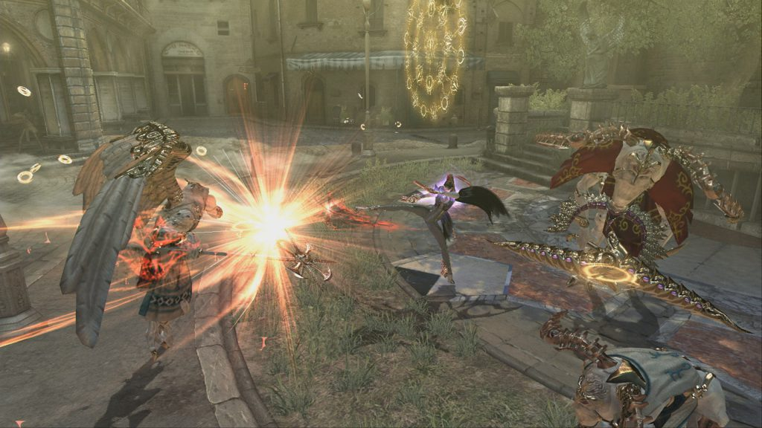

Bayonetta
4.5 Excellent
The original Bayonetta is one of the best action games ever made, and it easily stands alongside such genre classics as God Hand, Devil May Cry 3, and Ninja Gaiden Black. Bayonetta features explosive action, and it tests your combo prowess against every divine creature in the good book. Despite Bayonetta's poor PlayStation 3 performance, this PC port is excellent. It delivers the action at a rock-solid frame rate and a range of uncommon resolutions, which makes this version the definitive angel-slaying experience.
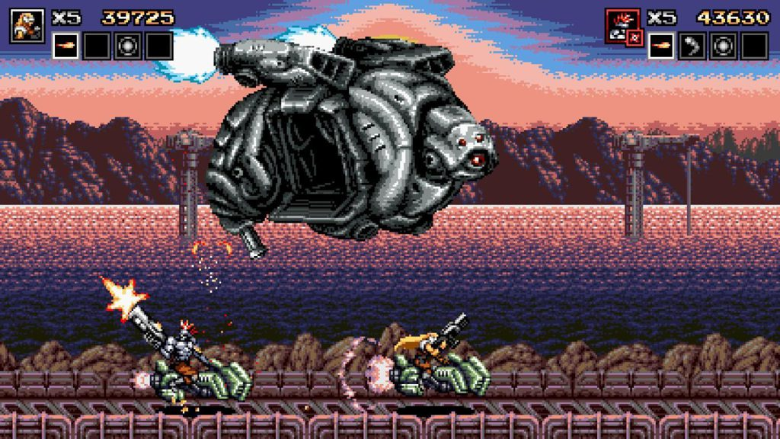

Blazing Chrome
4.5 Excellent
Simply put, the JoyMash-developed Blazing Chrome is one of the best run-and-gun shooters ever made. In its Terminator-like world, one wrecked by a robot apocalypse, you control characters toting high-powered weaponry designed to obliterate legions of mechanical enemies. Across the games' six stages you experience chunky explosions, wild multiplayer action, and hulking bosses. It doesn't do much to push the genre forward with fresh gameplay features, but Blazing Chrome's does nearly everything right.
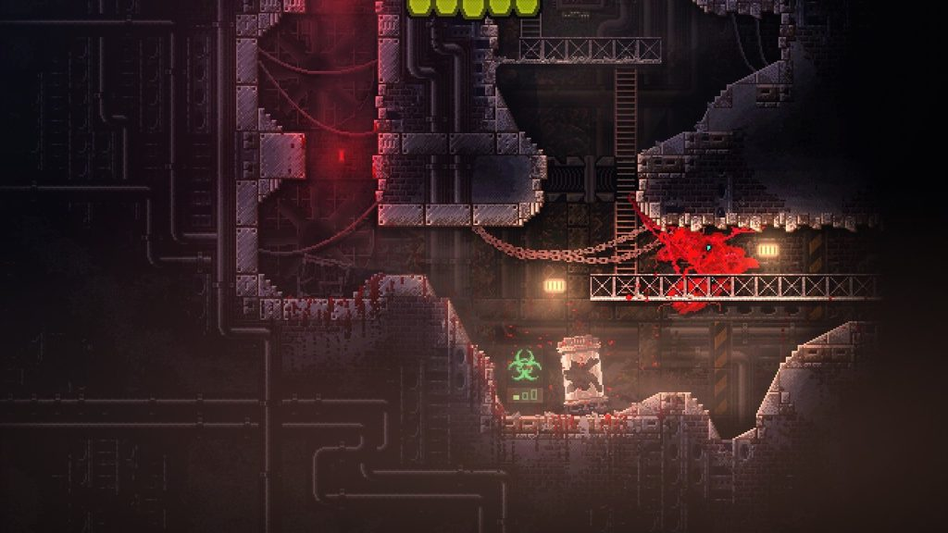

Carrion
4.0 Excellent
Carrion is a Metroid-like, 2D platformer published by Devolver Digital in which you play as a gruesome, alien parasite. That statement contains all the information you need to understand exactly how the PC game plays. There's the genre: Metroid-like 2D platformer. Then there's the subject matter: playing as a gruesome, alien parasite. Finally, there's the game's scope and style: published by Devolver Digital. In other words, Carrion is a wonderfully stylized, indie platformer with plenty of bloody violence.
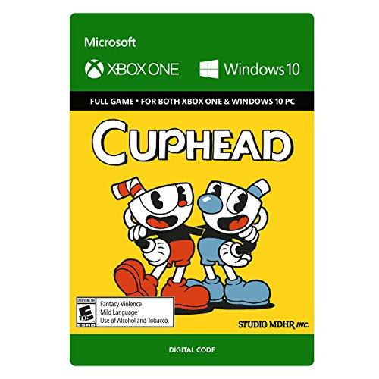

Cuphead
4.0 Excellent
Cuphead is a charming run-and-gun/shoot-'em-up hybrid that channels Konami's iconic Contra series, while also taking heavy inspiration from the rubber-hose animation style that was prominent during 1920s- and 1930s-era cartoons. If you're familiar with the Contra series' fast-paced gameplay, then Cuphead should be right up your alley. The titular protagonist and his brother Mugman must best a wide variety of perilous stages and bosses to complete their quest. Cuphead lacks the expansive level design featured in Contra and other genre classics, but the hardcore action game gives you a beefy list of complex and satisfying boss fights to overcome, in the style of Treasure's beloved Alien Soldier.
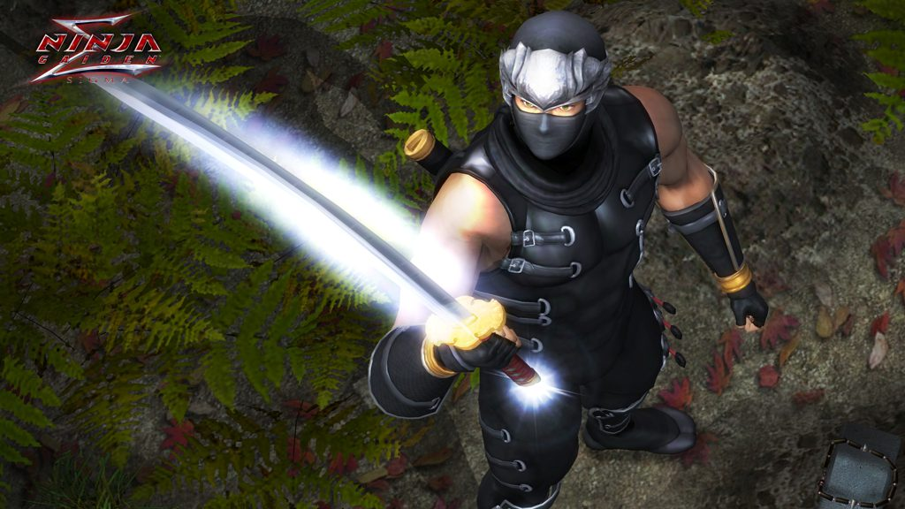

Ninja Gaiden: Master Collection (for PC)
3.5 Good
The Ninja Gaiden: Master Collection is a blend of great, decent, and disappointing elements. The collection includes Ninja Gaiden Sigma, Ninja Gaiden Sigma 2, and Ninja Gaiden 3: Razor’s Edge, remarkable action games featuring rich, thrilling combat mechanics. Unfortunately, the flaws present in the later games live on in this collection, with no real changes made to improve upon the framework. Worse, this bundle removes the games' multiplayer modes, and features meager performance-adjusting options. Series newcomers will enjoy the superb action, but veterans looking for these games' ultimate versions will be left wanting more.
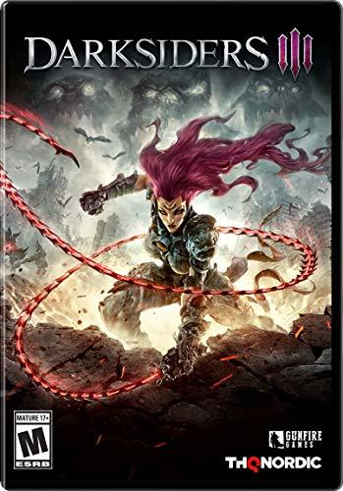

Darksiders III
3.5 Good
The Darksiders series, a creative reinterpretation of the Christian end-of-the-world scenario that follows the misadventures of the Four Horsemen of the Apocalypse, returns with a twist. With Darksiders III, you take control of the irate and unpredictable Fury who's tasked with capturing the Seven Deadly Sins. Armed with a barbed whip and wicked agility, Fury explores the ruins of the modern world and exterminates menaces in an interconnected, Metroid-esque environment. The combat system has a few annoyances, such as an unreliable camera and frustrating mobs, that hinder the experience. Still, Darksiders III is an enjoyable action game that you should play if the theme appeals to you.
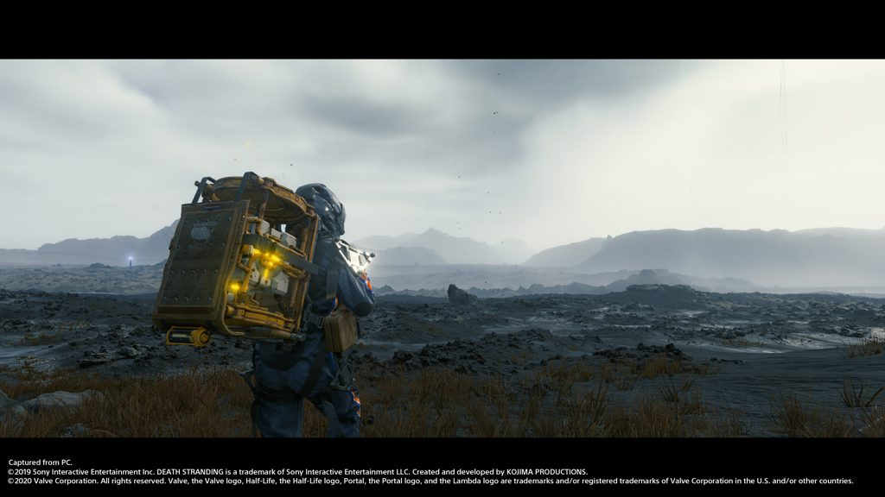

Death Stranding
3.5 Good
Death Stranding baffled PlayStation 4 owners who weren't quite prepared for a plot involving extinction, isolation, mortality, and humanity’s remnants trying to piece together a broken world. The controversial console game is now a PC game that sports enhanced graphics, platform-specific Half-Life themed missions, and a photo mode. Taking gameplay cues from the action, stealth, and survival genres, Death Stranding is a more daring affair than the typical mainstream video game title. After all, not many games feature a delivery person who fights flying whales one minute, and then discusses the afterlife with Guillermo del Toro the next. It's an odd, slow burn.
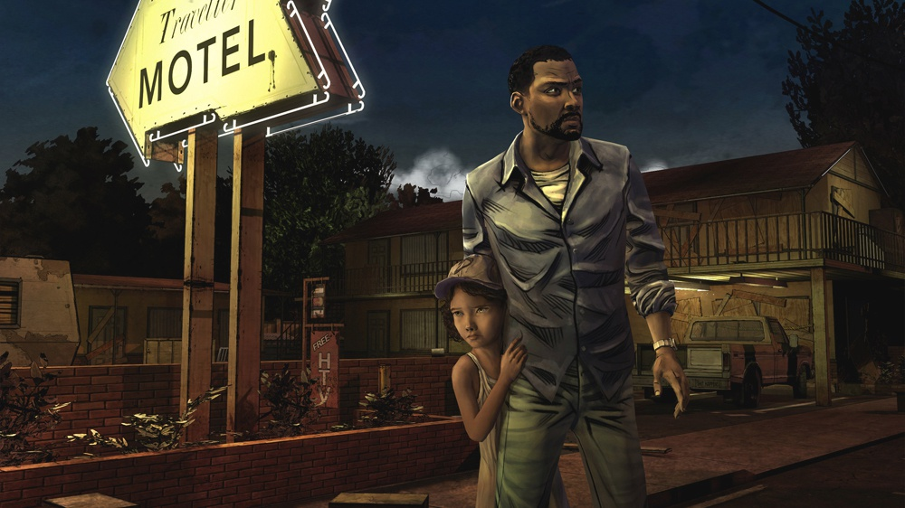

The Walking Dead: Episode 2 - Starved For Help
4.5 Excellent
The Walking Dead is back! After disappearing from digital marketplaces when developer Telltale Games went under, the touching and harrowing The Walking Dead returns to life courtesy of publisher Skybound Games. The choice-based adventure game puts you in the role of Lee, a former professor and convicted criminal who tries to survive a zombie invasion while safeguarding a young girl named Clementine. Keep some tissues close for the ending.
Please note that PCMag didn't review this new five-part series collection, but we did review chapter one and chapter two back when they were available individually.
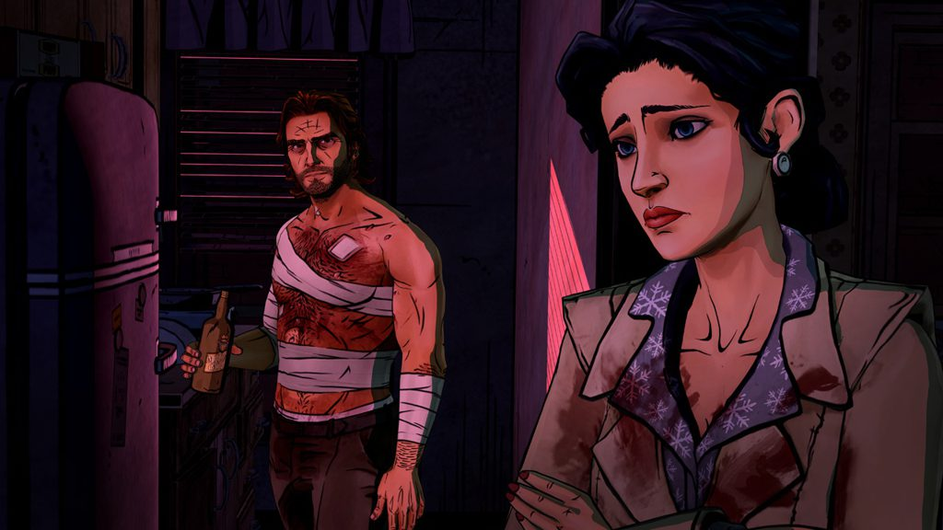

The Wolf Among Us (for PC)
4.0 Excellent
The Wolf Among Us, a game that's a canonical prequel to Bill Willingham's popular Fables comic book series, features a well-written story, light puzzle-solving challenges, and reflex-testing Quick Time Event (QTE) sequences. The visually striking title draws inspiration from film noir cinema, while keeping the heavy black outlines and bright colors associated with its source material. The murder-mystery isn't particularly challenging, but if you want to spend a few hours in an immersive world filled with interesting characters and top-notch voice acting, The Wolf Among Us should find a home in your PC gaming library.
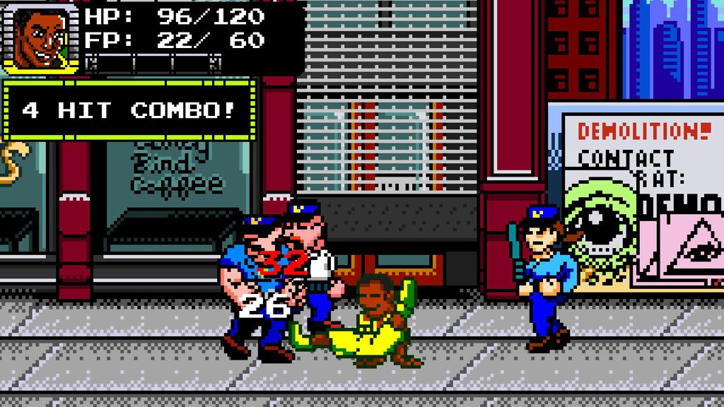

Treachery in Beatdown City (for PC)
3.5 Good
On the surface, Treachery in Beatdown City appears to be a strict homage to classic beat ‘em up games from the 1980s and 1990s. However, the brawler's menu-driven, tactical combo system and biting urban satire reveals a game that's radically different than what's come before it. Developed by Nuchallenger, Treachery in Beatdown City is a fun indie game that requires you to use your brain to battle the way through the gentrification elements that plagues a fictional city's streets, but its pace may prove too slow for traditional beat 'em up fans. Tactics fans, on the other hand, may dig it.
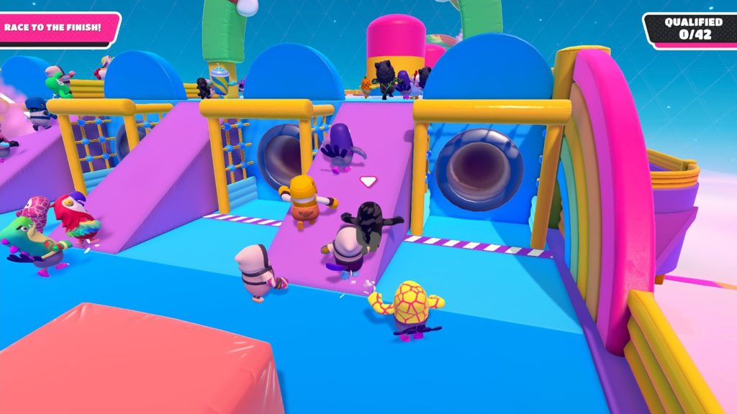

Fall Guys: Ultimate Knock Out
4.0 Excellent
Fall Guys: Ultimate Knockout, 2020's biggest surprise hit, is loads of chaotic, obstacle-course-navigating fun. The bright, cheery, game show-inspired title sees you bounce through candy-colored obstacle courses and take on other challenges, while competing against 59 online contestants. Beware the Big Yeetus!
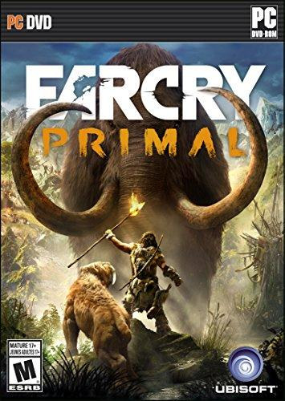

Far Cry Primal
4.0 Excellent
With Far Cry Primal, developer Ubisoft abandons all political pretenses and focuses on what made Far Cry stand out from its peers when the series debuted: the open-world sandbox. You play as a Stone Age hunter named Takkar, and your goal is to secure a safe haven for your people, the wandering Wenja tribe, in the prehistoric realm of Oros. Melee combat and beast companions set Primal apart from past Far Cry games and make exploration feel much more personal and engaging. Primal's story is simpler and more straightforward, so if you were hoping for eccentric villains and outlandish melodrama, you may be left a tad disappointed.

For Honor
3.5 Good
For Honor is a medieval-themed combat game has two faces. One is a splendid multiplayer blend of large- and small-scale battles. The other is a forgettable single-player campaign that unfortunately requires an online connection. However, For Honor's strategic combat—a resplendent combination of positioning, pacing, awareness, and timely opponent reads—gracefully lifts the entire package from the mediocre AAA bog that might otherwise have slid into.
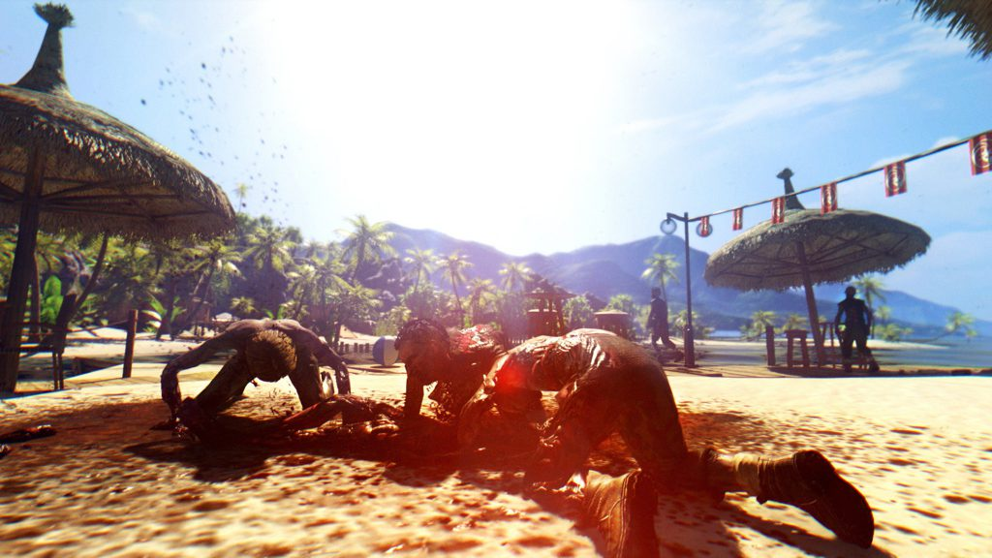

Dead Island (PC)
3.5 Good
When Techland's Dead Island trailer debuted, it featured one of the most moving video game sequences ever produced: a small child and her family being slaughtered by zombies against the backdrop of a soft, haunting Giles Lamb musical score. Dead Island's gameplay doesn't quite match the trailer's promise, but the open-world action-RPG offers a very solid zombie-slaying good time as you craft weapons and try to stay alive in an island paradise gone wrong.
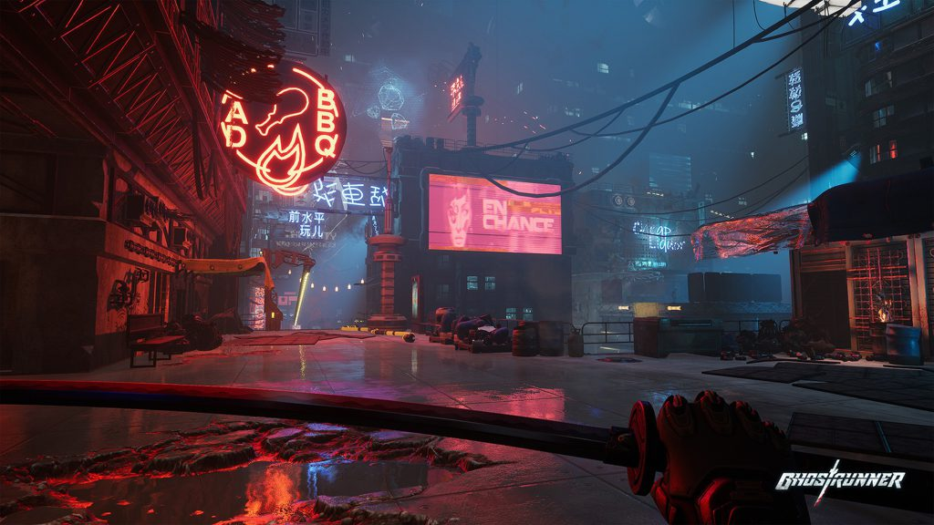

Ghostrunner
3.5 Good
Video games love cyberpunk. The medium excels at exploring the chaos of a society where corporations and technology run rampant. Cyberpunk: 2077 and Watch Dogs: Legion delivered cyberpunk with an open-world spin, but if you’re looking for something a little leaner and a lot meaner, try the beautiful and brutal Ghostrunner. This first-person action game has a punishing difficulty level that may turn off many people, but hardcore gamers will eat up its fast, ninja-like action.
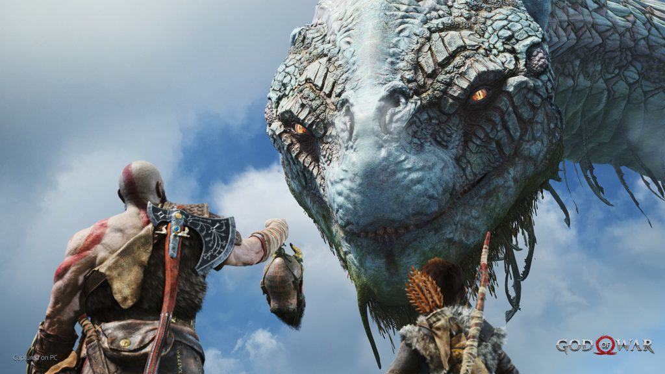

God of War
4.0 Excellent
Kratos, one of the highest-profile PlayStation characters, brawls his way into new territory: the PC. With his son by his side, an older, reflective Kratos ventures into the Norse realms to spread his deceased wife's ashes and honor her last wish. Naturally, the god slayer encounters a new pantheon, and must return to bloody combat. This PC version doesn't add much to the base console game, but it includes many, useful graphics options.
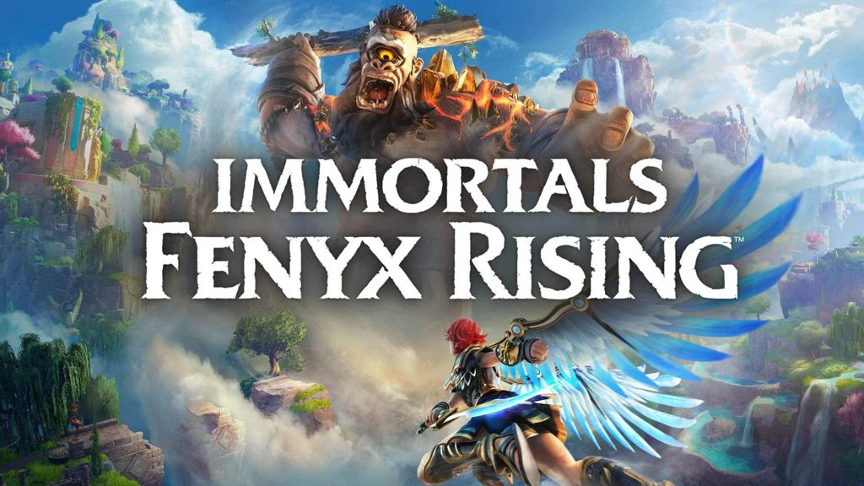

Immortals Fenyx Rising
4.0 Excellent
Immortals Fenyx Rising is the best game that publisher Ubisoft released in 2020, despite being shoved into the holiday season behind its bigger siblings, Assassin’s Creed Valhalla and Watch Dogs: Legion. Developer Ubisoft Quebec pivoted from Assassin’s Creed's massive quest to a shorter action-adventure game, a move that helps this story of Greek gods and monsters shine brighter. Immortals Fenyx Rising is a PC game forged from the pieces of other titles, notably Assassin’s Creed Odyssey and The Legend of Zelda: Breath of the Wild, but it excellently establishes its own identity.
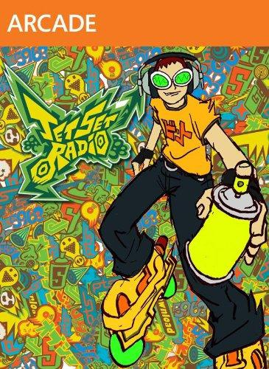

Jet Set Radio
4.0 Excellent
In 2000, Sega gave us a look into the future of funk with Jet Set Radio, a cel-shaded action game that starred a cute band of rollerblading miscreants who tagged walls, battled rival delinquents, and avoided out-of-control cops. This updated PC version flexes high-definition graphics, developer interviews, and all the bells and whistles you'd expect from a Steam game. Dripping in manga-influenced hip-hop flavor and boasting one of the greatest soundtracks ever crafted for a video game, the grind-happy Jet Set Radio is a title that belongs in the library of anyone who digs fast-paced action games, incredibly catchy tunes, and street culture.

Katamari Damacy Reroll
4.0 Excellent
PlayStation 2 gamers likely remember how difficult it was to avoid the hype surrounding Katamari Damacy. Publisher Namco Bandai's action-puzzle game tasked you with rebuilding a destroyed cosmos, and went on to become a sequel-spawning hit, thanks to its addictive gameplay, charming graphics, and amazing score. The delightful original game has now been given the remaster treatment with Katamari Damacy Reroll, a game featuring updated graphics and keyboard support. Katamari Damacy Reroll delivers the same whimsical enjoyment as the original did in 2004, but with the addition of a new coat of paint that makes this PC game one you should not miss.
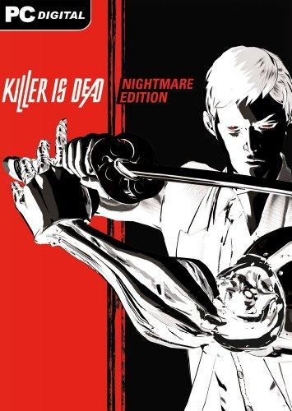

Killer Is Dead: Nightmare Edition
3.5 Good
Goichi Suda (aka Suda51) is the Robert Rodriguez of the video game industry. The Japanese developer crafts projects noted for their style, edginess, and violence, but once you peep beneath the cool veneer, the work is exposed as a somewhat empty, if fun, experience. Such is Suda51's Killer Is Dead: Nightmare Edition, a Steam game that stars a cybernetically enhanced assassin named Mondo Zappa who slays vampires, mystics, and other monstrosities for a government agency. Killer Is Dead is dripping with Suda51's trademark humor, character swag, and fast-paced action, but it lacks the killer level design and supporting elements that would elevate the game to the top of its genre.
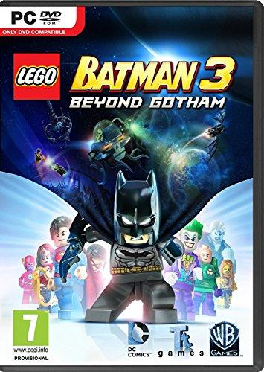

Lego Batman 3: Beyond Gotham
3.5 Good
TT Games's Lego Batman 3: Beyond Gotham squeezes in a lot of DC Comics fan service and silliness, while maintaining a whimsical and simplistic approach to its action and story. Whether it's the subtle 1978 Superman theme that plays when the caped do-gooder is flying, or Nightwing reminiscing about his sidekick days while compulsively spewing "holy" exclamations, Lego Batman 3 is so filled with Easter eggs that it feels like a love letter to all of DC Comics. The gameplay doesn't deviate much from the familiar Lego formula, but the experience is solid, nonetheless.
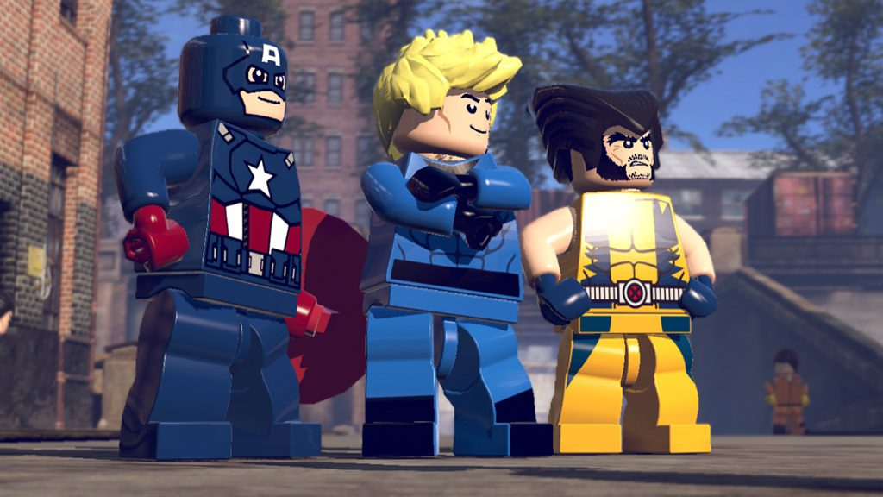

Lego Marvel Super Heroes
4.5 Excellent
Lego Marvel Super Heroes is a near-perfect blend of three wonderful childhood staples: comic books, video games, and, well, Lego. Steeped in Marvel Comics goodness, Lego Marvel Super Heroes puts players in the role of superheroes—including the Avengers, Fantastic Four, and Spider-Man—who are tasked with recovering all-powerful Cosmic Bricks before top-tier baddies such as Loki, Dr. Doom, and Magneto get their hands on them. The open-world game features fun brick-bashing action and light puzzle challenges.
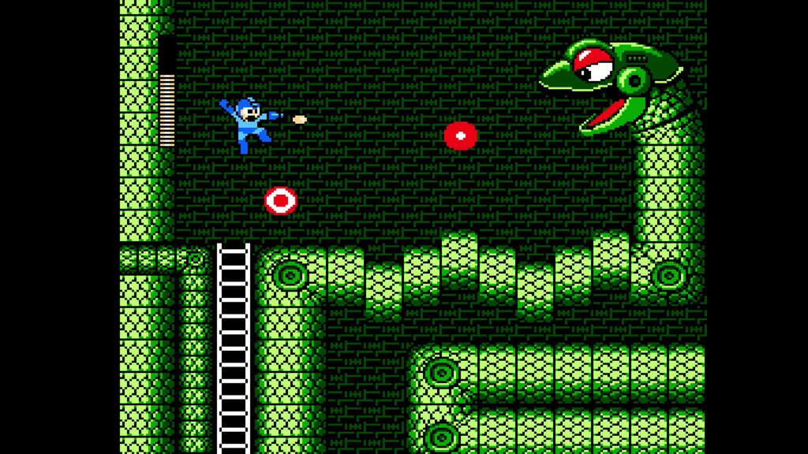

Mega Man Legacy Collection
4.5 Excellent
Capcom, in collaboration with Digital Eclipse, revisits Mega Man's past with a package that does the original six NES Mega Man games justice. Besides featuring high-definition versions of the classic 8-bit games, the collection contains new trial challenges, leaderboards, video replays, and developer art. It's one of the best retro compilations around. Besides the recent Rare Replay, Mega Man Legacy Collection is the closest to a video game equivalent of the Criterion Collection the medium has seen. If you're a Mega Man fan, consider this a must-have collection.

Mega Man Legacy Collection
4.5 Excellent
Capcom, in collaboration with Digital Eclipse, revisits Mega Man's past with a package that does the original six NES Mega Man games justice. Besides featuring high-definition versions of the classic 8-bit games, the collection contains new trial challenges, leaderboards, video replays, and developer art. It's one of the best retro compilations around. Besides the recent Rare Replay, Mega Man Legacy Collection is the closest to a video game equivalent of the Criterion Collection the medium has seen. If you're a Mega Man fan, consider this a must-have collection.

Metal Gear Rising: Revengeance
Konami's Metal Gear Solid series is known for its stealth-based gameplay, but its spin-off, Metal Gear Rising: Revengeance, is a straight hack-and-slash action game starring stooge-turned-badass, Raiden. Developer Platinum Games bundles the game with numerous goodies not associated with the original console version, including graphical enhancements and three DLC packages that were separate console purchases—all at a reasonable price. In short, if you liked the console version of Revengeance, you'll dig this one, too, despite the occasional rough camera angle and frame rate drop.
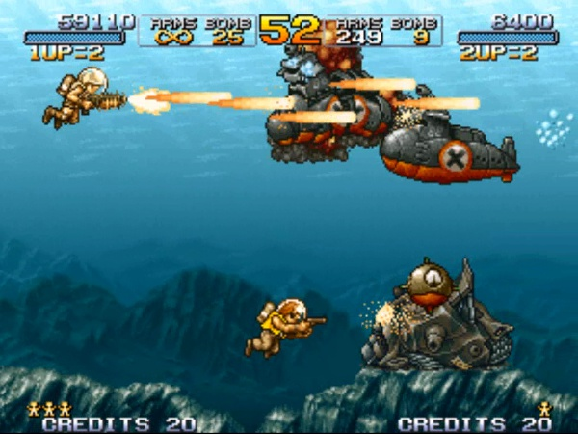

Metal Slug 3
4.5 Excellent
Run-and-gun video games have a long history of thrilling fans with high-octane, shoot-everything-that-moves action, but few do it better than SNK's Metal Slug 3. Originally released to the Neo Geo platform in 2000, the acclaimed Metal Slug 3 has appeared on nearly every console and handheld since then—and now it's available for PCs. In this title, you control adorable, armed-to-the teeth soldiers who defend Earth from an alien invasion using guns, rocket launchers, and the eponymous Metal Slug tanks. Metal Slug 3 is a genre masterpiece due to its charming (and hyper-violent) cartoony graphics, tough-as-nails challenges, creative weapons, and varied level design.

Ninja Gaiden: Master Collection
3.5 Good
The Ninja Gaiden: Master Collection is a blend of great, decent, and disappointing elements. The collection includes Ninja Gaiden Sigma, Ninja Gaiden Sigma 2, and Ninja Gaiden 3: Razor’s Edge, remarkable action games featuring rich, thrilling combat mechanics. Unfortunately, the flaws present in the later games live on in this collection, with no real changes made to improve upon the framework. Worse, this bundle removes the games' multiplayer modes, and features meager performance-adjusting options. Series newcomers will enjoy the superb action, but veterans looking for these games' ultimate versions will be left wanting more.
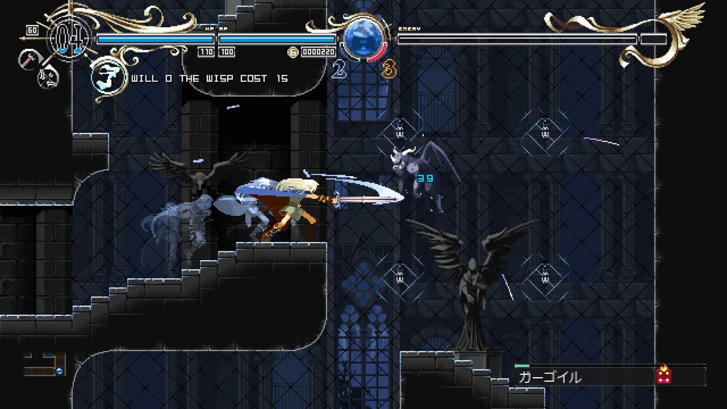

Record of Lodoss War: Deedlit in Wonder Labyrinth (for PC)
3.5 Good
At a glance, Record of Lodoss War: Deedlit in Wonder Labyrinth shares much in common with Konami’s classic Castlevania: Symphony of the Night. The games are similar, visually and tangibly, which is great if you’re looking to fill the undead-slaying void that Konami left behind once the developer shelved the Castlevania franchise. Wonder Labyrinth features excellent 2D visuals, tight controls, and clever element-swapping mechanics that expands the combat and exploration. The action-RPG is a bit short due to its linear progression, but the PC game is a satisfying Castlevania homage that tweaks the gameplay enough to feel fre

6. The Legend of Zelda: Breath of the Wild 2

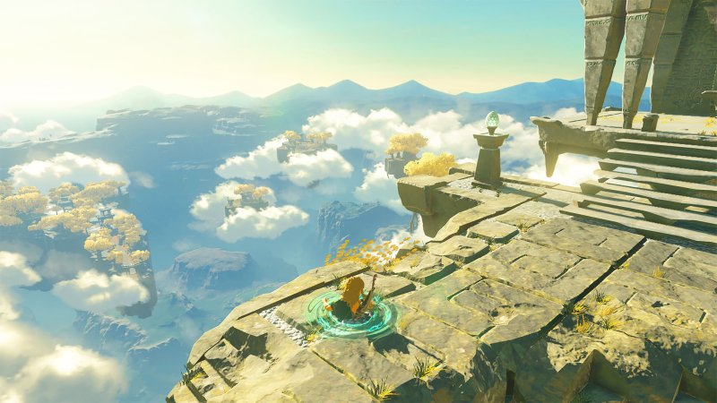

TBA on Nintendo Switch
We have arrived at the yet-unnamed Breath of the Wild sequel, whose predecessor was perhaps the most influential, groundbreaking and popular video game to debut in the last decade. Do I really need to pitch you on this? It picks up right where the last one left off. The open world is even bigger. Yada, yada, yada. You already know you’re buying this game if you own a Switch

5Hogwarts Legacy

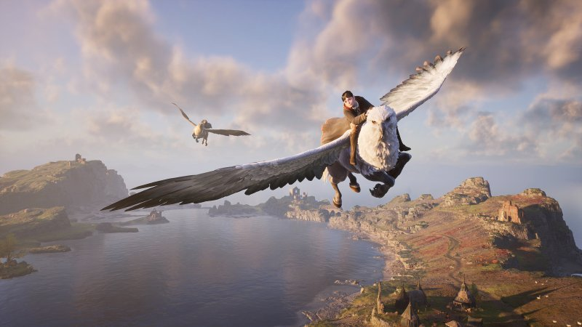

TBA on PlayStation 5, Xbox Series X|S, PlayStation 4, Xbox One and PC
I have personally been waiting 20 years for a playable Harry Potter game. Not even good. Just playable. And this latest attempt at a game based on J.K. Rowling’s universe has suffered its fair share of controversy, from one of the lead developers defending the misogynistic #gamergate movement to Rowling’s own anti-trans rights comments. That developer departed the game, and the creators who were left leaked to Bloomberg that the game will have a transgender character option. Now finally, finally millions of Potter fans will be able to design their own character, submit them to the sorting ceremony, and take classes at Hogwarts. The open-world adventure game is set in the 1800s, and beyond attending Transfiguration classes and petting your owl, you’ll get to decide whether you dabble in dark magic. You presumably can fight to protect Hogwarts or join up with the 1800s equivalent of the Death Eaters.

4.Boneworks! Boneworks is considerably one of the BEST VR GAMES ever! Boneworks is a 2019 virtual reality game developed and published by Stress Level Zero. It was developed using the Unity engine and supports all PC-compatible VR headsets. It was released on Windows on December 10, 2019, sold on Steam.
Initial release date: 10 December 2019
Developer: Stress Level Zero
Engine: Unity
Composer: Michael Wyckoff
Publisher: Stress Level Zero
Genres: Virtual reality, First-person shooter, Action-adventure game, Simulation Video Game, Fighting game
Platform: Microsoft Windows

3.grand turizmo 7-is a fast paced driver with stunning graphics

Gran Turismo 7 is a 2022 sim racing video game developed by Polyphony Digital and published by Sony Interactive Entertainment. The game is the eighth mainline installment in the Gran Turismo series.
Initial release date: 4 March 2022
Mode: Multiplayer video game
Developer: Polyphony Digital
Publisher: Sony Interactive Entertainment
Series: Gran Turismo
Platforms: PlayStation 4, PlayStation 5
Genres: Sim racing, Sports Video Game, Vehicle simulation game

2. Olliolli world.

Olliolli world is fast-paced and a bit of a challenge to celebrate skateboarding and the skateboarding culture. This game is goofy, funny and silly but also very hard; to excel, you must master precision based flicks and button presses that put your gaming skills to the test.

1. Nobody saves the world.

Nobody saves the world is a fun, bizarre little video game, all about shape shifting-unlocking new powers to build yourself into the perfect weapon for the job or an extremely specific tool needed to solve a single puzzle. It’s about exploration and experiment and is just silly, interesting and deeply clever.

Some of our favourite games also deserved to be mentioned including:

Undertale, Minecraft, Roblox, Fortnite.

Anticipated games

1. Splatoon 3

2. ChooChoo Charles

3. Dune: Spice wars

4. God of war Ragnarok

5. Goodbye volcano high

6. Gotham knights

7. LIL devil inside

8. Lord of the rings: Gollum

9. Tunic

10. Redfall

The end

