What I think of some new football strips

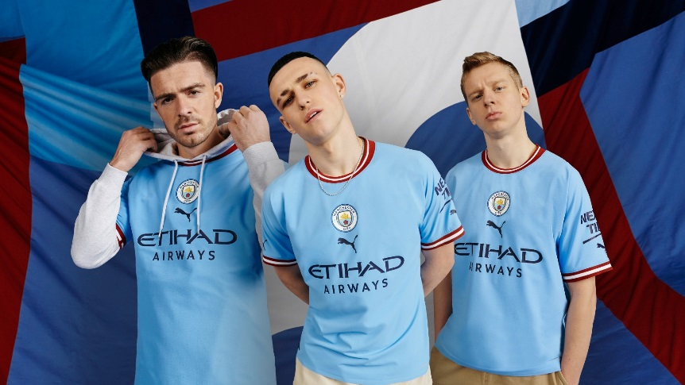I like this strip at first I wasn’t to sure if I liked it but I now love it.
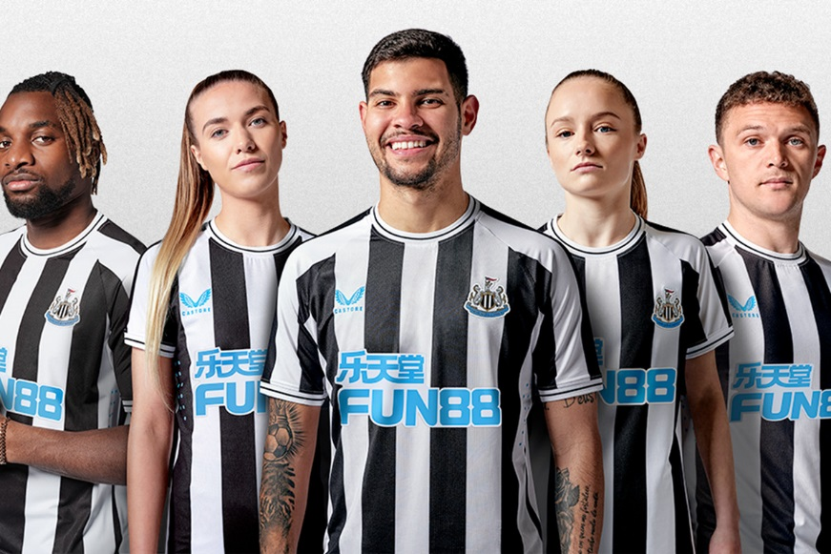I like this one butt I do not like how the castore badge is blue and not black.
I like this one I would bye this one because it looks nice on and I love the collar .
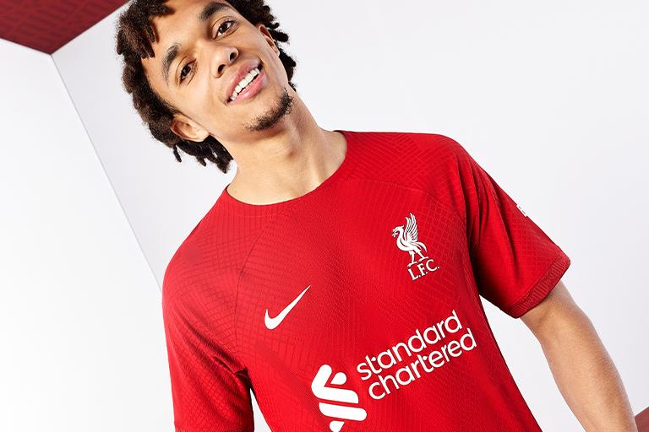I like this one because it’s a nice fit I like the pattern of it and it is really basic and that’s what I like.
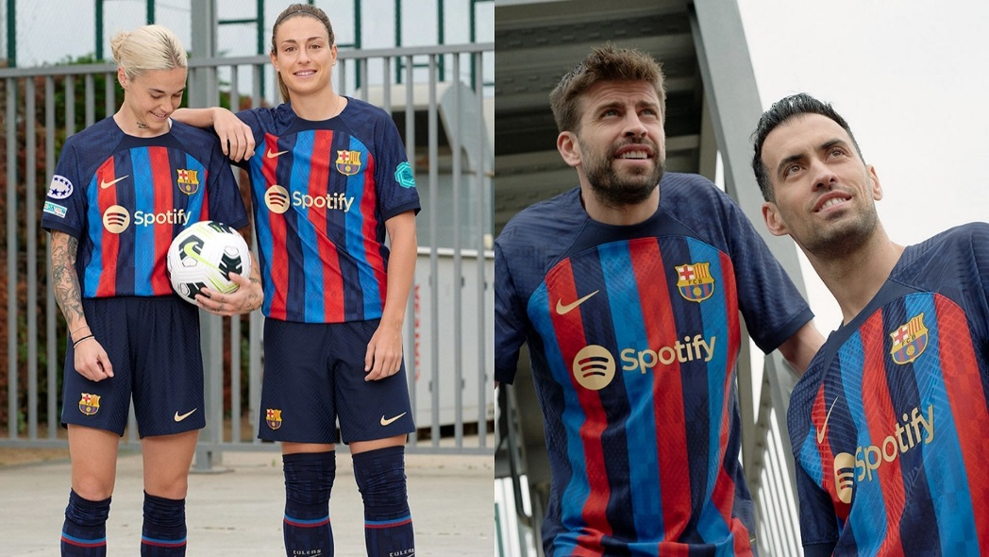I personally love this one because I love the colours the pattern and the sponsor is on top.
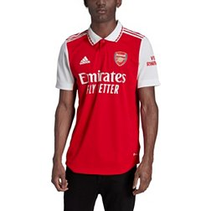personally I don’t like this one because of the collar just doesn’t fit .
Byeeee have a good week.

