What football boots you should get for your position
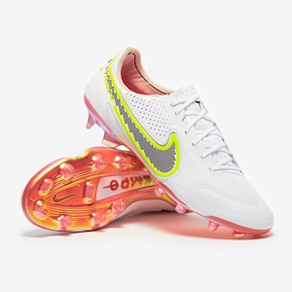Nike tempos I would recommend getting these boots if you play defence or midfield but mainly midfield because they have lots of padding and there light , if you do want a boot for defence I would recommend
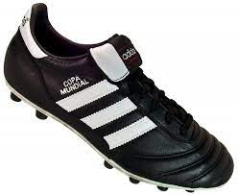adidas copa mundial they are a bit heavy but got way more protection.
For a striker I would recommend you
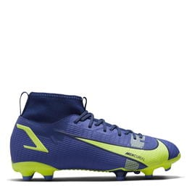Nike mercurial because they are light , some protection and they have grip and if you are a winger I would recommend you the same boots.
Hope that helps have a good day

