Why to go to derwent hill.
1. Because it is really fun.
2. Because you can get peace and quiet away from your siblings.
3. Because when you go to derwent hill you can go rock climbing bouldering hiking get full English breakfast’s canoeing,

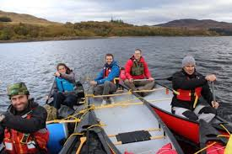
My favourite part probably will be the death swing because from when my mam went to derwent hill she said that it will be really exciting.
- canoeing
- bush craft
- rock climbing
- mine exploration
- orienteering
- ghyll scrambling
- a full day’s hill-walk
- the Big Swing and Gladiator Challenge
- team tasks.

