ALL ABOUT DERWENT HILL!!
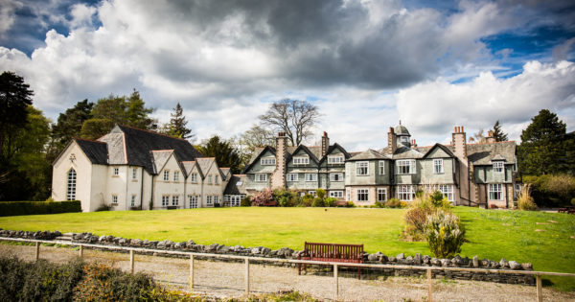
This is where year fives go!
We will go for 5 days and we are leaving in 5 weeks
We will do water sports and fun games during the day
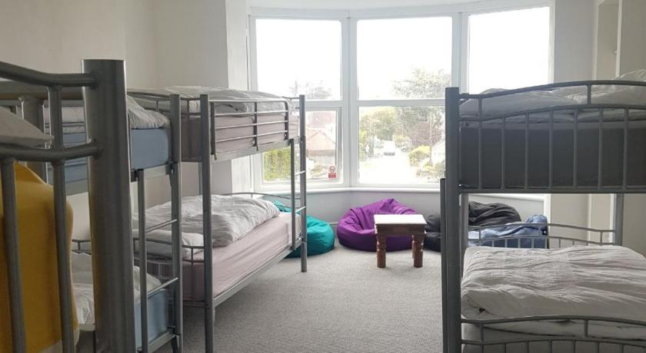

So we are so exited we can barley wait!!!!!

