Hello 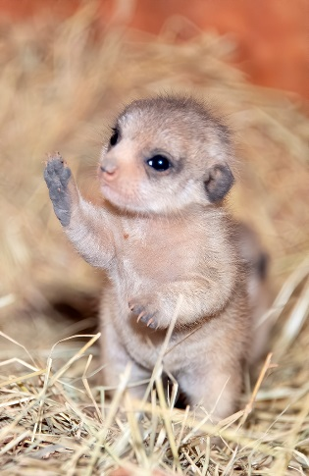
Name-Caitlin
Favourite colour-Green
Favourite animal-Meerkat
Favourite toy-Teddy bear
Favourite food-Pasta

