Learning review
History
We are learning about the Anglo Saxons
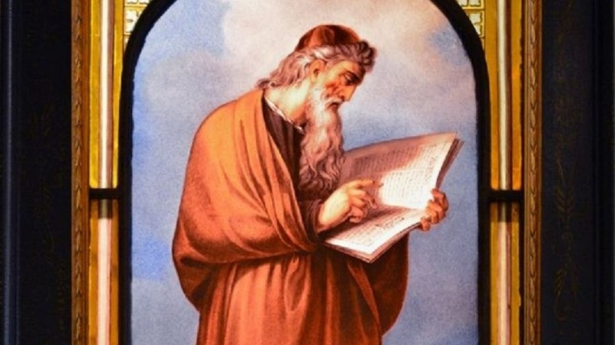
And St Bede
He was sent to the monastery at the age of 7 away from his mum. It is so sad! From that, he became a saint. WOW!
MATHS
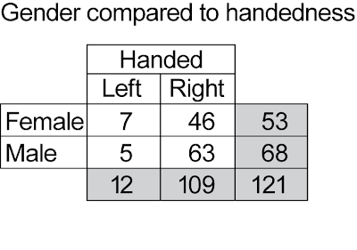This is what we are learning in maths two way tables I really enjoy it and I find it wonderful to learn.

